October  7th S.S. | 2019
Sunday | Monday | Tuesday | Wednesday | Thursday | Friday | Saturday
 |  | 1 | 2 | 3 | 4 | 5
 |  |  |  |  | 7th grade field trip
6 | 7 | 8 | 9 | 10 | 11 | 12
 | Current Events H.W. Due |  | MAP QUIZ 2
13 | 14 | 15 | 16 | 17 | 18 | 19
 | Columbus Day  No School |  |  |  | CRQs H.W. Due
20 | 21 | 22 | 23 | 24 | 25 | 26
 | Unit 2 Vocab  Review Sheet Due | 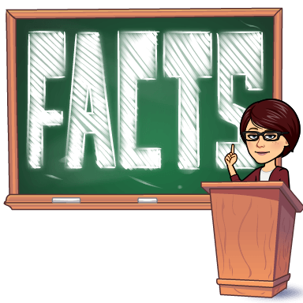  Unit 2 VOCAB Quiz |  | Superintendents Conference Day  No School | Superintendents Conference Day  No School
27 | 28 | 29 | 30 | 31
 | Current Events H.W. Due |  |  | MAP QUIZ 3
October  7th S.S. | 2019
Sunday | Monday | Tuesday | Wednesday | Thursday | Friday | Saturday
 |  | 1 | 2 | 3 | 4 | 5
 |  |  |  |  | 7th grade field trip
6 | 7 | 8 | 9 | 10 | 11 | 12
 | Current Events H.W. Due |  | MAP QUIZ 2
13 | 14 | 15 | 16 | 17 | 18 | 19
 | Columbus Day  No School |  |  |  | CRQs H.W. Due
20 | 21 | 22 | 23 | 24 | 25 | 26
 | Unit 2 Vocab  Review Sheet Due | Unit 2 VOCAB Quiz |  | Superintendents Conference Day  No School | Superintendents Conference Day  No School
27 | 28 | 29 | 30 | 31
 | Current Events H.W. Due |  |  | MAP QUIZ 3

