Labor Movement in the Gilded Age
Analysis
Objective | What can we learn about the labor movement in the Gilded Age by comparing the Haymarket Riot, the Homestead Strike, the Pullman Strike, and the Ludlow Massacre?

Labor in the Gilded Age - Directions: You have been assigned to read about ONE of four major labor related events in US History from the Gilded Age. Read about your event, and fill out the table below based on your reading. When your group is ready, should share the information about your Labor Movement event with the group, using the information to complete the table below and the analysis questions that follow.
Event | Industry | People Involved | What happened: Cause, Effect, Impact
Haymarket Riot
1886
Homestead Strike
1892
Pullman Strike
1894
Analysis Questions:

- Analysis: What similarities or patterns do you notice among the causes of these events?

- Analysis: What similarities or patterns do you notice among the effects and impacts of these events?

- Based on these four events, write two claims about the causes and/or effects of the labor movement during the Gilded Age. Support each claim with evidence from at least two of the events examined in this activity. See the example below:

The labor movement during the Gilded Age was mostly caused by low wages, however they were largely unsuccessful.

- Evidence: Pullman Strike and Homestead Strike laborers wanted more wages, both times the strike was put down by the US Army or national guard and the laborers did not win an increase in wages.

Haymarket Riot 1886
Historical Context: Following the Panic of 1873, there was a rapid expansion of industrial production in the United States. To fuel this, factories and mills such as those found in the steel, railways, and lumber industries, employed many new immigrants from Europe working 60 - 100 hour work weeks over 6 days, with wages as low as $1.50 per day ($37.64 in today’s dollars). In Chicago, German and Bohemian immigrants organized unions to try and demand better working conditions. Many of these organizers were also members of anarchist and socialist parties that believed that capitalism was ruining America and squeezing the working class into poverty while the rich simply became richer. Employers in Chicago responded to the forming of unions with anti-union measures such as firing and blacklisting union members, locking out workers, and employing spies and private security forces to harass workers. In 1884, the unions around the nation banded together and had grown strong enough that they were able to lobby for an 8 hour work day. On May 1st they organized rallies across the United States in support of the 8 hour work day. Their slogan was: “Eight hours for work, eight hours for rest, and eight hours for what you will."

Events of the Haymarket Riot: On May 3, 1886, at a rally outside of a factory, union leader August Spies gave a speech in which he told striking workers to stay calm and stand by their union, or they would not succeed in their strike for better working conditions and an 8 hour work day. At the end of his speech, the bell for the end of the work day rang out, and striking unionists attacked men who had broken the strike and gone to work. In trying to calm the fights that followed this attack, police opened fire, killing four demonstrators. The next day, workers held a vigil and rally at Haymarket Square to protest the police killings. August Spies and fellow union leader Albert Parsons gave speeches. At the end of the speeches, the police marched towards the protesters and asked them to break up the rally and go home. As they advanced, gun shots were exchanged between the protesters and the police, when suddenly a bomb exploded killing six police officers.

Effect and Impact: As a result of the Haymarket Square bombing, August Spies, Albert Parsons, and 6 other union leaders were arrested. They were charged with inciting violence and sentenced to death. Additionally, harsh anti-union measures were put into place by the police including raiding and ransacking their offices without a warrant. The entire German and Bohemian community came under suspicion, fueling an anti-immigrant movement. Additionally, newspapers persecuted union leaders in the press, spreading an anti-union, anti-socialist sentiment throughout the nation. The unions were weakened, laborers lost their battle for fairer working conditions, and the interests of wealthy industrialists were protected.

Homestead Strike 1892
Historical Context: Owned by Carnegie Steel Company, the Homestead Steel Mill in Pennsylvania became nationally known during the strike of 1892. Carnegie's corporation was known for cutting costs associated with labor to achieve higher profit margins. In the early 1880’s, the standard work week at a Carnegie Company steel mill was about 85 hours a week; laborers made about an average of $10 a week (about $250 in today’s dollar value). Most of the workers in his steel mills were Eastern European immigrants. In 1889, the Amalgamated Association of Iron and Steel Workers had won a favorable contract with higher wages. In 1892, Carnegie's plant manager at the Homestead Mill, Henry Clay Frick, tried to negotiate a new contract with the unionized workers. In his list of demands, he included increased production demands while also proposing to lower the wages by 22%. On June 29th 1892, the union went on strike. In response, Frick locked the workers out of the plant and sent for 300 Pinkerton Guards (who were from a private detective agency who could be hired to do work on behalf of or protect any private citizen).
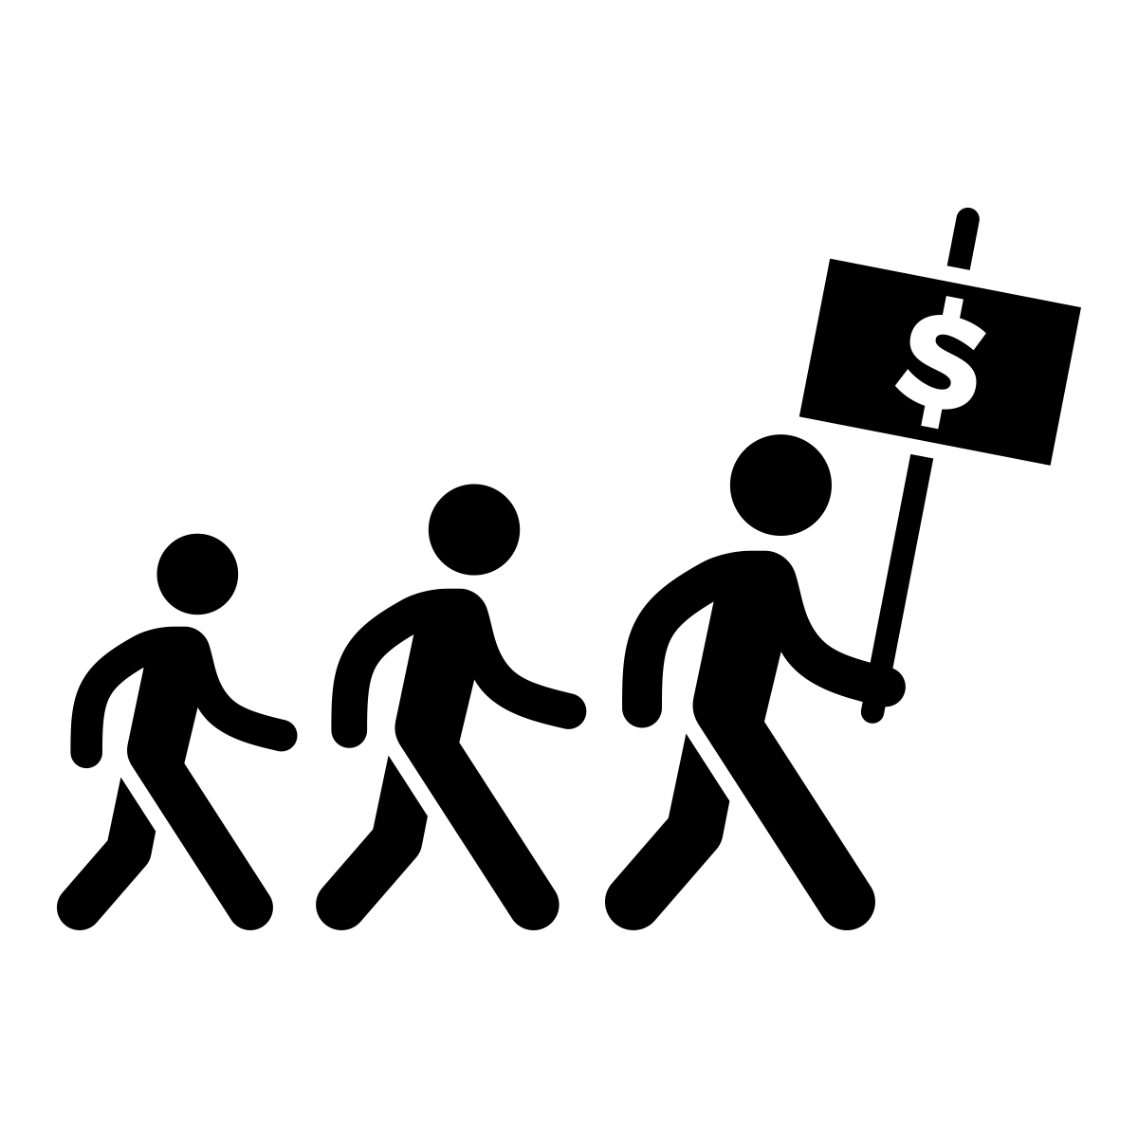

Events of the Homestead Strike: When the Pinkerton Guards arrived on July 6th, they were met by 10,000 striking workers. The two groups battled nearly all day, with the striking laborers winning after approximately 10 - 15 deaths on both sides. Frick and the Sheriff of the region appealed to the governor who sent in the state militia to force workers to end the strike. The militia occupied the mill and surrounding areas; meanwhile, the Carnegie Corporation was abe to get production up and running again by convincing some striking members to return to work using threats and intimidation. Up until mid-July, public support for the striking workers was strong. This changed on July 23rd when anarchist Alexander Berkman attempted to assassinate Frick. Unsuccessful, this attempt on Frick’s life largely shifted public sympathies to be with the Carnegie Corporation. Newspapers called the striking workers, mostly Eastern Europeans, horrible names and blamed them for the economic damage to the steel industry and town of Homestead. The strike didn’t last much longer. The militia occupied Homestead, Pennsylvania until October when workers, feeling overwhelmed, abandoned the strike.

Effect and Impact: The Homestead Strike effectively crushed and collapsed the Amalgamated Association of Iron and Steel Workers. With the Amalgamated Association virtually destroyed, Carnegie Steel moved quickly to institute longer hours and lower wages. The Homestead Strike inspired many workers, but it also underscored how difficult it was for any union to prevail against the combined power of a corporation and the government.

Pullman Strike 1894

Historical Context: During and after the Civil War, the railway industry dominated the American economy and was the nation’s single largest employer. In Chicago, George Pullman built a different kind of company for manufacturing railroad cars. To produce the cars, he built a manufacturing plant in a company-owned town on the outskirts of Chicago. The company town was touted as a model community filled with content, well paid workers. During the economic depression of 1893, George Pullman sought to preserve profits by lowering labor costs - so he slashed his workforce by 1,200 workers and cut wages by 25 percent. Workers were required to live in the company town, which meant they rented and bought household provisions from the Pullman company. While wages had been slashed, the cost of living in the company town did not change, drastically altering the lives of the Pullman railway workers.

Events of the Pullman Strike: The Pullman factory workers went on strike and were joined by the American Railway Union (ARU) and its leader, Eugene Debs. The ARU supported the strike by refusing to run trains containing Pullman cars. The plan was to force the railroads to bring Pullman to compromise. Once on strike, the laborers proceeded to obstruct railroad tracks preventing the transportation of goods and attracting national attention. The strike affected nearly all of America. The media coverage was extensive and generally negative. The editorials and articles depicted the boycotters as foreigners who were Anti-American. The strike was ended when President Grover Cleveland used the US Marshals and US Army troops to force the workers to resume their duties. His lawyers also argued that the strike violated the Sherman Antitrust Act and represented a threat to public safety.

Effect and Impact: The American Railways Union was weakened as a result of their loss in this action. Eugene Debs was jailed for six months for his part in the strike, but he also gained a national following as a strong leader willing to fight for workers rights. As a result, he was able to run for president five times as the head of the Socialist party. In 1894, President Cleveland designed Labor Day as a federal holiday to appease workers. Many Americans were appalled at the class conflict that the strike (and others like it) represented. The events of the Pullman Strike led to a deepening awareness that there was a "labor problem" in America and a "labor question" in American politics. As a result of Pullman Strike, reformers energetically began searching for a new way of protecting the "public interest" in the face of the competing interests of labor and capital.

