- “A house divided against itself cannot stand. I believe this government cannot endure permanently half slave and half free.” -Abraham Lincoln, 1858

According to this quotation, Abraham Lincoln believed that
- slavery was immoral and should be abolished immediately
- sectional differences threatened to destroy the Union
- the Southern states should be allowed to secede
- to save the nation, the North should compromise with the South on slavery

- “[The registrar] brought a big old book out there, and he gave me the sixteenth section of the constitution of Mississippi, . . . I could copy it like it was in the book, but after I got through copying it, he told me to give a reasonable interpretation and tell the meaning of the section I had copied. Well, I flunked out.” Source: A History of the United States since 1861
The main intent of the literacy test described in the passage was to
- encourage reform of the political system
- encourage Mississippi residents to learn about their state’s legal system
- prevent African Americans from exercising a basic right
- enforce the provisions of the United States Constitution

- Before the Civil War, the collapse of the Whig Party and the formation of the Free Soil and the Republican parties showed that
- opposing views on slavery affected national unity
- Americans were united in their political views
- major political parties received most of their support in the South
- Americans were divided over the issue of unlimited coinage of silver
Speaker A:
The right way to settle the question of slavery in the territories is to let the people who live there determine if their state is to be slave or free.

Speaker B:
The Supreme Court’s decision in Dred Scott v. Sanford is exactly what this country needs. Perhaps now the abolitionists will stop their meddling.

Speaker C:
Secession is unlawful and treasonous. Everything possible must be done to preserve the Union.

Speaker D:
The rights of the states must be protected. The federal government is exceeding its authority.
- The solution proposed by Speaker A is known as
- nullification
- the spoils system
- popular sovereignty
- federal supremacy

- Which speaker most accurately represents the opinions of President Abraham Lincoln?

- Speaker A
- Speaker B
- Speaker C
- Speaker D

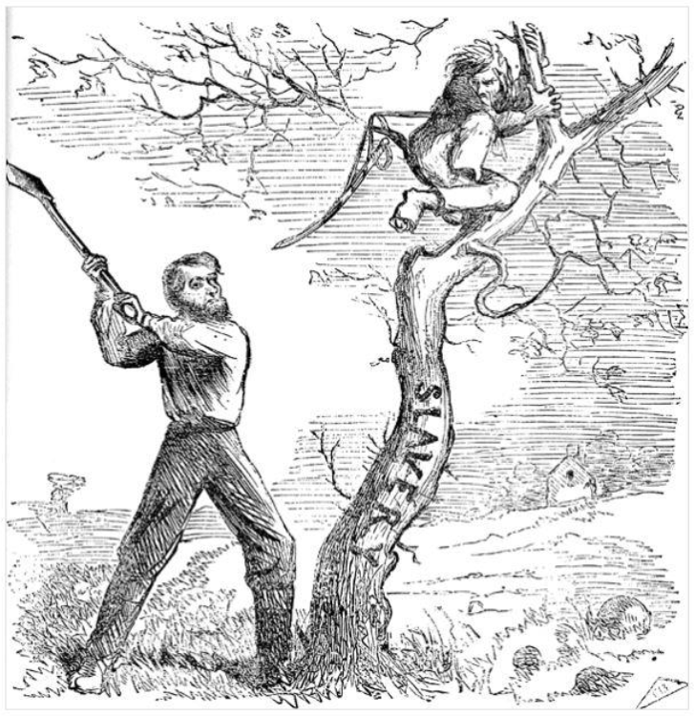
- Political Cartoon Analysis
  - Was this cartoon created from a northern or southern perspective?

  - Explain the main idea of the cartoon and use evidence from your learning this unit.

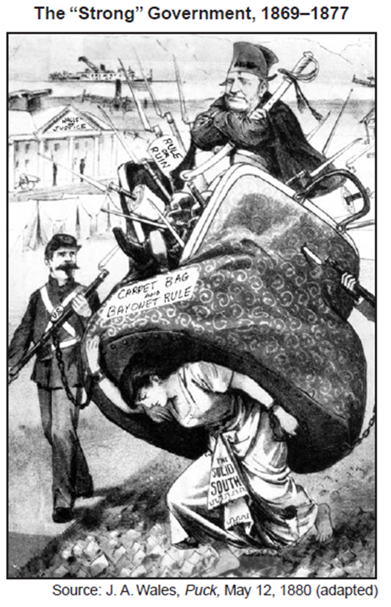
- Which congressional action led to the Southern viewpoint expressed in this cartoon?

- The Battle of the Ironclads  March 9 1862 | - __________ After Lee’s surrender the Union allowed him and his troops to return back to the South to await a decision from the Union government on how the reorganization of the United States would proceed.
- Wade-Davis Bill | - _____________ This battle marked the turning point of the Civil war for the North as the South began to realize they were running out of men and supplies to keep fighting
- The Battle of Bull  July 21, 1861 | - _____________ This battle marked the end of the wooden naval vessel era and in the introduction of modern naval warfare for both the North and the South
- Battle of Gettysburg  July 3, 1863 | - _____________ resulted in the freeing of slaves in only the Southern Confederate States, but didn’t free the slaves in the Border States for fear the Union would loose them as allies.
- Surrender at Appomatax Court House  April 9, 1865 | - ____________ The Union retreated back to Washington, D.C. and the Confederate troops collected the gear left behind by the fleeing soldiers. This is the battle that General Thomas Jackson received the nickname “Stonewall”. It also marked the realization that the Battle between the North and the South would not be a quick one.
- The 15th Amendment | - ___________ The Fort was controlled by the Union and the Confederates asked for a surrender since the fort was guarding Charlestown Harbor in South Carolina. After much debate by Lincoln who did not want to engage the Seceded States, the Union surrendered the Fort and THE CIVIL WAR STARTED
- Fort Sumter  April 11, 1861 | - ___________ required that a majority of prewar voters in the Confederate states swear loyalty to the Union before restoration could begin
- The Emancipation Proclamation | - _______ 1870 constitutional amendment that guaranteed voting rights regardless of race or previous condition of servitude

Choose 2 Questions. For each question write on 4-7 sentnece short answer response. Each response needs to include 4 facts/ evidence to support the answer. Please Underline your evidence.

How did the Union Strategy in the War differ from the Confederates strategy?

How did the Union finally collapse into a civil war?

How did each side’s resources and strategies affect the early battles of the Civil war?

How did Radical Republicans plans for Reconstruction differ from Lincoln’s and Johnson’s?

_____________________________________________________________________________________________________________________________________________________________________________________________________________________________________________________________________________________________________________________________________________________________________________________________________________________________________________________________________________________________________________________________________________________________________________________________________________________________________________________________________________________________________________________________________________________________________________________________________________________________________________________________________________________________________________________________________________________________________________________________________________________________________________________________________________________________________________________________________________________________________________________________________________________________________________________________________________________________________________________________________________________________________________________________________________________________________________________________________________________________________________________________________________________________________________________________________________________________________________________________________________________________________________________________________________________________________________________________________________________________________________________________________________________________________________________________________________________________________________________________________________________________________________________________________________________________________________________________________________________________________________________________________________________________________________________________________________________________________________________________________________________________________________________________________________________________________________________________________________________________________________________________________________________________________________________________________________________________________________________________________________________________________________________________________________________________________________________________________________________________________________________________________________________________________________________________________________________________________________________________________________________________________________________________________________________________________________________________________________________________________________________________________________________________________________________________________________________________________________________________________________________________________________________________________________________________________________________________________________________________________________________________________________________________________________________________________________________________________________________________________________________________________________________________________________________________________________________________________________________________________________________________________________________________________________________________________________________________________________________________________________________________________________________________________________________________________________________________________________________________________________________________________________________________________________________________________________________________________________________________________________________________________________________________________________________________________________________________________________________________________________________________________________________________________

