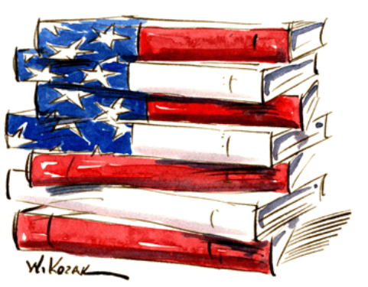

dATE:______________

Name:______________

United States

Maps

**MAP QUIZ 1**

1. Maine
2. New Hampshire
3. Vermont
4. Massachusetts
5. New York
6. Rhode Island
7. Connecticut
8. New Jersey
9. Pennsylvania
10. Maryland
11. Delaware

**MAP QUIZ 2**

1. Virginia
2. North Carolina
3. South Carolina
4. Georgia
5. Florida
6. Arkansas
7. Louisiana
8. Mississippi
9. West Virginia
10. Kentucky
11. Tennessee
12. Alabama

**MAP QUIZ 3**

1. Ohio
2. Indiana
3. Michigan
4. Wisconsin
5. Illinois
6. Minnesota
7. Iowa
8. Missouri
9. North Dakota
10. South Dakota
11. Nebraska
12. Kansas

**MAP QUIZ 4**

1. Oklahoma
2. Texas
3. Montana
4. Wyoming
5. Colorado
6. New Mexico
7. Arizona
8. Utah
9. Idaho
10. California
11. Nevada
12. Oregon
13. Washington
14. Alaska
15. Hawaii

**MAP QUIZ 5**

1. Tropic of Cancer
2. Bering Sea
3. Bahamas
4. Cuba
5. Mexico
6. Washington D.C.
7. Canada
8. Atlantic Ocean
9. Pacific Ocean
10. Gulf of Mexico

**MAP QUIZ 6**

1. Rocky Mountains
2. Appalachian Mountains
3. Great Plains
4. Sierra Nevada Mountains
5. Ozark Mountains
6. Lake Superior
7. Lake Michigan
8. Lake Huron
9. Lake Erie
10. Lake Ontario

**MAP QIUIZ 7**

1. St. Lawrence River
2. Mississippi River
3. Ohio River
4. Colorado River
5. Rio Grande
6. Colombia River
7. Missouri River
8. Arkansas River
9. Yukon River
10. Hudson River

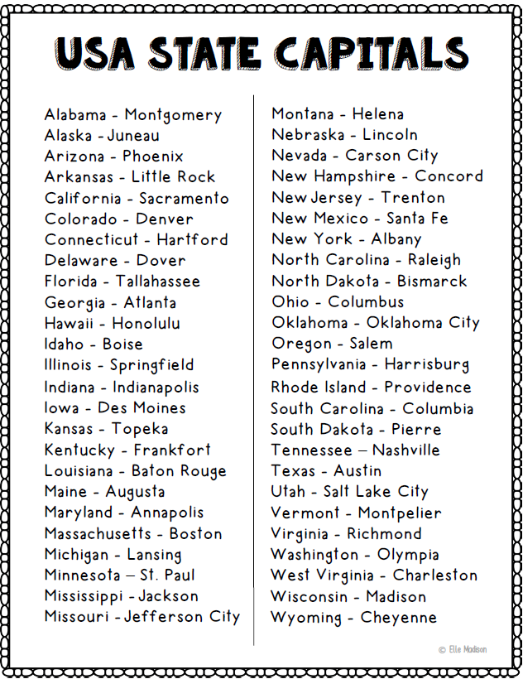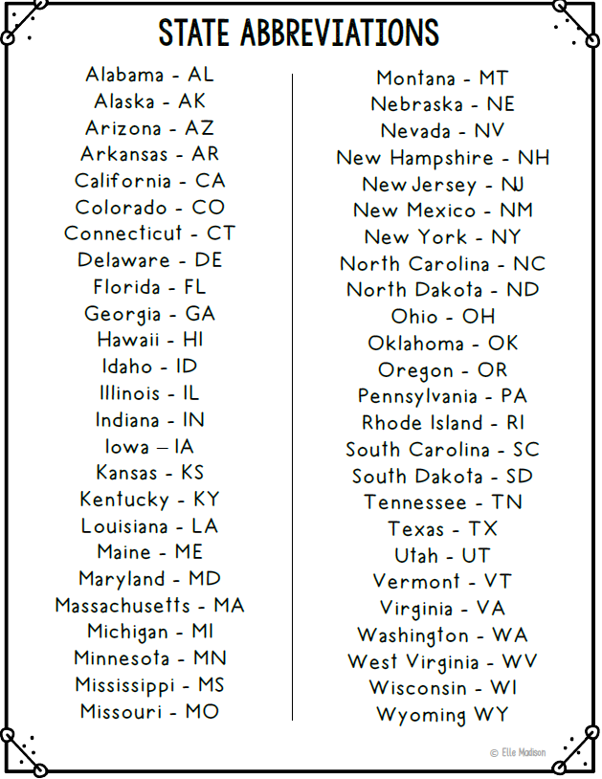

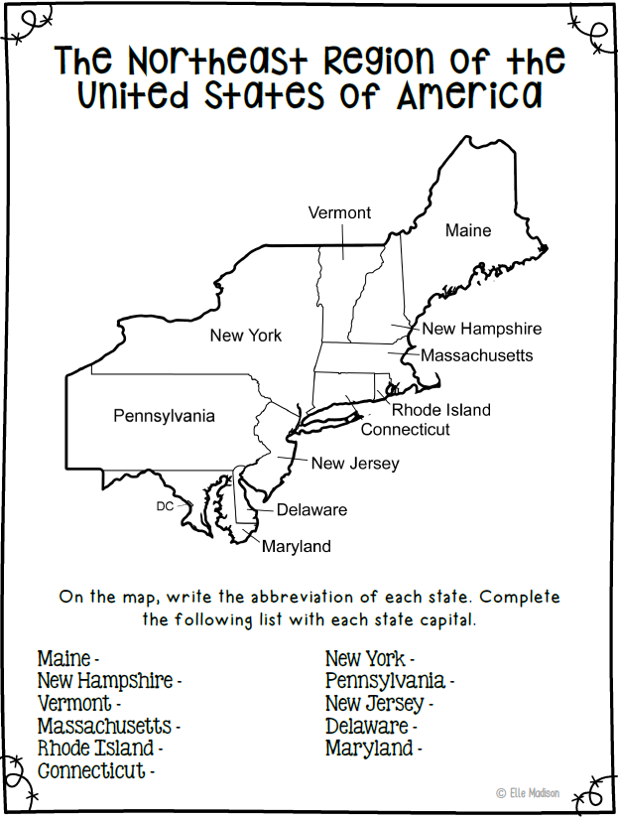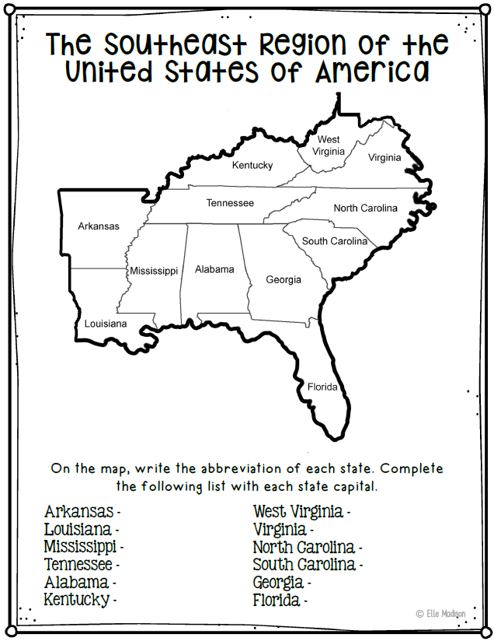

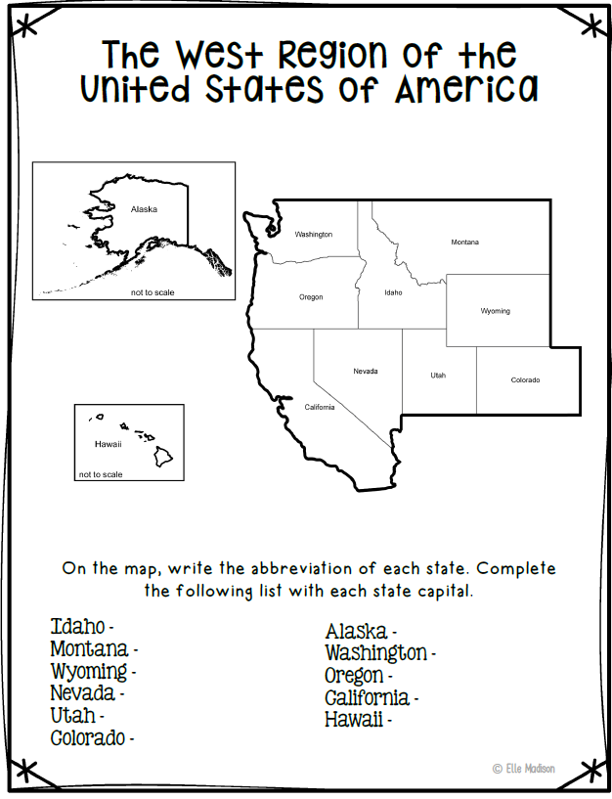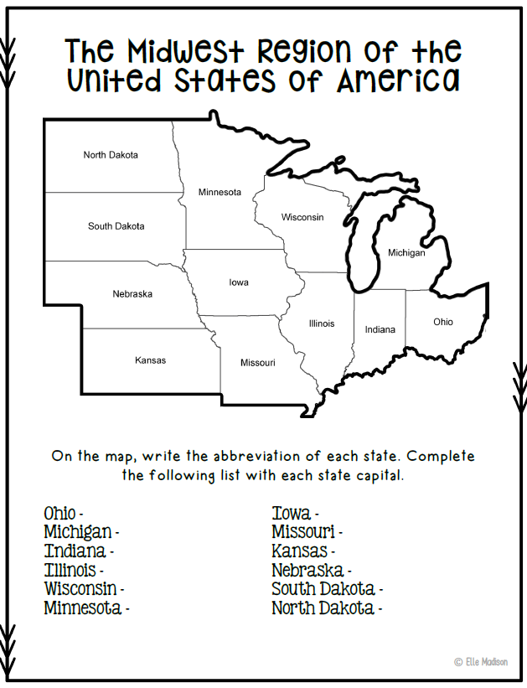

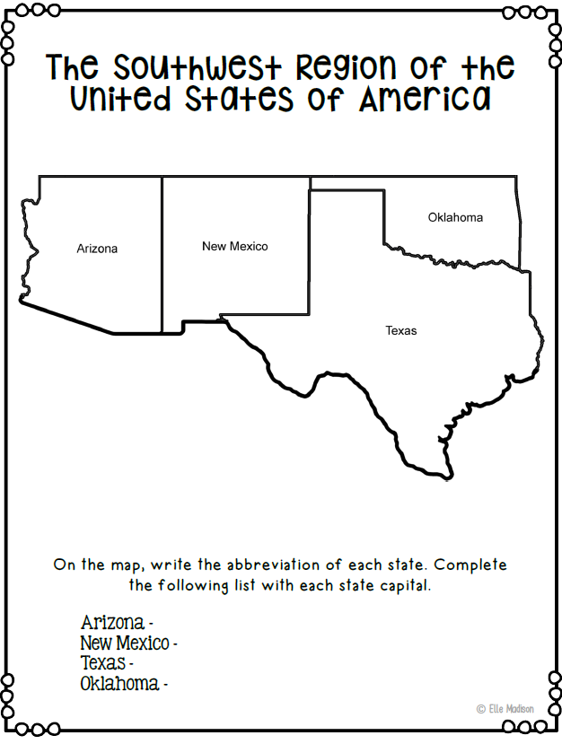

T- Title O-Orientation D-Date A- Author L- Legend S-Scale

States Blank Map – 2019/2020

[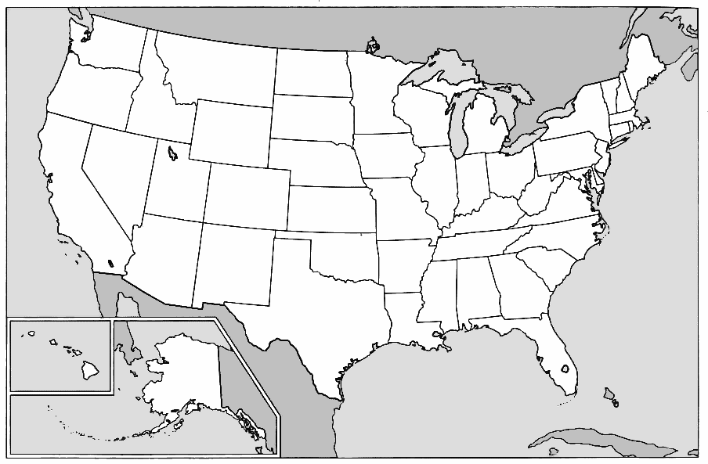](http://www.google.com/url?sa=i&rct=j&q=&esrc=s&source=images&cd=&cad=rja&uact=8&ved=0ahUKEwjz1qmtw53WAhVG7RQKHcf1BtgQjRwIBw&url=http://jobxyz.us/blank-map-of-united-states-images.html&psig=AFQjCNEdaJDmIGRtFTcMw8enuHIJduvdDg&ust=1505232773793855)

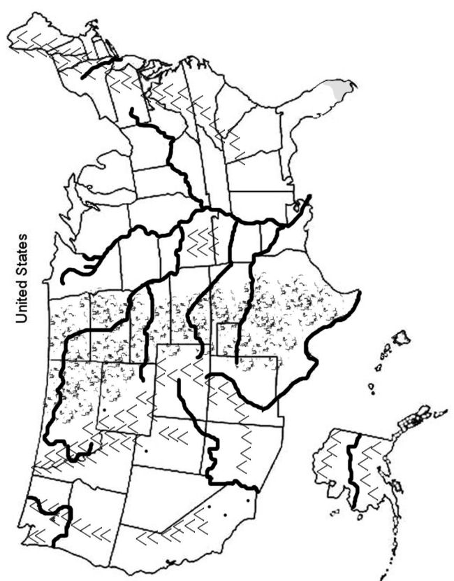

T- Title O-Orientation D-Date A- Author L- Legend S-Scale

US Mountains and Rivers – 2019/2020

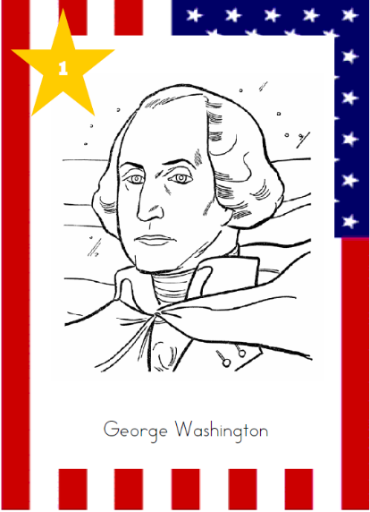

**President:**

**Dates in Office:**

**ACHIEVEMENTS**

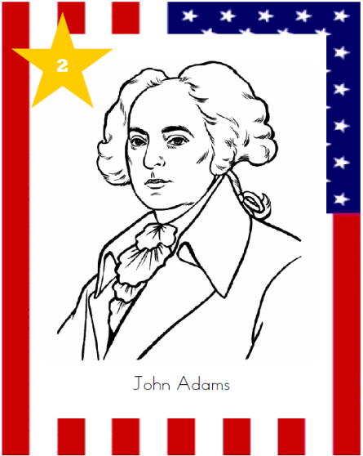

**ACHIEVEMENTS**

**President:**

**Dates in Office:**

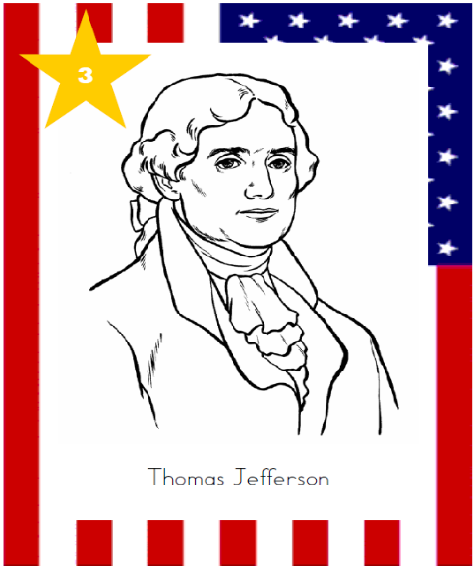

**ACHIEVEMENTS**

**President:**

**Dates in Office:**

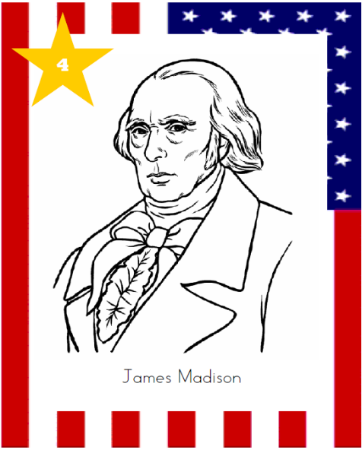

**ACHIEVEMENTS**

**President:**

**Dates in Office:**

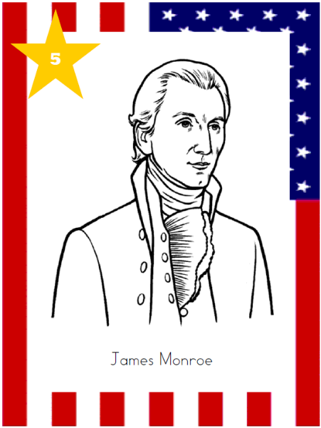

**ACHIEVEMENTS**

**President:**

**Dates in Office:**

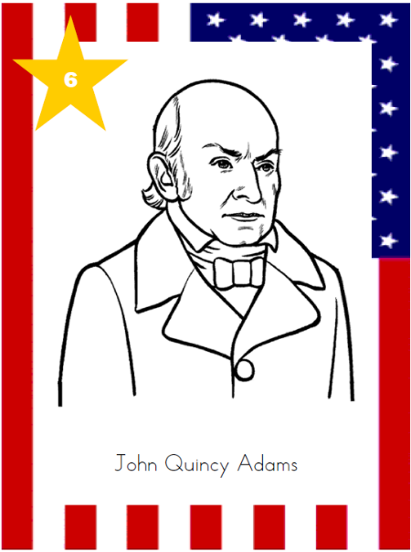

**ACHIEVEMENTS**

**President:**

**Dates in Office:**

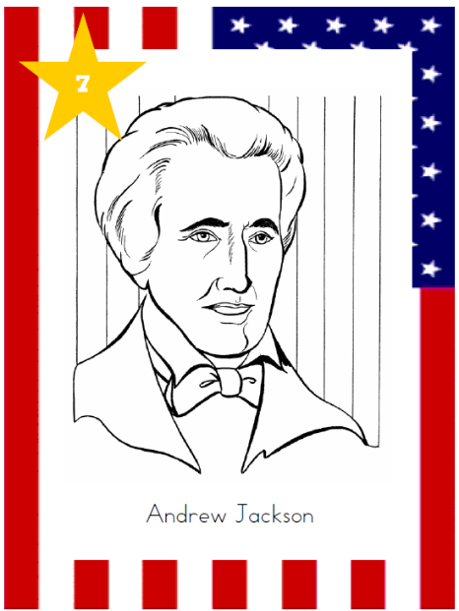

**ACHIEVEMENTS**

**President:**

**Dates in Office:**

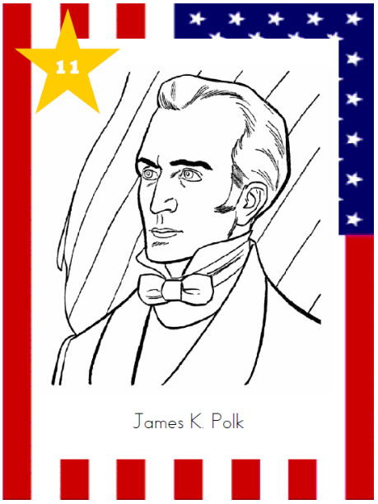

**ACHIEVEMENTS**

**President:**

**Dates in Office:**

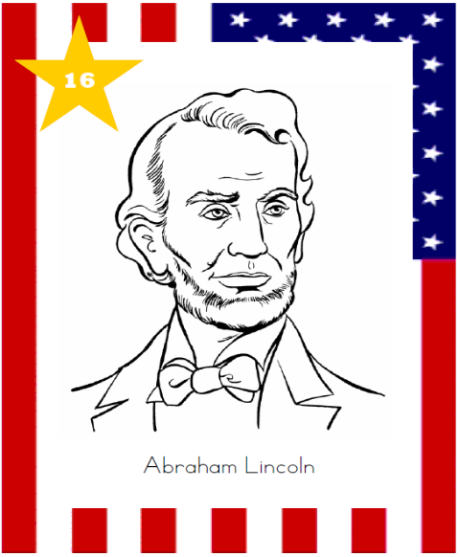

**ACHIEVEMENTS**

**President:**

**Dates in Office:**

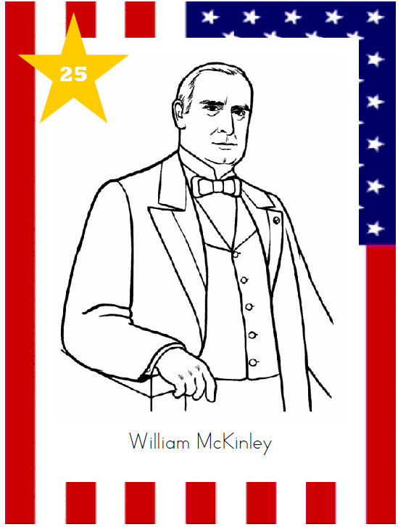

**ACHIEVEMENTS**

**President:**

**Dates in Office:**

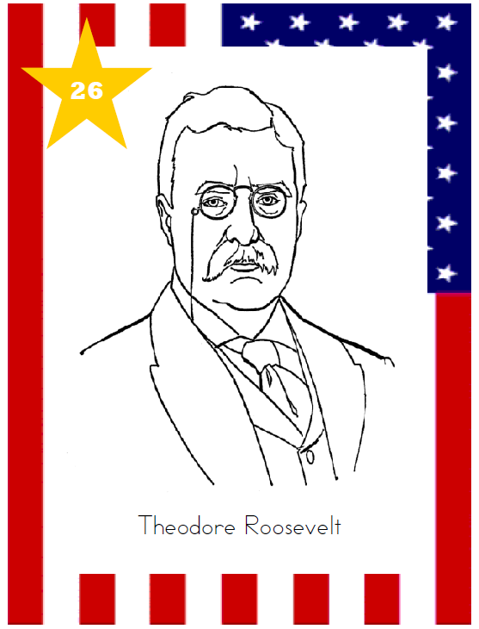

**ACHIEVEMENTS**

**President:**

**Dates in Office:**

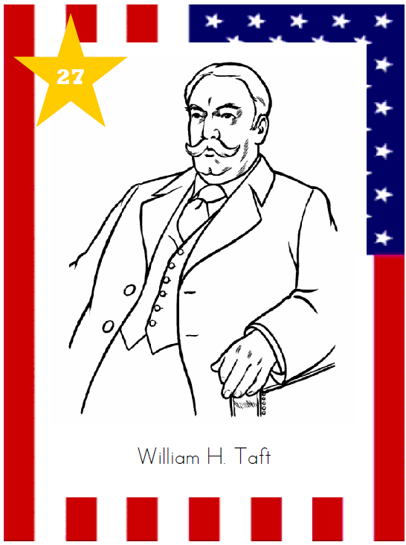

**ACHIEVEMENTS**

**President:**

**Dates in Office:**

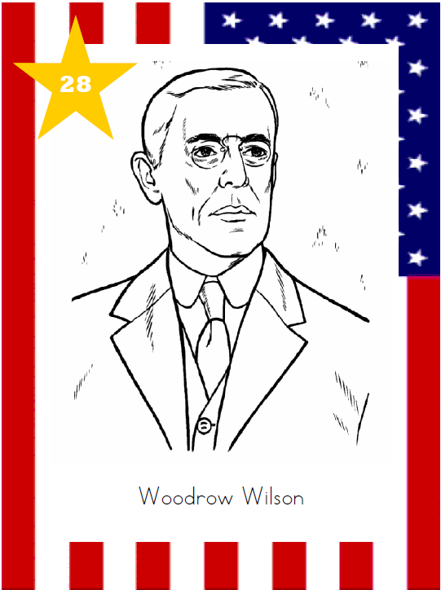

**ACHIEVEMENTS**

**President:**

**Dates in Office:**

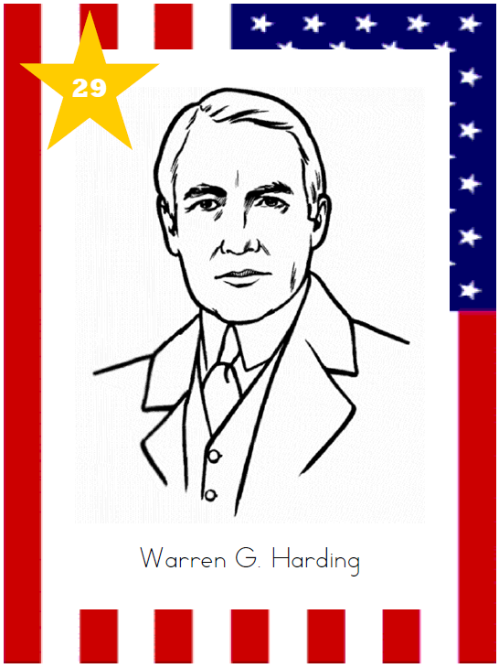

**ACHIEVEMENTS**

**President:**

**Dates in Office:**

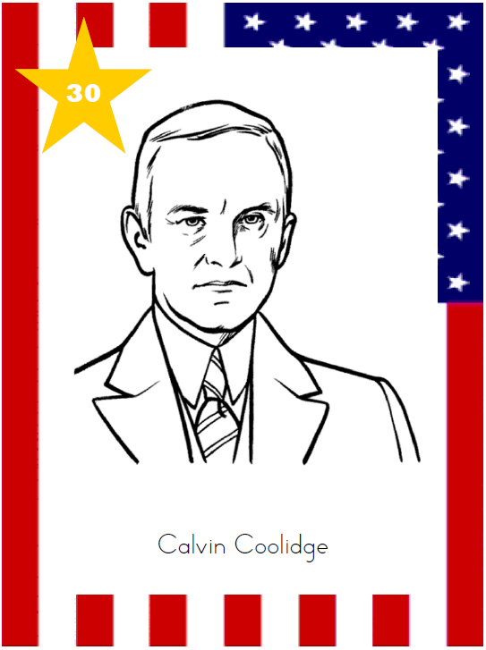

**ACHIEVEMENTS**

**President:**

**Dates in Office:**

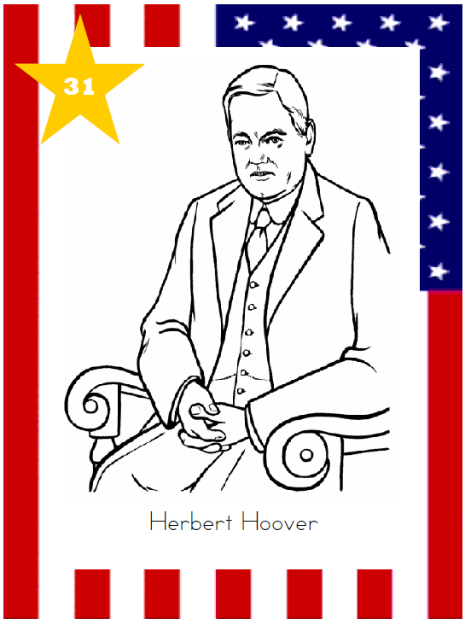

**ACHIEVEMENTS**

**President:**

**Dates in Office:**

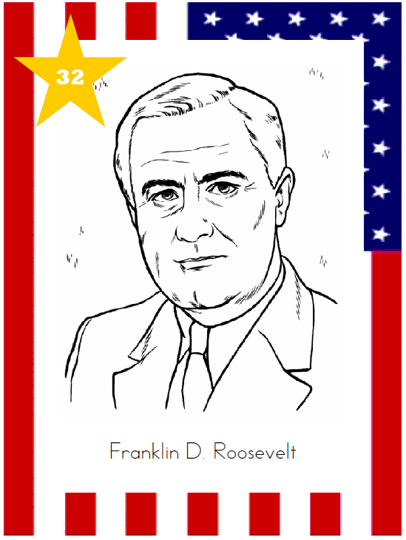

**ACHIEVEMENTS**

**President:**

**Dates in Office:**

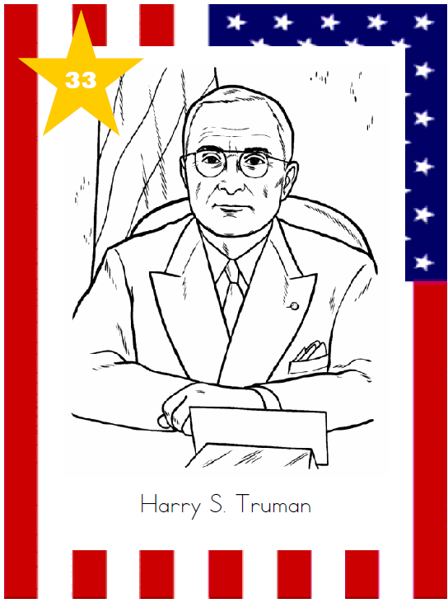

**ACHIEVEMENTS**

**President:**

**Dates in Office:**

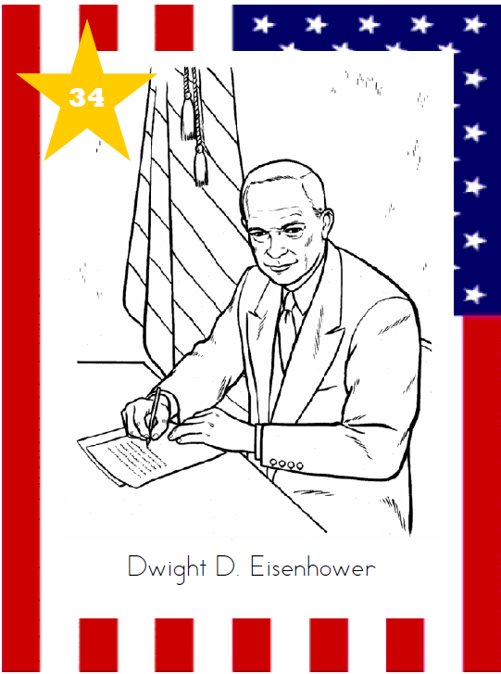

**ACHIEVEMENTS**

**President:**

**Dates in Office:**

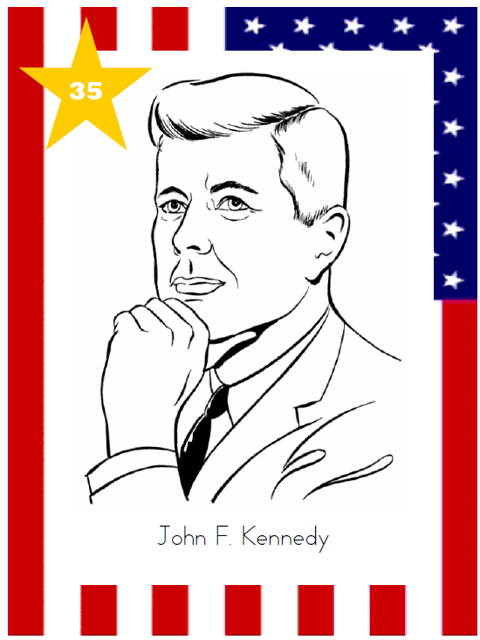

**ACHIEVEMENTS**

**President:**

**Dates in Office:**

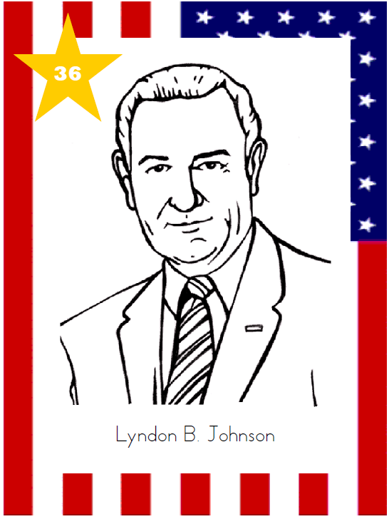

**ACHIEVEMENTS**

**President:**

**Dates in Office:**

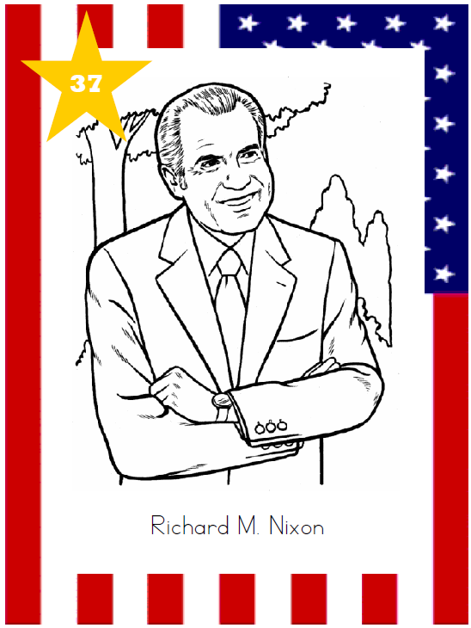

**ACHIEVEMENTS**

**President:**

**Dates in Office:**

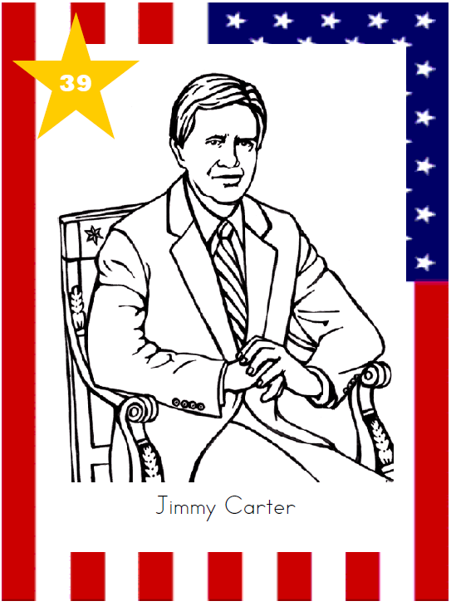

**ACHIEVEMENTS**

**President:**

**Dates in Office:**

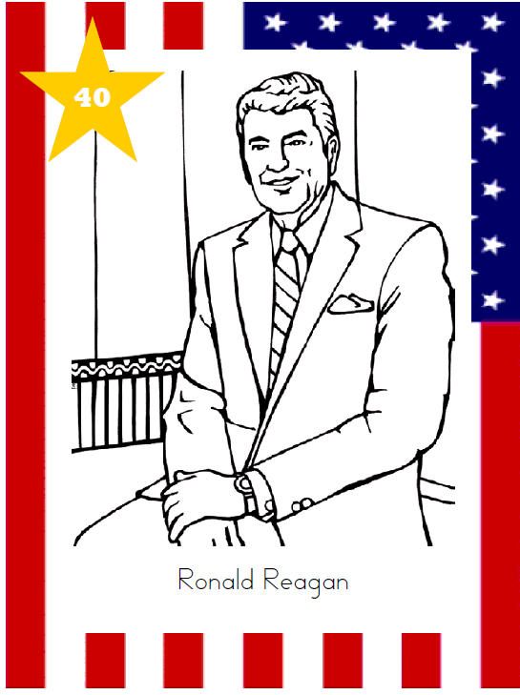

**ACHIEVEMENTS**

**President:**

**Dates in Office:**

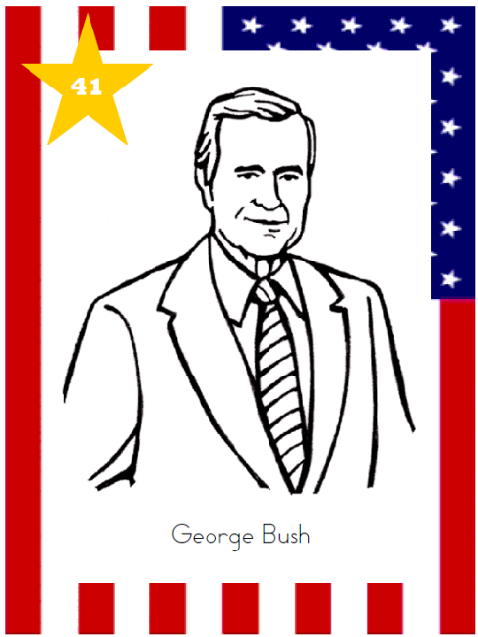

**ACHIEVEMENTS**

**President:**

**Dates in Office:**

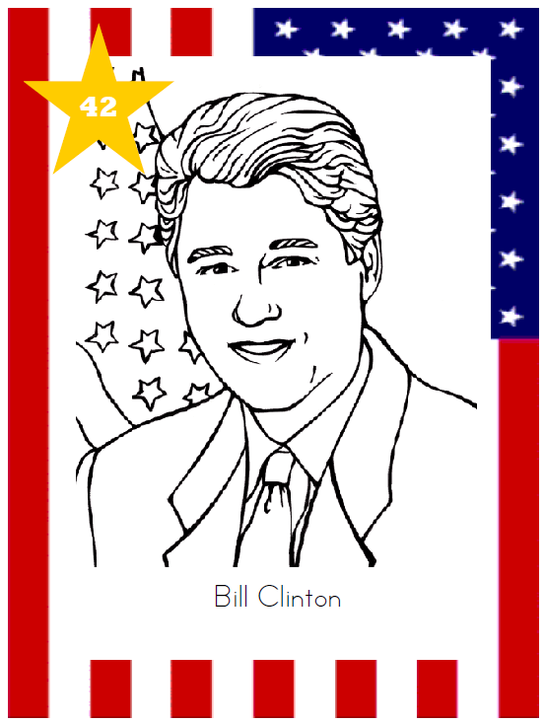

**ACHIEVEMENTS**

**President:**

**Dates in Office:**

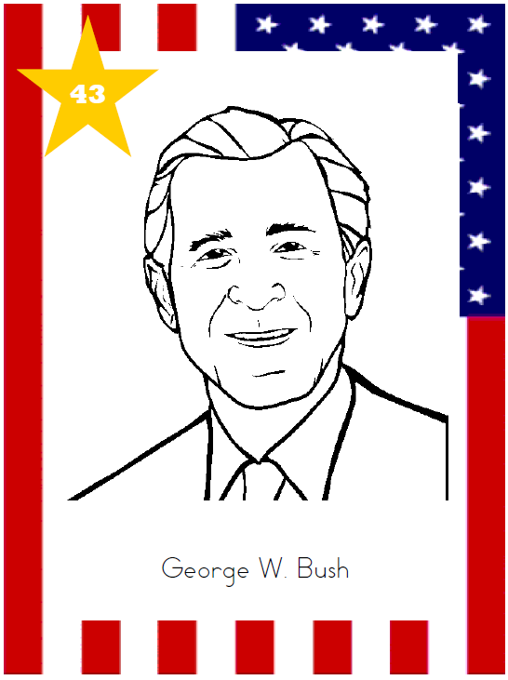

**ACHIEVEMENTS**

**President:**

**Dates in Office:**

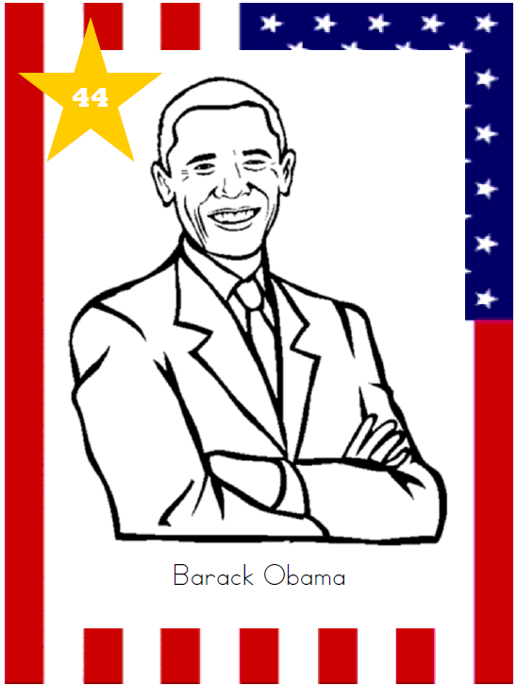

**ACHIEVEMENTS**

**President:**

**Dates in Office:**

**ACHIEVEMENTS**

**President:**

**Dates in Office:**

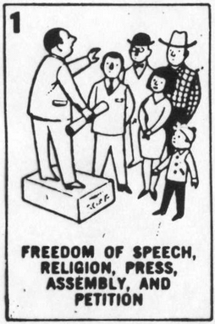

Amendment # 1

What Rights Does It Protect?

Amendment # 2

What Rights Does It Protect?

Amendment # 3

What Rights Does It Protect?

Amendment # 4

What Rights Does It Protect?

Amendment # 5

What Rights Does It Protect?

Amendment # 6

What Rights Does It Protect?

Amendment # 7

What Rights Does It Protect?

Amendment # 8

What Rights Does It Protect?

