Industrialization
Graphic Organizer
Objective | How did technology, natural resources, and transportation support the growth of industrialization in America between 1870 - 1910?

Directions: Review the graphic organizers on the attached pages. When you are done, in the appropriate spaces below, explain HOW natural resources, transportation, and technology supported the post Civil War Industrial Revolution in the United States.

- Make TWO claims each for how natural resources, transportation, and technology supported the post Civil War Industrial Revolution

- Support each claim with examples from the graphic organizers

Transportation

Natural Resources

Technology

Industrialization in the United States
Late 1800’s - Early 1900’s

Natural Resource | Iron Ore | Coal | Oil | Lumber
Description of Resource | The largest iron deposits were discovered in the mid to late 1800’s in the midwest. Iron ore could be processed into steel, which could be used to build railroads, buildings, bridges, etc. | Coal was first mined in the United States during the early 1700’s. It is used as a fossil fuel to produce heat and energy. | With the discovery of a large oil well in Western Pennsylvania in the late 1850’s, an industry was born in the US. Drilling for oil also led to the petroleum refining industry. | The eastern United States was covered in forests that could be used to harvest lumber. Deforestation impacted the US economy until the US expanded further west and more forest lands were acquired. Lumber could be used to fuel the steam engines.
Impact on Industrial Revolution | As the US expanded, the need for more infrastructure (railroads, buildings, bridges) grew as well. Additionally, steel could be used to build factories for manufacturing consumer goods. | Coal replaced wood in fueling the steam engine and machinery; it was used in both transportation and manufacturing. During the Industrial Revolution, coal helped power the railways of America (needed to transport goods across a growing nation) and power machines in factories. | Oil could be transformed into kerosene, which could be used for lighting lamps and later as gasoline for automobiles. Kerosene was the major source of lighting for most American homes until 1930. Additionally, as the use of the automobile grew in the early 1900’s, oil was a needed commodity. | Lumber was used for engines that were used on trains, steamboats, any other new machinery that ran on steam. Lumber was also used to build homes and other buildings during the rapid expansion of the United States during the Gilded Age.

Technology | Incandescent Light Bulb | Electrical Power Distribution System | Telephone
Description of Technology | The light bulb was perfected by Thomas Edison in 1878. The incandescent light bulb is an electric light with a wire filament heated to a temperature that causes it to glow with a visible light. | The first electric power grid was developed in the United States in the 1880’s in New York City. Growing slowly in the following years, the electrical power grid led to the development of more electrically powered machines and consumer electronics, such as radios. | Prior to the the telephone, the telegraph was the only way to communicate over long distances. With the rapidly expanding United States, the need for an effective and cheaper communication device was necessary- the telephone was invented by Alexander Graham Bell in 1876.
Impact on Industrial Revolution | This meant that homes and businesses could have better lighting, and lighting that would last later into the evening. This eventually led to longer work hours and night shifts in factories where manufactured goods could be produced in large quantities. | Electrical power provided energy for machines in industry and the community such as electric street cars, fans, and the printing press. Additionally, electrical power meant the development of new machinery in factories that was capable of producing more goods, for cheaper. | New and efficient form of communication that impacted businesses and office work. The telephone also created jobs for women as secretaries.

Transportation | Transcontinental Railroad  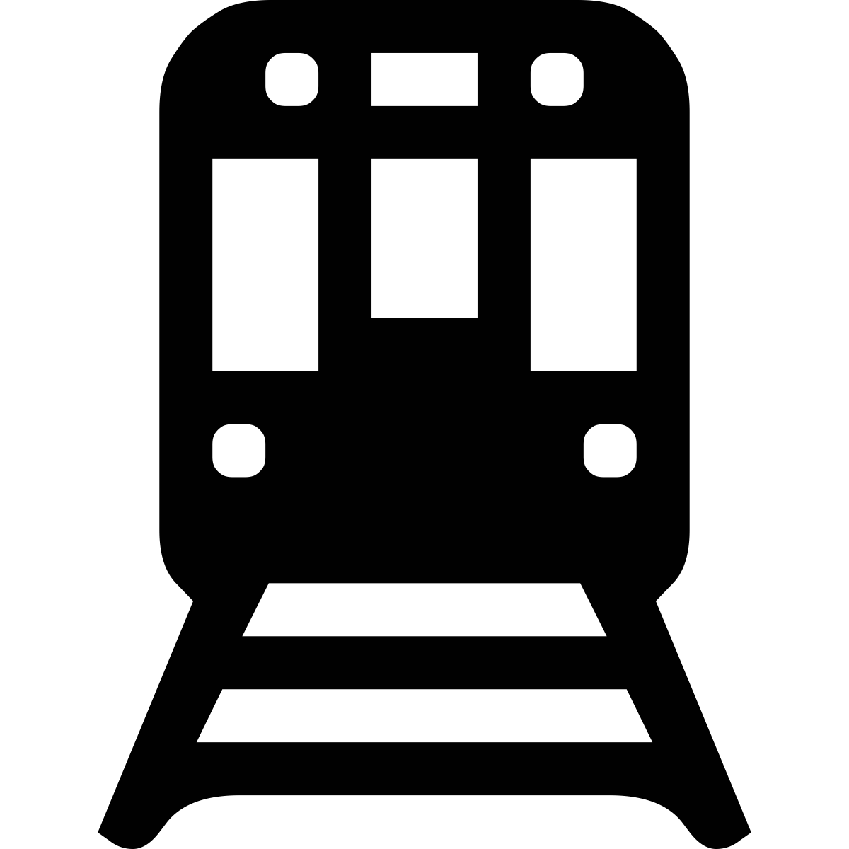 | Canal System  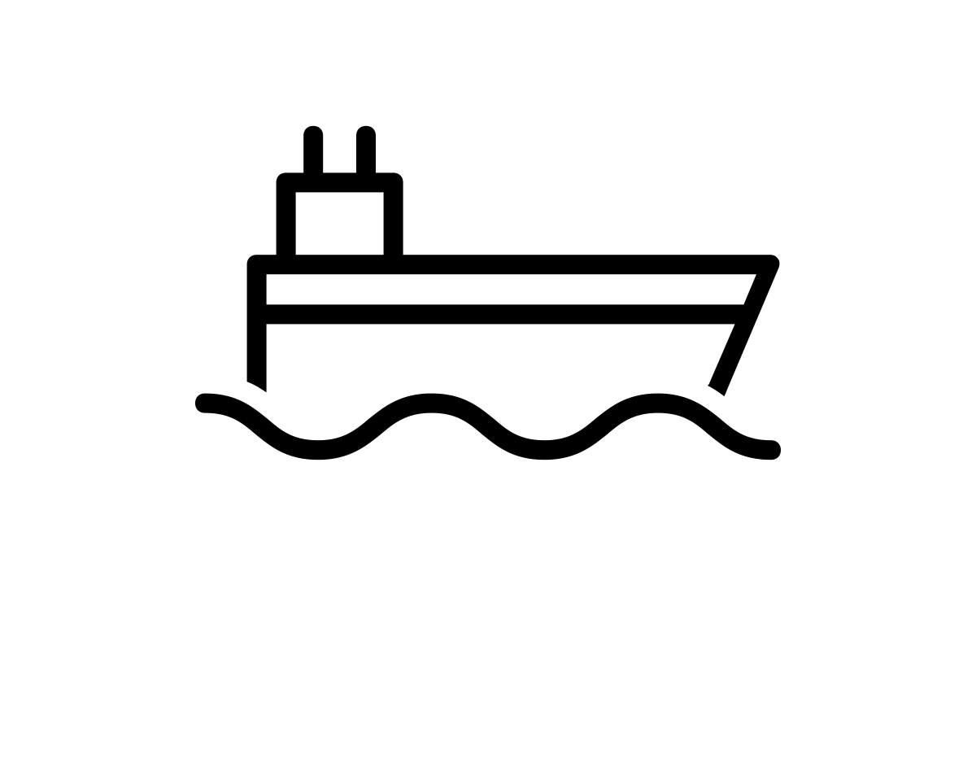 | Automobile
Description of Transportation | The transcontinental railroad was a series of railroad tracks. The tracks allowed California, Texas, and Washington state to be connected with the factories and large cities on the east coast. As the US grew in size and population, the Transcontinental Railroad provided quick transportation from the east to the west coast, a journey that used to take many months now took one week. | Before the transcontinental railroad was fully built out across the United States, the quickest mode of transport was through steamships travelling the rivers of the United States. Canals helped connect lakes and rivers to larger bodies of water and allowed for more transport of goods across longer distances at a faster rate. The Erie Canal was one of the earliest major canal projects. | Henry Ford and the Ford Motor Company are largely credited with inventing the automobile in 1908. In order to meet overwhelming demand for the revolutionary vehicle, Ford introduced revolutionary new mass-production methods, including large production plants, the use of standardized, interchangeable parts and, in 1913, the world’s first moving assembly line for cars.
Impact on Industrial Revolution | This allowed for expansion of farmland available due to the railroad being able to get goods to market in a  reasonable time. It also lead to the creation of time zones so travel time would be uniform (adopted by  Congress in 1918). It influenced business and industry because of the need for natural resources including iron, coal, steel, lumber, and glass. | The canal system ensured that Americans far and wide could receive supplies, ship good and natural resources and trade. The canal, river, and lake systems were the first major highways of the United States allowing the industrial revolution to get off the ground before the full expansion of the railroads. | The automobile and Henry Ford introduced the revolutionary mass-production method of assembly lines - which allowed for faster production of more goods. Additionally, the car meant faster and more efficient transportation, and the automobile spun off many other industries including oil and gas, etc.

