|  |  |  |
| --- | --- | --- |
| **Progressives Primary Goals:**  **\*** To correct the political and economic injustices that had resulted from America’s industrialization  * Appalled at the increasing inequalities between the wealthy and the poor  * Did not oppose industrialization but wanted to use the power of government to correct its evils so that all Americans, not just the wealthy, could enjoy better lives  * Felt they also had to reform government itself – which had been corrupted by big business and political “bosses” | **The Need for Reform:**  * The rise of industry had brought many new social problems: brutal working conditions, child labor, political corruption, urban overcrowding, misuse of the environment, extreme inequalities of wealth, and the abuse of consumers  * Support came mainly from the middle class who felt threatened by the rise of big business, labor unions, and political machines  * Often acted out of a sense of moral responsibility derived from religion [Social gospel Movement; especially concerned with the needs of thepoor] | **Muckrakers:**  * Investigative reporters, writers and social scientists who exposed the abuses of industrial society and corruption in government  * Became known as muckrakers because they “raked” up the muck or dirt of American life  * The examined the rise of industry and the abuses that had often led to the accumulation of large fortunes  * Jacob Riis, Ida Tarbell, Lincoln Steffens, Frank Norris, and Upton Sinclair  **~ The Key to Understanding U.S. History and Government** |

1. **Why did Progressives believe that it was necessary to reform government? TTQA**
   1. Progressives had to reform government itself – which had been corrupted by big business and political “bosses”.
2. **Why did members of the middle class support the Progressives? TTQA**
   1. Support came mainly from the middle class who felt threatened by the rise of big business, labor unions, and political machines

1. **How did religion influence the Progressives? TTQA**
   1. acted out of a sense of moral responsibility derived from religion [Social gospel Movement; especially concerned with the needs of thepoor]

*“The term ‘Muckrakers’ was first used by President Theodore Roosevelt in referring to a character in John Bunyan’s Pilgrim’s Progress who rejected a crown for a muckrake (a rake used to gather dung into a pile). The term was applied to writers who investigated and attacked social, political, and economic wrongs. Books and magazine articles in McClure’s, Collier’s, and Hampton’s exposed the worst abuses of the period and stirred public outcry against them.” ~ U.S. History and Government*

1. **Using your previous knowledge from Global history, why would the Progressives & Muckrackers remind you of the European Enlightenment Philosophers? HINT LMRSVP (Historical Significance) Answer with a 1 -2 sentence response**

**The Progressive Movement**

“The early progressives rejected Social Darwinism. In other words, they were people who believed that the problems society faced (poverty, violence, greed, racism, class warfare) could best be addressed by providing good education, a safe environment, and an efficient workplace. Progressives lived mainly in the cities, were college educated, and believed that government could be a tool for change.

Social reformers, like Jane Addams, and journalists, like Jacob Riis and Ida Tarbel, were powerful voices for progressivism. They concentrated on exposing the evils of corporate greed, combating fear of immigrants, and urging Americans to think hard about what democracy meant. Other local leaders encouraged Americans to register to vote, fight political corruption, and let the voting public decide how issues should best be addressed (the initiative, the referendum, and the recall).

On a national level, progressivism gained a strong voice in the White House when Theodore Roosevelt became president in 1901. TR believed that strong corporations were good for America, but he also believed that corporate behavior must be watched to ensure that corporate greed did not get out of hand (trust-busting and federal regulation of business). Progressivism ended with World War I when the horrors of war exposed people’s cruelty and many Americans associated President Woodrow Wilson's use of progressive language (‘the war to make the world safe for democracy’) with the war.”

1. **What did early progressives reject? Highlight the evidence in the text that supports the answer and number it.** 
   1. **Social Darwinism was rejected because they believed that the problems faced could be addressed through education and a productive work environment. They also thought change could be completed by using the government.**
2. **What did Theodore Roosevelt believe about strong corporations? Highlight the evidence in the text that supports the answer and number it.** 
   1. **Roosevelt believed that while strong corporations were good, but that they needed to be kept in line with federal regulation.**

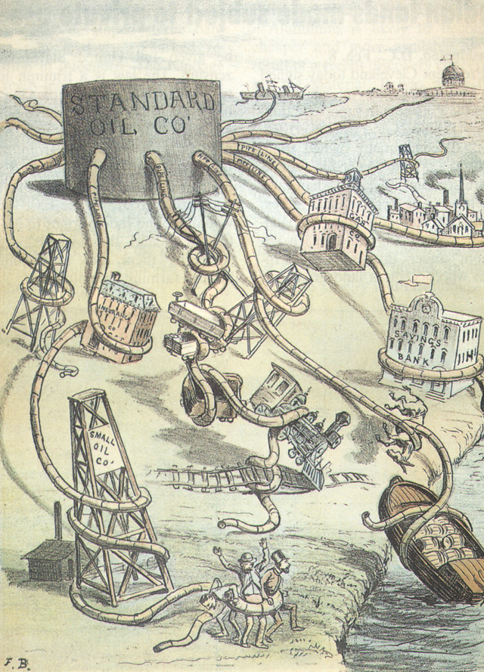

1. **How did World War I affect the Progressive Movement? TTQA**
   1. **It ended progressivism**
2. **What Progressive goal matched up with Authors message in this political cartoon ?** 
   1. Did not oppose industrialization but wanted to use the power of government to correct its evils so that all Americans, not just the wealthy, could enjoy better lives

|  |  |
| --- | --- |
| **Municipal Reform**  * Cities had grown so fast in the late 19th century that city services were inadequate  * City governments were often controlled by “political machines” run by political bosses  * Political machines provided immigrants and the working poor with jobs, housing, loans, and help in obtaining citizenship  * In exchange, these residents voted for candidates recommended by the boss  * The machine used its control of city government to steal from the public treasury through bribes  * Progressives replaced the rule of “bosses” with public-minded mayors  * Progressives expanded city services to deal with overcrowding, fire hazards, and the lack of public services  ~ The Key to Understanding U.S. History and Government | **State and Political Reform**  * At the state level, Progressive governors like Robert LaFollette in Wisconsin and Theodore Roosevelt in New York took steps to free their state governments from corruption and made them more democratic  * Many of the measures Progressives introduced to state governments were later adopted at the federal level  * Progressive Measures:   * Secret ballot * Initiatives; voters could directly introduce bills in the state legislature and could vote on whether they wanted a bill passed * Referendum; voters could compel legislators to place a bill on the ballot for approval * Direct Party Primaries * Direct Election of Senators (17th Amendment) * Laws to deal with the worst effects of industrialization * Laws to conserve natural resources and to create wildlife preserves |

**\* In 1883, Congress passed the Pendleton Act, creating a Civil Service Commission which gave competitive exams and selected appointees to permanent posts on the merit system.**

1. **How were municipal and political reforms similar and different? Give one example of each. 2 sentences**

“Progressivism emerged in full force during the presidency of Theodore Roosevelt between 1901 and 1909. In addition to calling for greater government intervention to protect the welfare of the American people from big business and the social evils of rapid industrialization, the Progressive Movement was marked by a change in the perception of executive leadership. Now reformers looked to the President to be both politically powerful and to demonstrate legislative leadership, while resisting the pressures from powerful business interests.

President William McKinley was assassinated in 1901 shortly after his inauguration for his second term. McKinley’s successor, Vice-President Theodore Roosevelt, finished out the term and was reelected in 1904. Roosevelt’s program of domestic reform was called the ‘Square Deal,’ a term developed from his promise to bring a ‘square deal’ and ‘opportunity’ to every citizen.”

~ U.S. History and Government

1. **What did reformers expect the President of the United States to be?** 
   1. Now reformers looked to the President to be both politically powerful and to demonstrate legislative leadership, while resisting the pressures from powerful business interests.
2. **Explain the promise of Theodore Roosevelt to the American people**

“Muckraker refers to any of a group of American writers, identified with pre-World War I reform and exposé [literature](http://www.britannica.com/EBchecked/topic/343579/literature). The muckrakers provided detailed, accurate [journalistic accounts](http://www.britannica.com/EBchecked/topic/306742/journalism" \o "journalistic accounts) of the political and economic corruption and social hardships caused by the power of big business in a rapidly industrializing United States. The name muckraker was pejorative [expressing disapproval] when used by President [Theodore Roosevelt](http://www.britannica.com/EBchecked/topic/509347/Theodore-Roosevelt" \o "Theodore Roosevelt) in his speech of April 14, 1906; he borrowed a passage from John Bunyan’s Pilgrim’s Progress, which referred to ‘the Man with the Muckrake . . . who could look no way but downward.’ But ‘muckraker’ also came to take on favorable connotations of social concern and courageous exposition.

The muckrakers’ work grew out of the [yellow journalism](http://www.britannica.com/EBchecked/topic/652632/yellow-journalism" \o "yellow journalism) of the 1890s, which whetted the public appetite for news arrestingly presented, and out of popular magazines, especially those established by S.S. McClure, Frank A. Munsey, and Peter F. Collier. The emergence of muckraking was heralded in the January 1903 issue of [McClure’s Magazine](http://www.britannica.com/EBchecked/topic/353984/McClures-Magazine" \o "McClure’s Magazine) by articles on municipal government, labor, and trusts, written by [Lincoln Steffens](http://www.britannica.com/EBchecked/topic/564894/Lincoln-Steffens), [Ray Stannard Baker](http://www.britannica.com/EBchecked/topic/49505/Ray-Stannard-Baker), and Ida M. Tarbell.”

|  |  |  |  |  |
| --- | --- | --- | --- | --- |
| **Upton Sinclair:**  **- Novelist**  **- Best-known novel, “The Jungle”**  **- Expose the appalling and unsanitary conditions of the meat inspection**  **- If a worker’s finger was cut off by the meat grinding machine, the human finger was ground into the meat and sold**  **- Influential in obtaining passage of the Pure Food and Drug Act** | **Ida Tarbell:**  **- America’s first great woman journalist**  **- Her most famous work, *The History of the Standard Oil Company***  **- She revealed the illegal means used by John D. Rockefeller to monopolize the early oil industry**  **- Yet did praise Rockefeller for his enormous accomplishments in organizing and stabilizing a volatile industry** | **Lincoln Steffens:**  **- a journalist, lecturer, and political philosopher, a leading figure among the writers whom Theodore Roosevelt called** **muckrakers**  **- Published stories of corruption in major American cities**  **- These sensational account stirred popular concern** | **Frank Norris:**  **- Wrote (1901), *The Octopus*, described the struggle between farming and railroad interests in California**  **- In August 1902, *Everybody's Magazine* published an article by Norris, A Deal in Wheat, exposing corrupt business dealings in agriculture** | **Jacob Riis:**  **- a police reporter whose work appeared in several New York newspapers, documented the living and working conditions of the poor**  **- Wrote *How the Other Half Lives***  **- Jacob Riis wrote and lectured on the problems of the poor**  **- He had exposed landlords and officials in articles, books, and public speeches, and with results** |

1. **How were muckrakers viewed by the public?**

|  |
| --- |
| Theodore Roosevelt and the Square Deal, 1901 – 1909 The Key to Understanding U.S. History and Government   1. In the late 19th century, the Presidency had been relatively weak, leaving the direction of the country’s affairs mainly to Congress 2. Theodore Roosevelt reversed this trend when he became President. 3. In Roosevelt’s view, the President acted as the “steward,” or manager, of the people’s interests. 4. Roosevelt revived the use of the Sherman Antitrust Act against big business consolidations, known as trusts, but he distinguished between “good trusts” and “bad trusts” which acted against the public interest. 5. He launched the break-up of Rockefeller’s Standard Oil Company. 6. Square Deal Legislation: 7. Congress passed the Meat Inspection Act (1906), providing for government inspection of meat 8. The Pure Food and Drug Act (1906), regulated the preparation of foods and the sale of medicines 9. Increased the power of the Interstate Commerce Commission to regulate railroads, and gave it authority over the telegraph and telephone 10. Drew attention to the need to conserve forests, wildlife, and natural resources; adding millions of acres to the national forests and parks   ~ |

1. **How did Theodore Roosevelt conserve the nation’s land and resources?**

**“We demand that big business give people a square deal; in return we must insist that when anyone engaged in big business honestly endeavors to do right, he shall himself be given a square deal.” *~ Theodore Roosevelt***

**_________________________________________________________________________**

1. **Explain the meaning of this cartoon and incorporate the terms Square Deal and Trust Busting.**
2. **How was Roosevelt Different than presidents before him. 2 Bullets**

**“We demand that big business give people a square deal; in return we must insist that when anyone engaged in big business honestly endeavors to do right, he shall himself be given a square deal.”**

***~ Theodore Roosevelt***

1. **Explain the quote. ____________________________________________________________________________**
2. **What is the meaning of the political cartoon? ____________________________________________________________________________**

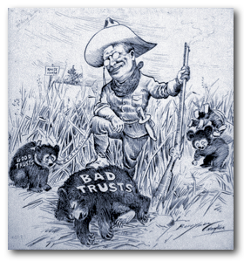

“With the assassination of President McKinley, Theodore Roosevelt, not quite 43, became the youngest President in the Nation’s history. He brought new excitement and power to the Presidency, as he vigorously led Congress and the American public toward progressive reforms and a strong foreign policy.

**16. Why was Theodore Roosevelt chosen to run for governor of New York? TTQA**

**17- What issues did Theodore Roosevelt address as President of the United States? TTQA**

**18. What did Theodore Roosevelt mean when he said, “Speak softly and carry a big stick.”?**

He took the view that the President as a ‘steward of the people’ should take whatever action necessary for the public good unless expressly forbidden by law or the Constitution. ‘I did not usurp power,’ he wrote, ‘but I did greatly broaden the use of executive power.’

Roosevelt’s youth differed sharply from that of the log cabin Presidents. He was born in New York City in 1858 into a wealthy family, but he too struggled – against ill health – and in his triumph became an advocate of the strenuous life.

In 1884 his first wife, Alice Lee Roosevelt, and his mother died on the same day. Roosevelt spent much of the next two years on his ranch in the Badlands of Dakota Territory. There he mastered his sorrow as he lived in the saddle, driving cattle, hunting big game – he even captured an outlaw. On a visit to London, he married Edith Carow in December 1886.

During the Spanish-American War, Roosevelt was lieutenant colonel of the Rough Rider Regiment, which he led on a charge at the battle of San Juan. He was one of the most conspicuous heroes of the war.

Boss Tom Platt, needing a hero to draw attention away from scandals in New York State, accepted Roosevelt as the Republican candidate for Governor in 1898. Roosevelt won and served with distinction.

As President, Roosevelt held the ideal that the Government should be the great arbiter of the conflicting economic forces in the Nation, especially between capital and labor, guaranteeing justice to each and dispensing favors to none.

Roosevelt emerged spectacularly as a ‘trust buster’ by forcing the dissolution of a great railroad combination in the Northwest. Other antitrust suits under the Sherman Act followed.

Roosevelt steered the United States more actively into world politics. He liked to quote a favorite proverb, ‘Speak softly and carry a big stick…’

Aware of the strategic need for a shortcut between the Atlantic and Pacific, Roosevelt ensured the construction of the Panama Canal. His corollary to the Monroe Doctrine prevented the establishment of foreign bases in the Caribbean and arrogated [take or claim for oneself without justification] the sole right of intervention in Latin America to the United States.

He won the Nobel Peace Prize for mediating the Russo-Japanese War, reached a Gentleman’s Agreement on immigration with Japan, and sent the Great White Fleet on a goodwill tour of the world.

Some of Theodore Roosevelt’s most effective achievements were in conservation. He added enormously to the national forests in the West, reserved lands for public use, and fostered great irrigation projects.”

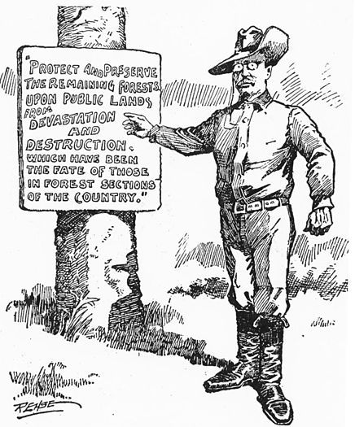

He crusaded endlessly on matters big and small, exciting audiences with his high-pitched voice, jutting jaw, and pounding fist. ‘The life of strenuous endeavor’ was a must for those around him, as he romped with his five younger children and led ambassadors on hikes through Rock Creek Park in Washington, D.C.

Leaving the Presidency in 1909, Roosevelt went on an African safari, then jumped back into politics. In 1912 he ran for President on a Progressive ticket. To reporters he once remarked that he felt as fit as a bull moose, the name of his new party.

While campaigning in Milwaukee, he was shot in the chest by a fanatic. Roosevelt soon recovered, but his words at that time would have been applicable at the time of his death in 1919: ‘No man has had a happier life than I have led; a happier life in every way.’

*~ WhiteHouse.gov; from “The Presidents of the United States of America,” by Frank Freidel and Hugh Sidey.*

**“We demand that big business give people a square deal; in return we must insist that when anyone engaged in big business honestly endeavors to do right, he shall himself be given a square deal.”**

***~ Theodore Roosevelt***

1. **Explain the quote. ____________________________________________________________________________**
2. **What is the meaning of the political cartoon? ____________________________________________________________________________**

***Image: 1908 editorial cartoon of President Theodore Roosevelt as “A Practical Forester.”  Source: St. Paul Minnesota “Pioneer Press”.***

**19. What is the meaning of the image?**

**20. Do you believe that Americans have successfully preserved and conserved the forest lands and natural resources? Explain your answer 2 Sentences.**

* + 1. A main purpose of President Theodore Roosevelt’s trustbusting policies was to
       1. reduce corruption in government
       2. save the nation’s banks
       3. encourage competition in business
       4. end strikes by labor unions
    2. During which period in United States history were the amendments concerning the income tax, direct election of Senators. Prohibition, and women’s suffrage enacted?
       1. Reconstruction
       2. The Gilded Age
       3. Progressive Era
       4. New Deal
    3. Which law was passed as a result of muckraking literature?
       1. Interstate Commerce Act
       2. Sherman Antitrust Act
       3. Meat Inspection Act
       4. Federal Reserve Act
    4. Which action was necessary to change from the indirect to the direct election of United States Senators?
       1. ratification of a constitutional amendment
       2. passage of a Federal law
       3. Supreme Court decision
       4. national referendum
    5. An important political aim of the Progressive movement was to
       1. guarantee government jobs for the unemployed
       2. stimulate democratic reforms such as the initiative and the referendum
       3. create a unicameral national legislature
       4. increase the participation of African Americans in the Federal Government
    6. Congress has attempted to deal with the issue of taxing citizens fairly by enacting a
       1. high tariff
       2. property tax
       3. sales tax
       4. graduated income tax
    7. Theodore Roosevelt, Woodrow Wilson, and Robert M. LaFollette are all considered progressives because they
       1. supported the formation of the first trade union
       2. used Presidential power to break up strikes
       3. worked to limit the power of big business
       4. formed the first civil rights organizations
    8. A major goal of reformers during the Progressive Era was to
       1. end segregation in the South
       2. correct the abuses of big business
       3. limit immigration from Latin America
       4. enact high tariffs to help domestic industry grow
    9. Jacob Riis, in How the Other Half Lives, and Lincoln Steffens, in The Shame of the Cities, contributed to reform movements in the United States by
       1. exposing poverty and corruption
       2. opposing westward expansion
       3. criticizing racial injustice
       4. supporting organized labor
    10. Lincoln Steffens and Jane Addams are best known for
        1. attempting to ease the problems of the urban poor
        2. fighting for temperance and Prohibition
        3. leading political movements on behalf of the Populist Party
        4. promoting the interests of organized labor