**Interviewee: MORRIS ABRAHAM SCHNEIDER Date of Birth: May 3, 1910 Date of Interview: November 17, 1991 Interviewer: Paul E. Sigrist, Jr. Immigrated from Poland in 1920 at age 10 Ellis Island Collection: EI-116**

1. **Define steerage & Describe conditions in steerage. Answer with 3 bullets**

When we got on the Rotterdam, we had a field day. One, I was never on ship before and it was absolutely, I was awed by it. It was overwhelming. All the people and boarding the ship, it was all a brand-new experience. We left Rotterdam, we set sail and about a half hour after the ship started my sister got very sea sick. It took us fourteen days to cross the Atlantic and in the entire crossing, she was in steerage, and the only time she came up for a breath of fresh air was just about a half hour before we saw the Statue of Liberty. Now the experience of the ship, being young was an adventure in that situation, because we were on the lowest level of the ship. We couldn’t go aboard. Some kids were more adventurous. My brother and I, we would sneak aboard, we were always chased. And we saw some people who traveled maybe in first or second class and we looked upon them as royalty, but we were confined primarily to steerage [a section of inferior accommodations in a passenger ship].

Steerage was one huge place. It was the lowest deck. The stench [the smell], it was the summer, in August, the humidity, the heat, having no air conditioning, having cooling facilities, it was very hot, compounded by the fact that there must have been anywhere from two to three hundred people in that huge cavernous area. The body smells, the body odors, the lack of sanitation, the lack of any kind of facilities, washing, there was no such thing as washing or bathing. The stench, the vermin, it was rat infested. But, being children, I guess, had its advantages, in this case because we always tried to get out of there. We tried to go, get out of the steerage, get out of the babble of voices, get out of the heat and the stench and get on the main deck. We all were permitted to stay there for a little while, but we were constantly chased. But the crossing went for us, for me, went very quickly.

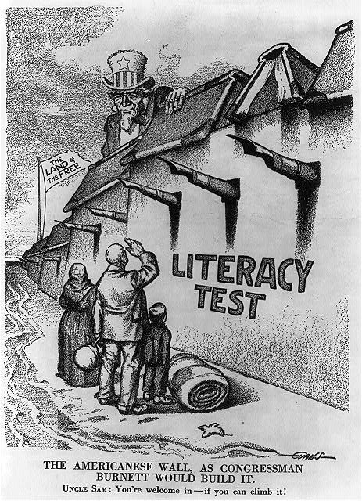

**Text book page 464 – 465**

1. **Why did new wave immigrants encounter more resistance than had earlier immigrants? 2 Reasons**
   * **The newer immigrants came from different countries often did not speak English and practiced religions different from the majority of those already established in the United States.**

Textbook page 467 -468

1. **How did Americanization programs help create America’s Melting Pot?** 
   * Although immigrants retained some of their native culture, Americanization programs taught them English and helped them to adopt American ways that allowed them to blend into American society

|  |  |  |
| --- | --- | --- |
| **Factors for Immigration:**  **Push Factors:**  * Conditions in immigrants’ native lands often “pushed” them to leave  * Immigrants escaped conditions of poverty or religious and political persecution  **Pull Factors:**  * Conditions in the U.S. also attracted or “pulled” many immigrants to come  * Greater political freedom, higher standards of living, availability of jobs in America  **~ The Key to Understanding U.S. History and Government** | **Shifting Patterns of Immigration:**  ***\**** *Between 1608 – 1880, most immigrants came from Northern Europe, especially Great Britain, Ireland, and Germany*   1. These immigrants were mostly Protestant, excluding the large numbers of Irish Catholics 2. These immigrants spoke English   *\* The “New Immigrants” came between 1880 and 1920*   1. They came from Southern and Eastern Europe, especially Poland, Italy, Austria-Hungary, Greece, and Russia 2. They were Catholic and Jewish 3. They were poor, spoke no English, and dressed differently from Northern Europeans 4. Asian immigrants also arrived 5. Their immigration was quickly limited by new laws | **Becoming Americanized:**  *\* The New Immigrants faced great hardships in making the passage to America*   1. They traveled in steamships in cheap compartments, often with their life’s belongings in a single bag 2. On arrival, they were processed at the vast government center at Ellis Island in New York harbor 3. If they had tuberculosis or other diseases, they were sent back 4. Becoming “Americanized” – learning to act, speak and behave like other Americans – was a gradual process   **Challenges:**   1. Faced discrimination 2. Lived in ethnic ghettos made it harder to become acculturated (learning the language and culture of their adopted land) 3. But immigrant children were assimilated [largely through schools] – they were made similar to other Americans |

1. **What is the difference between “Push” and “Pull” immigration? TTQA**
2. **Where were the New Immigrants processed when they arrived in the United States? Give both locations TTQA**
3. **Why were many adult immigrants not acculturated? TTQA**
4. 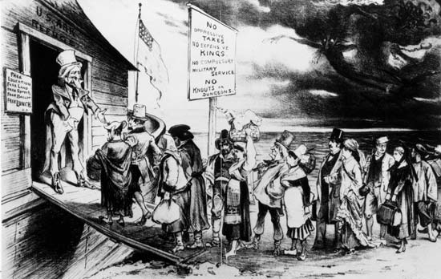**How were many immigrant children assimilated? TTQA**
5. **According to the advertisement, why should Immigrants learn English?**

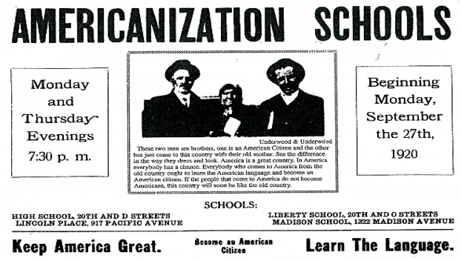

**A Puck magazine cartoon of 1880 expressed the American's image of his country's immigration policies. A decade later Puck expressed the view of citizens who urged severe restrictions on immigration.**

1. **Explain the meaning of the political cartoon.**

|  |  |  |
| --- | --- | --- |
| **Cultural Pluralism Versus the Melting Pot:**  a) The “melting pot” is the concept that suggests that all immigrants absorb the aspects of a uniform American culture, and as a result, become “Americanized.”  b) Yet although different ethnic groups become Americanized, they also maintain a degree of their cultural heritage. This idea of “cultural pluralism,” rather than a pure melting pot, was first expressed in 1915 by Horace Kallen**.**  **~ U.S. History and Government** | **Nativism:**  **a**) Native-born Americans have demonstrated “nativism” toward immigrants of minority groups who have deviated from the dominant culture.  b) Nativists groups discriminated against individuals because of race, religion, political beliefs, and economic fears.  c) The Ku Klux Klan originated as primarily an anti-black organization during the Civil War era and resurfaced as an anti-Semitic, anti-Catholic, and anti-immigrant group in the 20th century | **Immigration Restrictions:**  **a**) On a number of occasions, Congress has responded to nativist sentiments with the passage of restrictive legislation.  1- The Chinese Exclusion Act (1882) – restricted Chinese immigration for a 10-year period  2- Gentleman’s Agreement (1907) – Japan persuaded to deny passports to those who wanted to emigrate  3- Literacy Test (1917) – Immigrant required to pass literacy test in either English or another language  4- Immigration Act of 1921 – Quota system set at 3% of total of that nationality in U.S. in 1910; general limit of 350,000 immigrants per year |

1. **Why does the concept of “cultural pluralism” accurately reflect the descendants of many immigrants? TTQA**
2. **How did representatives in Congress sometimes respond to nativist concerns? TTQA**

“In the mid-1840’s, following defeat by Britain in the first Opium War, a series of natural catastrophes occurred across China resulting in famine, peasant uprisings and rebellions. Understandably, when the news of gold and opportunity in faraway Gum San, (Golden Mountain – the Chinese name for America) reached China, many Chinese seized the opportunity to seek their fortune.

The Chinese were met with ambiguous feelings by Californians. In 1850, San Francisco Mayor John W. Geary invited the ‘China Boys’ to a ceremony to acknowledge their work ethic. However, as the American economy weakened, the Chinese labor force became a threat to mainstream society. Racial discrimination and repressive legislation drove the Chinese from the gold mines to the sanctuary of the neighborhood that became known as Chinatown. The only ethnic group in the history of the United States to have been specifically denied entrance into the country, the Chinese were prohibited by law to testify in court, to own property, to vote, to have families join them, to marry non-Chinese, and to work in institutional agencies.” ~ pbs.org

1. **Identify the ways in which Chinese immigrants faced discrimination in the United States. 4 Bullets**
2. **Why did nativism increase in the United States during this period? Highlight and number the Text that supports the answer to this question.**

“Nativism, in general, refers to a policy or belief that protects or favors the interest of the native population of a country over the interests of immigrants. In the United States, greatest nativist sentiment coincided with the great waves of 19th-century European immigration on the East Coast and, to a lesser extent, with the arrival of Chinese immigrants on the West Coast.

Nineteenth-century nativism in the United States contained a strong anti-Catholic strain, since many of the newly arrived immigrants hailed from predominantly Roman Catholic countries. Although both religion and ethnicity helped identify targets of nativist bias, its motivations were often economic. The large waves of immigrants, many of whom were skilled tradesman, provided a large pool of inexpensive labor that threatened the well-being of native artisans and other workers.

The most prominent American nativist organization of the 19th century was the Know-Nothing party, which flourished originally in the 1840s and experienced a revival in the 1880s. The Ku Klux Klan was also notable for its nativist sentiment.”

**Source: Higham, John, *Strangers in the Land: Patterns of American Nativism*, 1860–1925 (1988); Michaels, Walter B., *Our America: Nativism, Modernism and Pluralism* (1997); Perea, Juan F., ed., *Immigrants Out! The New Nativism and the Anti-Immigrant Impulse in the United States* (1996).**

*Nativism during this period increased as waves of immigrants including skilled tradesman were a source of inexpensive labor that were willing to work for less and where there for a threat to native artisans and other workers.*

**The Know Nothing Party:**  “Members, when asked about their nativist organizations, were supposed to reply that they knew nothing, hence the name. As its membership and importance grew in the 1850s, the group slowly shed its clandestine character and took the official name American Party. As a national political entity, it called for restrictions on immigration, the exclusion of the foreign-born from voting or holding public office in the United States, and for a 21-year residency requirement for citizenship.” ~ Britannica

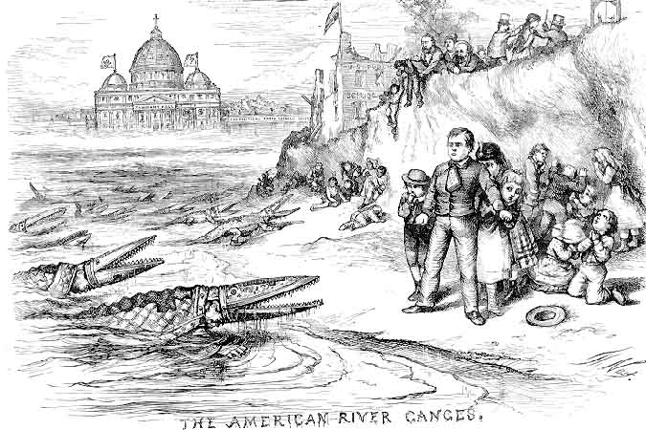

1. **What organizations were American nativist organizations? Highlight and number the Text that supports the answer to this question.**

*The KKK and the No Nothing Party were two organizations that favored Nativism.*

1. **An Anti-Catholic cartoon by Thomas Nast (1871)**

**Identify the images that reflect the Anti-Catholic bias of the cartoonist: 2 -3 Bullets**

1. **What does Lincoln’s letter reveal about the Know-Nothing Party and about his views regarding the party? TTQA**

The Know Nothing or American Party formed in 1853 and soon became the second largest political party in the United States behind the Democratic Party. By 1857, the party was dead. It was a victim of the growing controversy over slavery.

A nativist group, the Know Nothings emerged in response to the influx of millions of Catholics from Ireland and Germany in the 1840s and 1850s. Nativism and anti-Catholicism had long been traditions in American politics, but the waves of immigrants reignited these sentiments. Prejudice against Catholics among middle-class and working-class Protestants was legitimized by the Protestant intelligentsia. Anti-Catholicism then became associated with the reform program of Protestant social activists campaigning for the abolition of slavery and the prohibition of liquor. Fear and hatred of Catholics created a need for secrecy among the nativists. When asked about their organization, they were instructed to say, “I know nothing.”

Using the name American Party, the Know Nothings swept to political victory in Massachusetts, Delaware, Pennsylvania, Connecticut, Rhode Island, New Hampshire, Maryland, and Kentucky. American party tickets also ran strong races in Virginia, Tennessee, Georgia, Alabama, Mississippi, Louisiana, and Texas. By 1855, nativism seemed on the verge of carrying the entire country.

In that year, Joshua F. Speed (1814–1882) of Kentucky, a longtime close friend of Abraham Lincoln, asked the future president about his views on the Know Nothings. Speed, the brother of Lincoln’s future attorney general James Speed, was a farmer and one-time state legislator who publicly supported slavery but who came from a family long opposed to it. During the Civil War, he would remain loyal to the Union and helped coordinate Union activities in Kentucky. ~ **Date: August 24, 1855 Lincoln, Abraham. “On the Know-Nothing Party.” galegroup.com**

**Social Darwinists versus Reformers**

**First Passage:** “The publication of *The Origin of Species* in 1850 by the Englishman Charles Darwin marked a major step in the theory of evolution. It proposed that many more individuals of each species are born than can possibly survive. As a consequence, there is a constant struggle for existence, and only the fittest survive. Social Darwinism affected American political thought by delaying legislation that required factory inspection, the limitation of work hours, and other protective measures.” ~ U.S. History and Government

**Second Passage:** “The social Darwinists believed that the process of [natural selection](http://www.britannica.com/EBchecked/topic/406351/natural-selection) would result in the survival of the best competitors and in continuing improvement in the population. Societies, like individuals, were viewed as organisms that evolve in this manner.

The theory was used to support [laissez-faire](http://www.britannica.com/EBchecked/topic/328028/laissez-faire) [capitalism](http://www.britannica.com/EBchecked/topic/93927/capitalism) and political [conservatism](http://www.britannica.com/EBchecked/topic/133435/conservatism" \o "conservatism). Class stratification was justified on the basis of ‘natural’ inequalities among individuals, for the control of property was said to be a correlate of superior and inherent moral attributes such as industriousness, temperance, and frugality. Attempts to reform society through state intervention or other means would, therefore, interfere with natural processes; unrestricted competition and defense of the status quo were in accord with biological selection. The poor were the ‘unfit’ and should not be aided; in the struggle for existence, wealth was a sign of success. At the societal level, social Darwinism was used as a philosophical rationalization for imperialist, colonialist, and racist policies, sustaining belief in Anglo-Saxon or Aryan cultural and biological superiority.” ~ Britannica

1. **According to Social Darwinists, what did class stratification [class hierarchy] justify? TTQA**

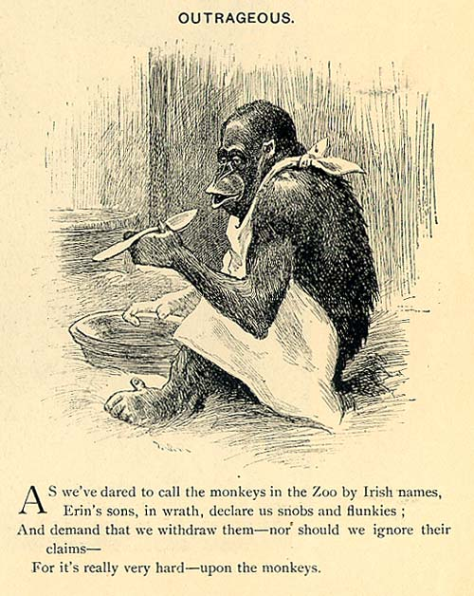

1. **According to Social Darwinists, what did state intervention interfere with? TTQA**

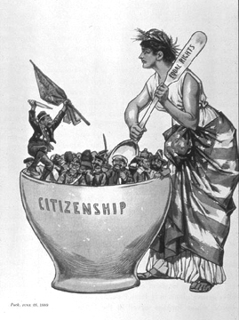**This cartoon printed in 1889, stereotypes the Irish as unmixable in America's melting pot.**

**19. What attitudes does the above image reveal about the perception of Irish immigrants in the Americas by older immigrants?**

**20. How does the image to the right reveal the attitudes of Social Darwinists?**

**21. How does this late 19th century political cartoon reveal the attitudes of nativists towards the Chinese?**

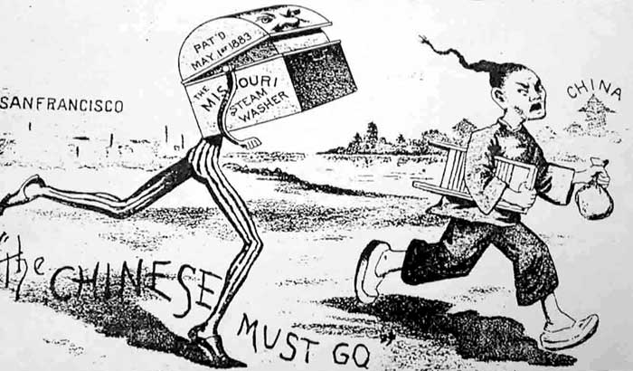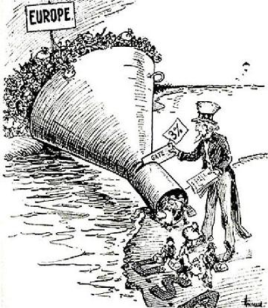

**Why did attitudes regarding immigration change?**

There was a fear over competition from immigrants for housing, and they also feared losing jobs to immigrants who would work for lower pay.

**Explain the meaning of the political cartoon with relation to immigrants in the 19th century:**

1. **Which expression most accurately illustrates the concept of nativism?**
2. “Help Wanted – Irish Need Not Apply”
3. “Go West, young man.”
4. “America – first in war and peace”
5. “The only thing we have to fear, is fear itself.”

*Speaker A:* “Our nation has grown and prospered from the ideas and labor of immigrants. The nation has been enriched by immigrants from different nations who brought new ideas and lifestyles, which have become part of American culture.”

*Speaker B:* “United States industries are competing with established European manufacturers. To prosper, American industries need the vast supply of unskilled labor that is provided by immigrants.”

*Speaker C:* “Immigrants are taking jobs at low wages without regard for long hours and workers’ safety. American workers must unite to end this unfair competition.”

*Speaker D:* “Immigrants arrive in American cities poor and frightened. They are helped to find jobs or housing. These newcomers should show their gratitude at voting time.”

1. **Which speaker is most clearly expressing the melting pot theory?**
2. A c) B
3. C d) D
4. **Speaker *D* is expressing an opinion most like that of a**
5. labor union member
6. religious leader
7. factory owner
8. political party boss
9. **The Gentlemen’s Agreement, literacy tests, and the quota system were all attempts by Congress to restrict**
10. immigration
11. property ownership
12. voting rights
13. access to public education

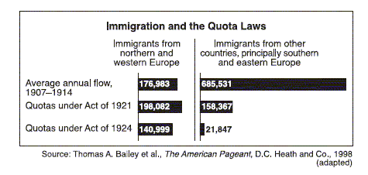

1. **The data in the chart support the idea that the immigration laws of 1921 and 1924 were primarily designed to**
2. stop illegal entry into the country
3. admit skilled workers
4. encourage immigration from southern Europe
5. reduce immigration from specific regions
6. **Between 1880 and 1920, the majority of the “new” immigrants to the United States came from**
7. northern and western Europe
8. southern and eastern Europe
9. Canada and Latin America
10. China and Southeast Asia
11. **1890 - 1915, the majority of immigrants to the United States were labeled “new immigrants” because they were**
12. considered physically and mentally superior to earlier immigrants
13. forced to settle in the cities of the Midwest
14. from China, Japan, and other Asian countries
15. culturally different from most earlier immigrants
16. **Which statement about immigration to the United States during the 19th century is most valid?**
    1. Organized labor supported unlimited immigration.
    2. Most immigrants to the United States were illegal aliens.
    3. Industrial growth led to a demand for cheap immigrant labor.
    4. Few immigrants came from Western Europe.
17. **“America’s strength lies in its diversity. Many immigrant groups have joined the mainstream of American life, while maintaining their languages, religions, and traditions. This has made the United States a strong nation.”  
      
    The author of this statement could best be described as a supporter of**
    1. nativism c. ethnocentrism
    2. cultural pluralism d. limited social mobility
18. **In the late 19th century, the pattern of United States immigration changed in that**
    1. far fewer immigrants arrived in the United States than in previous years
    2. most immigrants chose to settle in the rural, farming regions of the western United States
    3. increasing numbers of immigrants came from eastern and southern Europe
    4. most immigrants were political refugees
19. **What was the experience of most of the “new immigrants” who arrived in the United States from southern and Eastern Europe in the late 1800s and early 1900s?**
    1. They lived in urban areas and most held lowpaying jobs.
    2. They obtained free land in the West and became farmers.
    3. They became discouraged with America and returned to their homelands.
    4. They were easily assimilated into mainstream American culture.
20. **Between 1890 and 1915, the majority of immigrants to the United States were labeled “new immigrants” because they were**
    1. considered physically and mentally superior to earlier immigrants
    2. forced to settle in the cities of the Midwest
    3. from China, Japan, and other Asian countries
    4. culturally different from most earlier immigrants
21. **Between 1880 and 1920, the majority of the “new” immigrants to the United States came from**
    1. northern and western Europe
    2. southern and eastern Europe
    3. Canada and Latin America
    4. China and Southeast Asia
22. **During the late 1800s and early 1900s, where did most of the immigrants to the United States settle?**
23. urban centers of the Northeast
24. plantations of the New South
25. mining areas of the Far West
26. farming regions of the Great Plains