1. **Why did Mark Twain call the late 19th century “the Gilded Age”? TTQA**

**The Gilded Age, Robber Barons, and Reform**

“Mark Twain called the late 19th century the ‘Gilded Age.’ By this, he meant that the period was glittering on the surface but corrupt underneath. In the popular view, the late 19th century was a period of greed…Robber Barons…scandal-plagued politics, and vulgar display.

It is easy to caricature the Gilded Age as an era of corruption, conspicuous consumption, and unfettered capitalism. But it is more useful to think of this as modern America’s formative period, when an agrarian society of small producers were transformed into an urban society dominated by industrial corporations.

The late 19th century saw the creation of a modern industrial economy. A national transportation and communication network was created, the corporation became the dominant form of business organization, and a managerial revolution transformed business operations.

… [But] the Gilded Age was also an era of reform. The Civil Service Act sought to curb government corruption by requiring applicants for certain governmental jobs to take a competitive examination. The Interstate Commerce Act sought to end discrimination by railroads against small shippers and the Sherman Antitrust Act outlawed business monopolies.

These were turbulent years that saw labor violence, rising racial tension, militancy among farmers, and discontent among the unemployed. Burdened by heavy debts and falling farm prices, many farmers joined the Populist Party, which called for an increase in the amount of money in circulation, government assistance to help farmers repay loans, tariff reductions, and a graduated income tax.” ~ uh.edu

glittering on the surface but corrupt underneath. In the popular view, the late 19th century was a period of greed…Robber Barons…scandal-plagued politics, and vulgar display

1. **What were 3 of the significant changes that occurred in the nation’s infrastructure and in business during the late 19th century? Bullets**



1. **Why was the Gilded Age also a turbulent time? Give 2 reasons. Bullets**

**Andrew Carnegie:**

1- Worked his way up from a penniless immigrant to become one of America’s richest and most powerful men

2- His steel mills undercut all competition

3- His workers put in 12-hour shifts at very low wages

4- He crushed any attempts by his workers to unionize

5- Andrew Carnegie was a philanthropist (engaged in charitable activities) He spent much of his later life giving away his fortune to support education, libraries, medical research, and world peace

**John D. Rockefeller:**

1- He formed Standard Oil Company in 1870

2- He forced railroad companies to give him special, secret rates for shipping oil, while charging competitors higher prices

3- By 1900, he controlled almost 90% of all oil refining in the nation

4- Like Carnegie, he gave millions to education and science

1. **Was Andrew Carnegie a Captain of Industry or Robber Barron? Provide at least one piece of evidence to support your answer. TTQA**
2. **Was John D. Rockefeller a Captain of Industry or Robber Barron? Provide at least one piece of evidence to support your answer. TTQA**
3. **According to Andrew Carnegie what must men of wealth do? High -lite the text where you find evidence to support the answers.**

This, then, is held to be the duty of the man of Wealth: First, to set an example of modest, unostentatious living, shunning display or extravagance; to provide moderately for the legitimate wants of those dependent upon him; and after doing so to consider all surplus revenues which come to him simply as trust funds, which he is called upon to administer, and strictly bound as a matter of duty to administer in the manner which, in his judgment, is best calculated to produce the most beneficial results for the community – the man of wealth thus becoming the mere agent and trustee for his poorer brethren, bringing to their service his superior wisdom, experience, and ability to administer, doing for them better than they would or could do for themselves. ~ Source: Andrew Carnegie, “Wealth,” *North American Review*, June 1889.

* 1. **According to Carnegie it is the responsibility of men of wealth to act as a trustee of finances and provide for the poor, also to set an example of how to live.**

|  |  |
| --- | --- |
| **Robber Barons:**   1. Because of the lavish lifestyle of those who became rich from industry, the period from 1865 to 1900 became known as the Gilded Age 2. Business entrepreneurs began to exercise a dominant influence on American life 3. Some observers thought of these entrepreneurs as captains of industry because they helped forge the modern industrial economy 4. Through efficiencies of large-scale production, these industrialists lowered the prices of many goods, making them more affordable 5. Others called them robber barons because of the ruthless tactics they used to destroy competition and to keep down workers’ wages | Reforms:  Government leaders strongly believed in free market capitalism but as some abuses of big business were so glaring, Congress began to regulate business.  Interstate Commerce Act (1887):  1- Prohibited unfair practices by railroads such as charging more for shorter routes  2- A special regulatory commission, the Interstate Commerce Commission, was established to enforce the act  Sherman Antitrust Act (1890):  1- Was passed to check the spread of monopolies  2- It made unfair monopoly practices illegal  3- The act marked a significant change in the attitude of Congress towards the abuses of big business  ~ Adapted from The Key to Understanding U.S. History and Government |

1. **Why were certain successful entrepreneurs referred to as “captains of industry”? TTQA**
   1. Business entrepreneurs began to exercise a dominant influence on American life
   2. Some observers thought of these entrepreneurs as captains of industry because they helped forge the modern industrial economy
2. **Why were some of these captains of industry referred to as “robber barons”? TTQA**
   1. Others called them robber barons because of the ruthless tactics they used to destroy competition and to keep down workers’ wages

**Text book page 447-448**

1. **How did the Federal Government regulate business? In your 2-sentence response use Interstate Commerce and Sherman Antitrust Act and mergers and monopolies.** 
   1. **The Federal Government regulated business by passing the Sherman Antitrust act to outlaw practices that restrained trade and outlawed mergers and monopolies. It regulated railroad operations through interstate commerce commission which would later require railroads to submit their records for investigation**
2. **How is the modern manufacturing system like a military organization and what have workers lost? High -lite the text where you find evidence to support the answers.**

[T]he modern manufacturing system has been brought into a condition analogous to that of a military organization, in which the individual no longer works as independently as formerly, but as a private in the ranks, obeying orders, keeping step, as it were, to the tap of the drum, and having nothing to say as to the plan of his work, of its final completion, or of its ultimate use and distribution. In short, the people who work in the modern factory are, as a rule, taught to do one thing – to perform one and generally a simple operation; and when there is no more of that kind of work to do, they are in a measure helpless. The result has been that the individualism or independence of the producer in manufacturing has been in a great degree destroyed, and with it has also in a great degree been destroyed the pride which the workman formerly took in his work – that fertility of resource which formerly was a special characteristic of American workmen, and that element of skill that comes from long and varied practice and reflection and responsibility. ~ Source: David A. Wells, engineer and economist, *Recent Economic Changes and Their Effect on the Production and Distribution of Wealth and the Well-Being of Society,* 1889.

* 1. **Modern manufacturing is like a military organization in that it requires the workers to blindly follow orders and as a result workers have lost their ability to not only think independently, but also has led to a loss of gratification in ones’ work.**

**Textbook Page 444-445**

1. **What strategies did corporations use to decrease costs and increase profits? Use the terms Trust, Horizontal and Vertical integration in your answer.**
   1. Businesses increased profits by lowering production costs with strategies such as horizontal integration, which increase the number of large corporations through the vehicles called trusts. Also, vertical integration controlled all phases of a products development and allowed businesses to charge higher prices.
2. **Explain in 2 sentences how monopolies affect the market and the consumers.** 
   1. 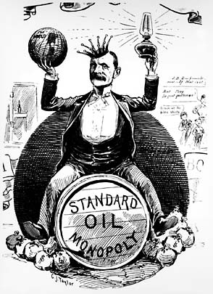– Corporations either bought out their competitors or drove them out of business.

**13. What does this image reveal about big business in the Gilded Age?**

Consumers had no other choices for products and the cost for them was driven up.

“I am but one of many victims of Rockefeller’s colossal combination,” said Mr. [George]Rice, “and my story is not essentially different from the rest…I established what was known as the Ohio Oil Works…I found to my surprise at first, though I afterward understood it perfectly, that the Standard Oil Company was offering the same quality of oil at much lower prices than I could do – from one to three cents a gallon less than I could possibly sell it for. I sought for the reason and found that the railroads were in league with the Standard Oil concern at every point, giving it discriminating rates and privileges of all kinds as against myself and all outside competitors.” ~ Source: George Rice, “How I Was Ruined by Rockefeller,” *New York World*, October 16, 1898.

1. **How did Standard Oil eliminate its competition?** **High -lite the text where you find evidence to support the answers.** 
   1. **Standard Oil was able to eliminate its competition by securing special transport rates by the Railroad companies and then selling their oil at a reduced cost as a result.**

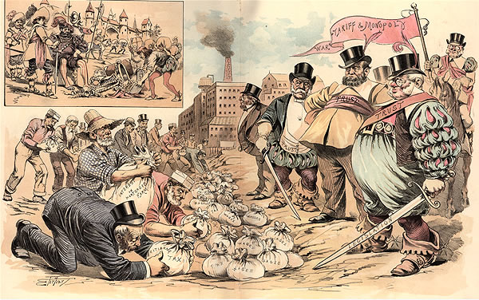**Textbook Pages 447 - 448**

1. **What assumption does Social Darwinism make about the poor, who were exploited by big business? TTQA**
   1. **Social Darwinism assumes that the poor are inferior or weak and that leaders of big businesses deserve to make money because they are stronger or smarter than others.**

**“*History repeats itself–the robber barons of the Middle Ages and the robber barons of today.*”**

**This nineteenth century cartoon depicts wealthy industrialists as “robber barons” - an allusion to the feudal lords of the Middle Ages who charged extravagant fees to travelers who passed through their lands. This perspective was based on the assumption that the enormous wealth of industrial leaders such as Andrew Carnegie, J.P. Morgan and John D. Rockefeller was gained through the exploitation of their workers and their influence on elected officials. ~ eyewitnesstohistory.com**

1. **How is the railroad president like a king or a Shah or a Sultan in how he treats the people and how he works with the government?** **High -lite the text where you find evidence to support the answers.**

The railroad president is a railroad king, whose whim is law. He collects tithes by reducing wages as remorselessly as the Shah of Persia or the Sultan of Turkey, and, like them, is not amenable to any human power. He can discharge (banish) any employee without cause. . .. He can withhold their lawful wages. He can delay trial on a suit at law and postpone judgment indefinitely. He can control legislative bodies, dictate legislation, subsidize the press, and corrupt the moral sense of the community. He can fix the price of freights, and thus command the food and fuel-supplies of the nation. In his right hand he holds the government; in his left hand, the people. ~ Source: George E. McNeill, labor leader, *The Labor Movement: The Problem of Today*,1887.

* 1. **The railroad president is similar to a king Shah or Sultan because he uses his absolute power to force taxes, fire without question, refuse to pay employees and control supply and demand of the country.**
  2. **The railroad president has control over the creation or laws, control of freedom of speech.**

**Source: Joseph Keppler, “The Bosses of the Senate,” *Puck*, January 23, 1889.**

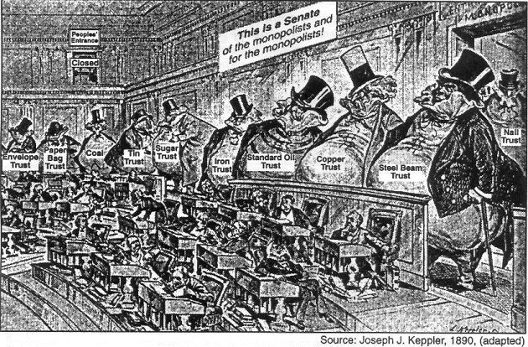

1. **What is the political cartoon suggesting about the U.S. Senate and the power of big business in government?**

**Textbook page 450-451**

1. **In what ways did factory owners exploit their workers? Include in your response Company Towns and Sweatshops.** 
   1. **The entire family worked to survive and enduring long hours and unsafe conditions in a sweatshop atmosphere. Accidents and illness were common and meant loss of wages to a family. The factory owners could require works to live in company towns and these owners charged high interest at company stores where workers were required to shop. Owners segregated workers according to their ethnicity.**
2. **What is the promise of the People’s Party? High -lite the text where you find evidence to support the answers.**

[W]e seek to restore the government of the Republic to the hands of “the plain people,” with which class it originated…Our country finds itself confronted by conditions for which there is no precedent in the history of the world;…We pledge ourselves that if given power we will labor to correct these evils by wise and reasonable legislation, in accordance with the terms of our platform. We believe that the power of government – in other words, of the people – should be expanded (as in the case of the postal service) as rapidly and as far as the good sense of an intelligent people and the teaching of experience shall justify, to the end that oppression, injustice, and poverty shall eventually cease in the land.~Source: “People’s Party Platform,” *Omaha Morning World-Herald*, July 5, 1892.

* 1. **The promise of the People’s Party is to establish a capitalistic economy that has more government jurisdiction, where big business has less power and the federal or state governments more power.**

1. **What did the Massachusetts high court rule in the case of *Commonwealth v. Hunt*? TTQA**
   1. held that labor unions had a right to combine and strike ‘in such manner as best to sub serve their own interests.’

“Organized labor in America can trace its roots to 1792 when the journeymen cordwainers (shoemakers) of Philadelphia organized a local union. Its successor, the Federal Society of Journeyman Cordwainers, operated until 1806 when, after a strike for better wages, the union was found guilty of conspiracy in a court of law.

Although the strike and subsequent decision of the courts ended the small union, it marked the beginning of decades of struggle for the bargaining power of workers in the workplace. In the case of *Commonwealth v. Hunt* (1842), the Massachusetts high court held that labor unions had a right to combine and strike ‘in such manner as best to sub serve their own interests.’

The development of the factory system made it impossible for individual workers to bargain on equal terms with a powerful employer. Only by organizing and presenting their demands as a group were the workers able to secure higher wages, shorter working days, improved working conditions, and protection against being discharged without just cause.” ~ U.S. History and Government

1. **What did the factory system make impossible for individual workers? High -lite the text where you find evidence to support the answers.**
   1. **Individual workers were unable to establish for themselves the improved conditions that they believed were rights they should be receiving including increased compensation, and more conducive work conditions.**
2. **According to Samuel Gompers, what are examples of the inalienable rights/demands of the workers? 3 Bullets**

The organized working men and women, the producers of the wealth of the world, declare that men, women and children, with human brains and hearts, should have a better consideration than inanimate and dormant things, usually known under the euphonious title of “Property.” …

“To protect the workers in their inalienable rights to a higher and better life; to protect them, not only as equals before the law, but also in their health, their homes, their firesides, their liberties as men, as workers, and as citizens…to this workers are entitled…The attainment of these is the glorious mission of the trade unions.”

We demand a reduction of the hours of labor, which would give a due share of work and wages to the reserve army of labor and eliminate many of the worst abuses of the industrial system now filling our poor houses and jails…

Labor…insists upon the exercise of the right to organize for self and mutual protection.…That the lives and limbs of the wage-workers shall be regarded as sacred as those of all others of our fellow human beings; that an injury or destruction of either by reason of negligence or maliciousness of another, shall not leave him without redress simply because he is a wage-worker…

And by no means the least demand of the Trade Unions is for adequate wages. **~ Source: Samuel Gompers, *What Does Labor Want;* an address before the International ~ Labor Congress in Chicago, August 28, 1893.**

**A.**

**B.**

**C.**

|  |  |  |
| --- | --- | --- |
| **The Knights of Labor:**   * Begun in 1869 * Hoped to form one large national union joining together all skilled and unskilled workers * After 1881, even women workers were admitted * Demanded 8-hour work day, higher wages, and safety codes in factories * Opposed child labor and supported equal pay for women * Supported restrictions on immigration * Under the leadership of Terrence Powderly, membership grew rapidly in the 1880s * Yet too loosely organized * But skilled workers resented being in the same union as unskilled * After losing several important strikes, the Knights of Labor fell apart   ~ The Key to Understanding U.S. History and Government | **The American Federation of Labor (AFL):**   * Formed in 1881 by a Jewish cigar-maker, Samuel Gompers * Hoped to create a powerful union by uniting workers with similar economic interests * Consisted of separate unions of skilled workers joined together into a federation * Participating craft unions limited their membership to skilled workers such as carpenters and cigar-makers * Gompers’ approach was known as “bread and butter” unionism because he limited his goals to winning economic improvements for his workers * Focused on obtaining higher pay, an 8-hour work day, and better working conditions * Sought closed shops or places where only union members were hired * Emerged as principal voice of organized labor * But weakened in early years by excluding unskilled workers | **Changing Government Attitudes toward Unions**:   * Business leaders contributed heavily to political campaign funds * Government leaders also feared the disruptive effect of strikes on the economy * Public opinion supported laissez-faire capitalism * Union activities were often associated with violence and radical ideas * In the Haymarket Affair of 1886, labor leaders were blamed when a bomb exploded at a demonstration of striking workers at Haymarket Square in Chicago * But when a fire at the Triangle Shirtwaist Factory in New York City in 1911 killed 146 garment workers, public sympathy for the workers grew when it was learned that the factory doors had been bolted shut from the outside, and that the building lacked a sprinkler system and had only one inadequate fire escape. |

1. **How did the Knights of Labor differ from the American Federation of Labor? TTQA**
   * + **The AFL was a loose organization of skilled workers and focused on specific labor issues such as wages and working hours. The Knights of labor included both skilled and unskilled workers and sought broad social reforms.**
2. **Why did government officials often favor the interests of big business?TTQA**
3. Government leaders also feared the disruptive effect of strikes on the economy
4. **Explain Collective Bargaining and the benefit that it had for workers. TTQA**

“Collective bargaining consists of negotiations between an employer and a group of employees so as to determine the conditions of employment. The result of collective bargaining procedures is a collective agreement. Employees are often represented in bargaining by a union or other labor organization. Collective bargaining is governed by federal and state statutory laws, administrative agency regulations, and judicial decisions. In areas where federal and state law overlap, state laws are preempted. *See*, U.S. Constitution, Art. VI.” ~ law.cornell.edu

Some individuals feel that collective bargaining gives unions too much power while other individuals feel that collective bargaining is necessary to ensure that workers are not mistreated or even exploited

1. **Is collective bargaining fair or does collective bargaining favor one group over the other group (employees/business owners)? Explain**

|  |  |  |
| --- | --- | --- |
| **Major Strikes of the Late 1800’s – Page 454 -457** | | |
| **Strike** | **Cause** | **Effect** |
| **Railroad Strike 1877** | **Response to cuts in workers’ wages** | * + - **Sets the scene for violent strikes to come** |
| **Haymarket square 1886** | * + - **Part of campaign to achieve an eight-hour workday** | * + - **Americans became wary of labor unions the knights of labor were blamed for the riot and membership declined** |
| **Homestead Strike 1892** | * + - **Economic depression led to cuts in steel workers’ wages** | * + - **After losing the standoff steel worker unions lost power throughout the country** |
| **Pullman strike 1893** | * + - **Wages cut without a decrease in the cost of living in the company town** | * + - **Employers used the courts to limit the influence of unions.** |

**Triangle Shirtwaist Factory Fire:**

* The fire at the Triangle Shirtwaist Company claimed the lives of 146 young immigrant workers
* The factory was a typical sweatshop factory in the heart of Manhattan
* Low wages, excessively long hours, and unsanitary and dangerous working conditions
* The International Ladies’ Garment Workers Union organized workers in the women’s clothing trade
* Near closing time on Saturday afternoon, March 25, 1911, a fire broke out
* 146 of the 500 employees died
* Owners locked the exit doors, claiming that workers stole materials
* The tragedy subsequently brought about a modern factory inspection system and laws to regulate the labor of women and children

~ cornell.edu

1. 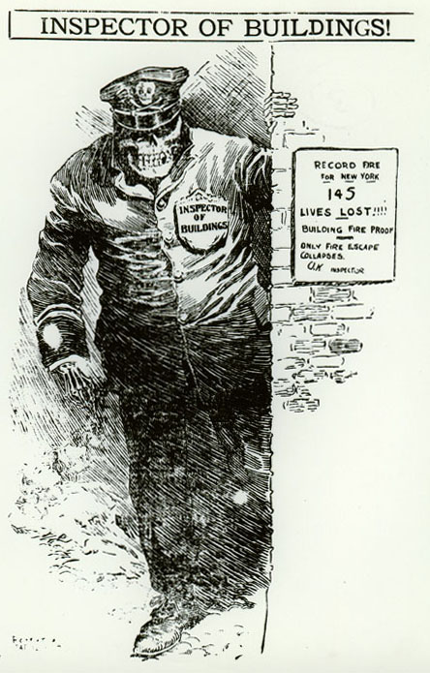**Explain the meaning of this political cartoon. In your answer, be sure to use the Triangle Shirt Waist Fire and**
2. **Why did the fire at the Triangle Shirtwaist Factory change public opinion?**
3. **The Federal Trade Commission, the Interstate Commerce Commission, and the Federal Communications Commission are similar in that each**
4. represents the interests of big business
5. is specifically provided for in the United States Constitution
6. has the power to formulate and enforce regulations
7. must get approval from the states to carry out national laws
8. **During the late 19th century, Samuel Gompers, Terence Powderly, and Eugene Debs were leaders in the movement to**
9. stop racial segregation of Native American Indians
10. limit illegal immigration
11. gain fair treatment of Native American Indians
12. improve working conditions
13. **Which factor most limited the growth of labor unions during the late 1800’s?**
14. Most employers were very hostile toward workers’ efforts to organize.
15. Most factory workers were satisfied with their wages and working conditions.
16. The Federal Government declared that unions were illegal.
17. Workers preferred to negotiate with factory owners as individuals rather than as members of a group.
18. **After the Civil War, one-way business leaders tried to eliminate competition was by**
19. forming monopolies or trusts
20. developing overseas markets
21. increasing the prices of their products
22. paying high wages to their workers
23. **During the latter half of the 19th century, many business organizations in the United States combined into large corporations because**
24. income levels for workers would be improved
25. government intervention in economic affairs would decline
26. efficiency in production methods could be increased
27. economic possibilities outside the United States could be explored
28. **Which term best describes United States economic policy during the era of the rise of big business (1865-1900)?**
29. laissez-faire capitalism
30. mercantilism
31. Marxism
32. welfare-state capitalism
33. **In the United States, industrial unions of the 1880’s and of the 1980’s had similar goals in that both campaigned for**
34. national health insurance
35. better unemployment insurance
36. greater job security and higher wages
37. wage and price freezes
38. **The American Federation of Labor became the first long-lasting, successful labor union in the United States mainly because it**
39. refused to participate in strikes against employers
40. concentrated on organizing workers in industries in the South
41. formed its own political party and elected many pro-labor public officials
42. fought for the rights of skilled workers
43. **In a United States history textbook, the terms bread and butter unionism, Gospel of Wealth, and mechanization would most likely be found in a chapter entitled**
    1. Reconstruction (1865–1877)
    2. Industrialization (1870–1900)
    3. Imperialism (1898–1905)
    4. The Roaring Twenties (1920–1929)
44. **Many reformers who opposed the laissez-faire attitude of the late 19th century argued that**
45. the National Government should not interfere in the activities of big business …big business
46. national wealth could best be assured by the accumulation of gold
47. the idea of rugged individualism is vital to the nation’s economic growth
48. government should protect society through the regulation of business
49. **In the 19th century, the major national labor unions wanted to improve the position of workers mainly by**
50. obtaining the legal right to organize and bargain collectively
51. using government troops to settle labor disputes with management
52. supporting government ownership of major industries
53. endorsing a third political party for workers only
54. **In response to the demands of farmers and small business owners, Congress enacted laws in the late 19th century that**
55. supported the organization of farm cooperatives
56. regulated the activities of railroads and trusts
57. provided direct payments to farmers to help them buy modem machinery
58. dropped tariff rates to the lowest point in the century
59. **“Labor Leaders Executed for Causing Haymarket Riot”**

**“State Militia Called In To End Homestead Strike”**

**“1,000 Jailed as Silver Miners Protest Wage Cuts”**

**Which statement about labor unions in the late 1800s is illustrated by these headlines?**

1. Strikes by labor unions usually gained public support.
2. The government frequently opposed labor union activities.
3. Labor union demands were usually met.
4. Arbitration was commonly used to end labor unrest**.**
5. **A negative effect of holding companies, mergers, and pools on the United States during the late 19th century was that these combinations**
6. encouraged the Federal Government to spend more than its income
7. reduced the need for labor unions
8. decreased competition between businesses
9. ended United States participation in inter-national trade
10. **The main purpose of this 1886 poster was to**

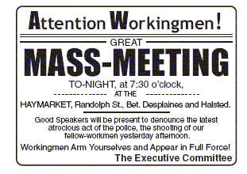

1. oppose immigrants who took jobs from American workers
2. support nativist calls for limitations on labor unions
3. organize a protest against acts of police brutality against workers
4. show support for police actions against foreign revolutionaries
5. **The growth of big business in the late 1800s resulted in**
   1. a reduction in child labor
   2. the elimination of the middle class
   3. the widening of the economic gap between rich and poor
   4. a shift in transportation investment from railroads to canals

**Choose one and provide a 5- 8 sentence response with 5 facts as evidence to support your answer.**

**Chapter 13 Section 2**

1. **How did Big Business shape the American economy in the late 1800’s?**

**Chapter 13 Section 3**

1. **How did the rise of labor unions shape relations among workers big business and government?**

**________________________________________________________________________________________________________________________________________________________________________________________________________________________________________________________________________________________________________________________________________________________________________________________________________________________________________________________________________________________________________________________________________________________________________________________________________________________________________________________________________________________________________________________________________________________________________________________________________________________________________________________________________________________________________________________________________________________________________________________________**