  - In what three ways was the American class/social system affected by industrialization?
“In the decades following the Civil War, the United States emerged as an industrial giant. Old industries expanded and many new ones, including petroleum refining, steel manufacturing, and electrical power, emerged. Railroads expanded significantly, bringing even remote parts of the country into a national market economy.

Industrial growth transformed American society. It produced a new class of wealthy industrialists and a prosperous middle class. It also produced a vastly expanded blue collar working class. The labor force that made industrialization possible was made up of millions of newly arrived immigrants and even larger numbers of migrants from rural areas. American society became more diverse than ever before.

Not everyone shared in the economic prosperity of this period. Many workers were typically unemployed at least part of the year, and their wages were relatively low when they did work. This situation led many workers to support and join labor unions.

Meanwhile, farmers also faced hard times as technology and increasing production led to more competition and falling prices for farm products. Hard times on farms led many young people to move to the city in search of better job opportunities.

Americans who were born in the 1840s and 1850s would experience enormous changes in their lifetimes. Some of these changes resulted from a sweeping technological revolution. Their major source of light, for example, would change from candles, to kerosene lamps, and then to electric light bulbs. They would see their transportation evolve from walking and horse power to steam-powered locomotives, to electric trolley cars, to gasoline-powered automobiles. Born into a society in which the vast majority of people were involved in agriculture, they experienced an industrial revolution that radically changed the ways millions of people worked and where they lived. They would experience the migration of millions of people from rural America to the nation's rapidly growing cities.” ~ loc.gov

    - It produced a new class of wealthy industrialists and a prosperous middle class.
    - It also produced a vastly expanded blue collar working class.
    - The labor force that made industrialization possible was made up of millions of newly arrived immigrants and even larger numbers of migrants from rural areas. American society became more diverse than ever before.

- Why did many farmers suffer?
- as technology and increasing production led to more competition and falling prices for farm products. Hard times on farms led many young people to move to the city in search of better job opportunities.

Textbook Page436-437
- How did the Civil War encourage the growth of industry?
  - The Civil war led factories and railroads to expand,
  - It also led to the improved methods of food storage and increase in immigration

Textbook Page 438-440
- How did the invention of the Bessemer process affect transportation?
  - Not only did companies develop to provide telephone service, but the telephone spurred economic growth by increasing the speed of communication.

Natural Resources:
- The United States possessed fertile soil, swift-flowing streams and rivers, vast quantities of timber, and rich deposits of coal, iron ore, copper, and oil
Laissez-faire
  - The 19th century American government followed a policy of laissez-faire
  - The government did not intervene in the economy
  - However, the government did promote industrialization in important ways
- Laws protected property and contracts
- Congress passed protective tariffs
- A tariff is a tax on foreign imports, making them costlier for U.S. consumers
- Tariffs encouraged Americans to buy American products at lower prices than foreign products
- How did new technologies shape industrialization?
- New technologies improved communication and transportation.
- Improved transportation allowed factories to change the way they created goods and led to the system of mass production, which replaced performing tasks by hand.

The Free Enterprise System:
  - Also called Capitalism or Free Market
  - Capital (money, factories, equipment) is privately owned and invested
  - The government does not intervene in the market
  - Producers who stay in business are those who are able to compete effectively
  - American culture stressed individualism, thrift, and hard work
  - Americans believed individual efforts were rewarded with material success
The Expansion of Railroads
  - The first transcontinental railroad, linking the east and west coasts, was completed in 1869
  - The amount of railroad tracks increased fivefold in the next 25 years
  - Railroads connected raw materials to factories and factories to consumers
  - Also promoted the settlement of the frontier
  - Irish and Chinese immigrants were used as cheap labor for railroad construction
Population Increase
  - Between 1860 and 1900, the population of the U.S. more than doubled
  - This increase was partly fueled by a constant stream of European immigrants
The Corporation:
  - Before the Civil War, most businesses were owned by individuals or partnerships.
  - Following the Civil War, the corporate form of business became more popular.
- A corporation is a company chartered by a state and recognized in law as a separate “person”
- A corporation issues shares to investors, making each stockholder one of its partial owners

Textbook Page 440-442

- How did industrialization change the population od U.S. Cities and rural areas?
- People moved from farms to cities because fewer agricultural works were needed.
- People lived in the more polluted environments of the cities

- Why was National Grange of the Patrons of Husbandry founded in 1867?
The Granger Movement: “The transition of the American farmers from self-sufficiency to the market economy brought hardships that eventually caused them to form political organizations. During the 19th century, farmers found themselves at the mercy of forces – commodity prices, grain storage charges, interest rates, and shipping costs – that were beyond their control.

The National Grange of the Patrons of Husbandry was founded in 1867 to organize farmers into local chapters dedicated to education, culture, and socialization. However, in the 1870s its aims became less social and more political, with membership reaching 1.5 million by 1874. The Grange accused the railroads of discriminatory practices (long haul compared to short haul, rebates, monopolizing practices), the grain-elevator operators of monopoly practices, charging ‘all that the traffic would bear,’ and manufacturers of raising prices and the cost of credit so that farmers were unable to make a profit.

By the middle of the 1870s the Grangers held the political balance in several of the Midwestern states. In four states Granger laws were passed to regulate railroad rates and the practices of the owners of grain elevators. The Supreme Court, in a series of landmark decisions, upheld the principle that government could regulate all those industries ‘affected with a public interest.’”
~ U.S. History and Government
“The Patrons of Husbandry, or the Grange, was founded in 1867 to advance methods of agriculture, as well as to promote the social and economic needs of farmers in the United States. The financial crisis of 1873, along with falling crop prices, increases in railroad fees to ship crops, and Congress’s reduction of paper money in favor of gold and silver devastated farmers’ livelihoods and caused a surge in Grange membership in the mid-1870s. Both at the state and national level, Grangers gave their support to reform minded groups such as the Greenback Party, the Populist Party, and, eventually, the Progressives.”
~ gilderlehrman.org

- to organize farmers into local chapters dedicated to education, culture, and socialization

- What did the Grange accuse railroads and grain-elevator operators of?
- The Grange accused the railroads of discriminatory practices (long haul compared to short haul, rebates, monopolizing practices), the grain-elevator operators of monopoly practices, charging ‘all that the traffic would bear,’ and manufacturers of raising prices and the cost of credit so that farmers were unable to make a profit.

- What factors devastated the livelihoods of farmers in the mid-1870s?
- The financial crisis of 1873, along with falling crop prices, increases in railroad fees to ship crops, and Congress’s reduction of paper money in favor of gold and silver devastated farmers’ livelihoods

Text book page 535-536
- How did the Grange compare with Farmer’s Alliances?
- The grange worked mainly for government reform, persuading the state governments to pass regulations on railroad rates and pushed the federal government to form the ICC to regulate interstate commerce
- The farmers alliances also worked for reform, but they created their own systems to change the economy through cooperatives and new lending institutions

The Greenback Party | The Populist Party | The Progressives
- Started in the 1870s  - Main support came from farmers who were suffering from declining farm prices, high railroad rates and the government’s deflationary currency policies  - Wanted to maintain or increase the amount of paper money in circulation  - Did not agree when the government announced that it would support all greenbacks with gold; this action would increase value of greenbacks  - With the currency’s value increasing and inflation decreasing, it became more difficult for people to pay their debts  - Wanted to keep the greenbacks in circulation and even urged that more be printed; thus making it easier to pay off debts with “cheap” money  Greenback Party Slogan:  “More Money, Cheaper Money.”  “The devastating depression unleashed by the Panic of 1873 shook American society to the core. Out of this crisis arose the Greenback Labor Party with its catchy slogan ‘More Money, Cheaper Money.’ Nothing ailed the crippled economy, the Greenbacks insisted, that a massive influx of paper currency could not cure.” ~ Bartee Haile | - The People’s Party  - In the 1880s, as drought hit the wheat-growing areas of the Great Plains and prices for Southern cotton sunk to new lows, many tenant farmers fell into deep debt  - Exacerbated long-held grievances against railroads, lenders, grain-elevator owners, and others with whom farmers did business  - Advocated more sweeping federal intervention to offset the economic depression, curtail corporate abuses, and prevent poverty among farming and working-class families  - Also advocated a graduated income tax, government ownership of railroads and telegraph lines, and the direct election of Senators |  | - The rapid industrialization and growth of a world economy in the Gilded Age gave birth to a reform movement in the last decade of the nineteenth-century  - Believed that people united behind a common cause could erase the social ills that plagued society  - Wanted to reform social ills such as mass immigration, overcrowding, child labor and sanitation  - Included liberals, agrarians, Republican progressives, socialists, and labor representatives  - The 1924 Progressives pledged a “housecleaning” of executive departments, public control of natural resources, public ownership of railways, and tax reduction
- Why would backing greenbacks with gold hurt farmers?

- What did the populist party advocate for?

- What groups would support the Progressives?

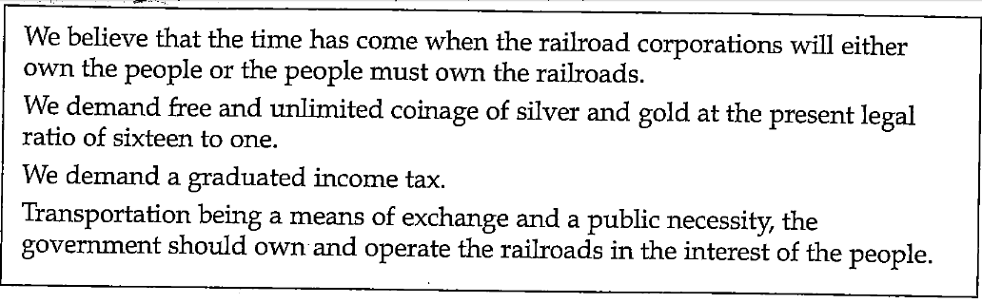

SPIRAL REVIEW SUPREME COURT CASE
Supreme Court Decision – Gibbons v. Ogden, 1824
“In 1798 the New York legislature gave Robert Fulton a monopoly for steamboat navigation in New York. In 1811 Fulton’s partner, Robert Livingston, assigned to Aaron Ogden an exclusive license to run a ferry service on the Hudson River between New York and New Jersey – a very profitable business. Seeking to take advantage of this flourishing trade, a competitor, Thomas Gibbons, secured a license from the federal government to operate a ferry between Elizabethtown, New Jersey, and New York City.
Claiming that his monopoly rights were being infringed, Ogden obtained an injunction in a New York state court forbidding Gibbons’s boat from docking in New York. (An injunction is an order by a court prohibiting a person or a group from carrying out a specific action.) Gibbons appealed the state court’s decision to the United States Supreme Court.

The Constitutional Issue:
The Constitution did not make clear what was meant by interstate commerce or the extent to which it could be regulated. At the time of this case in 1824, New York had closed its ports to vessels not owned or licensed by a monopoly chartered by the state. In retaliation, other states passed similar laws that limited access to their ports. The United States attorney maintained that the country faced a commercial ‘civil war.’ In the absence of a clear statement of what is meant by interstate commerce, how did the federal government have the power to intervene?
The Gibbons v. Ogden case presented the Supreme Court with the first opportunity to consider the ramifications of the commerce clause contained in Article I, Section 8 of the Constitution. This clause gave Congress the power ‘to regulate commerce with foreign nations, and among the several States, and with the Indian tribes.’ Several constitutional questions were involved in the case, revolving around an interpretation of the commerce clause.
The first question was whether navigation should be considered to be a part of commerce. Then, if navigation should be so considered, to what extent might Congress regulate it? Another question was whether Congress had an exclusive right to regulate interstate commerce or if this was a ‘concurrent’ power to be shared with the states.”
~ The American Vision

- What constitutional issue was raised? & What did the Constitution seem to suggest about the issue?

- What did the Supreme Court have to decide?

- What is meant by “interstate commerce”

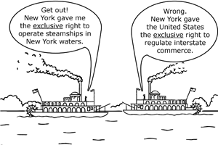 “Gibbons v. Ogden (1824) vastly expanded the powers of Congress through a single clause in the Constitution: the Commerce Clause of Article I, Section 8. The Court ruled that under that clause Congress had powers to regulate any aspect of commerce that crossed state lines, including modes of transportation, and that such regulation preempted conflicting regulation by the states. Since Gibbons, the Commerce Clause has provided the basis for sweeping congressional power over a multitude of national issues.”~ pbs.org
- What did the Supreme Court rule in Gibbons v. Ogden?
The Supreme Court’s Decision:
The Court held in favor of Gibbons. Chief Justice John Marshall wrote that commerce ‘describes the commercial intercourse between nations, and parts of nations, in all its branches, and is regulated by prescribing rules for carrying on that intercourse. The mind can scarcely conceive a system for regulating commerce between nations which shall exclude navigation…’
Marshall applied the same reasoning to commerce between states. In fact, he noted, the
United States government had always regulated navigation. ‘All America understands,’ he wrote, ‘and has uniformly understood the word ‘commerce’ to comprehend navigation…’
Thus the Court held that ‘a power to regulate navigation is expressly granted as if that term had been added to the word ‘commerce.’’
Marshall now turned to the meaning of ‘among,’ as in ‘among the several states.’ He reasoned that since ‘among’ means ‘intermingled with,’ ‘commerce among the states cannot stop at the external boundary line of each state but may be introduced into the interior.’ Congress had no power over commerce which was confined to one state alone, but that power was in full force as soon as a state’s boundary line had been crossed. And the power to regulate must necessarily follow any commerce in question right across those boundaries.’
Marshall concluded that, like other congressional powers, the power to regulate commerce is unlimited so long as it is applied to objects specified in the Constitution.
…By broadening the meaning of interstate commerce, Marshall laid the groundwork for including not only such clearly interstate activities as railroads and pipelines, but also the minimum wage regulation and prohibition of child labor. Robert Jackson, a Supreme Court justice who served in the mid-1900s, was thus correct when he declared, ‘Chief Justice Marshall described the federal commerce power with a breadth never exceeded.’” ~ The American Vision

- If you operated a trucking service between San Francisco, California, and Portland, Oregon, could you be subject to regulation by either or both of the states and the federal government? Explain.

- Why was it necessary for Marshall to take the trouble to explain why navigation should be considered as part of commerce?

- In what way is Marshall’s ruling in the Gibbons case consistent with his other decisions, such as McCulloch v. Maryland, that related to federal versus state powers?

Munn v. Illinois (1877) | Wabash v. Illinois (1886)
- A case in which the U.S. Supreme Court upheld the power of government to regulate private industries  - Illinois legislature had set the maximum rates that private companies could charge for the storage and transport of agricultural products (due to pressure from Granger Movement)  - The Chicago grain warehouse firm of Munn and Scott was subsequently found guilty of violating the law but appealed the conviction on the grounds that the Illinois regulation represented an unconstitutional deprivation of property without due process of law  - Court ruled grain storage facilities were devoted to public use; thus their rates were subject to public regulation  ~ Britannica | - The Wabash, St. Louis and Pacific Railway Company challenged the intervention of the state of Illinois in its business  - The state of Illinois had passed a law penalizing railroads if they charged the same or more for shipping freight for shorter distances than for longer distances  - The Supreme Court declared that states could not regulate commerce that went beyond their boundaries  - The Court ruled that only Congress could regulate rates on interstate commerce  - In 1887, Congress passed the Interstate Commerce Act; prohibiting railroads for charging different rates to customers shipping goods the same distance; also banned the charging of more for short hauls than for long hauls over the same route
- What did the Supreme Court uphold in Munn v. Illinois?

- What did the railroads challenge in Wabash v. Illinois?

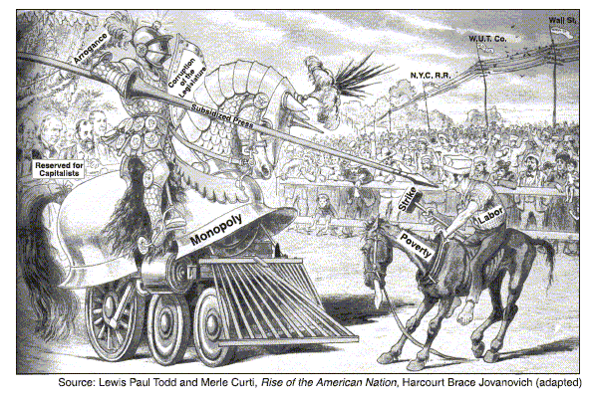
- What did Congress do immediately following the ruling?

- What is the main idea of this cartoon from the 1800s?

- Business has advantages over labor.

The Grange Movement:  * 1867  * Formed to reduce the isolation of farmers and to spread information about new farming techniques  * Began urging economic and political reform  * Blamed the railroads for many of their difficulties  * Elected candidates to state legislatures who promised to regulate the railroads  * When the Supreme Court decision in Wabash ended state regulation of railroads; turned to Congress  * Congress passed the Interstate Commerce Act; the first step towards having the federal government regulate unfair business practices  ~ The Key to Understanding U.S. History and Government | Populist Party:  * 1891 – 1896  * Despite the successes of the Grange Movement, farmers continued to experience problems  * In 1892, farmers gave their support to the Populist Party, a new national political party representing laborers, farmers, and industrial workers in the struggle against banking and railroad interests  * Goals:  - Unlimited coinage of silver to raise farm prices and make loan repayments easier  - Direct election of Senators instead of by state legislatures  - Secret ballot to protect voters from intimidation  - Immigration Restrictions with quotas  - Graduated Income Tax to tax wealthy individuals at a higher rate  - Eight-hour work day  - Government Ownership of railroads, telegraphs, and telephones | Election of 1896:  * The Democratic Party nominated William Jennings Bryan for President after he delivered a speech at the convention  - “Cross of Gold” Speech praised farmers and denounced bankers for “crucifying mankind on a cross of gold”  - But Bryan’s moral outrage frightened many voters, and he lost to Republican William McKinley  Election of 1900:  * Pitted Bryan against McKinley  - McKinley’s second victory marked the end of the Populist Party  - In subsequent years, new gold discoveries, higher farm prices, and rural migration to the cities weakened interest in a separate farmer’s party
- The Populist Party demonstrates how a third party can influence American politics. What goals of the Populist Party have been adopted in the United States?
    - Graduated income tax
    - Regulation of the railroads
    - More flexible monetary system

Textbook Page 538

- What was the effect of William Jennings “Cross of Gold Speech?
  - Democrats nominated him for the president, however it was a bad choice because the party lost local support as a result

- Why did William Jennings Bryan not win the election of 1896?
- But Bryan’s moral outrage frightened many voters, and he lost to Republican William McKinley

Precious Metals and Railroads:  * Gold and silver had been discovered in California, the Rocky Mountains, and the Black Hills of South Dakota from 1848 onwards  * Thousands of prospectors and adventures moved to these areas hoping to strike it rich  * The extension of the railroads was one of the principal factors behind the settlement of the Great Plains  * With the completion of the first transcontinental railroad in 1869, the journey from one coast to another was cut from several months to a few weeks  *Sharp-shooters on the railroads killed off many of the buffalo  *Railroads made it possible for ranchers and farmers to ship their cattle and grain to eastern markets | Availability of Cheap Land:  * Immigrants from Europe and farmers from the East and Midwest of the United States were attracted by the prospect of cheap land under the terms of the Homestead Act.  * The Homestead Act of 1862 gave federal land away to anyone who settled it  a) Anyone over twenty years old could claim a 160-acre lot  b) In order to obtain ownership, a person only needed to farm the land for five years  c) After paying a small fee, the land then became the homesteader’s  ~ The Key to Understanding U.S. History and Government | The Impact on the Native American Indians:  * From 1830 to 1890, the government systematically followed a policy of pushing Native American Indians from their historic lands onto government reservations in the West  * In 1830, Congress ordered the removal of all Native American Indians to west of the Mississippi: Nearly one-quarter of the Cherokees perished on the journey westward, known as the Trail of Tears  * The “Indian Wars,” which pitted settlers and federal troops against Native American Indians, lasted from 1860 to 1890  * The completion of the transcontinental railroad and the Homestead Act made Native American lands more desirable  * Once a Native American tribe submitted to federal authority, its members were settled on reservations
SPIRAL REVIEW
- How did railroads benefit ranchers and farmers?

- What was the Homestead Act?

- What happened to Native American Indians as a result of the Homestead Act and the completion of the transcontinental railroad?

Threatened Tribal Ways: Assimilation threatened tribal culture;  The act encouraged individual farm ownership as opposed to tradition of sharing lands | Hunters, Not Farmers: Many Native American Indian tribes had never farmed the land, since they were hunters by lifestyle and tradition | Infertile Lands: The lands given to Native American Indians were often infertile and the government never provided assistance in learning how to farm | Reservation Life: Many suffered from malnutrition, poverty, and untreated health problems; reservation schools provided an inferior education

- The theory of laissez-faire economics was used during the late 1800s to
  - justify unregulated business growth
  - call for more consumer protection
  - support Progressive programs
  - achieve equal distribution of income

- In the 1870s, the Granger movement was organized to promote the interests of
- suffragists
- farmers
- factory workers
- recent immigrants

Kansas Fool
We have the land to raise the wheat
And everything that’s good to eat
And when we had no bonds or debts
We were a jolly, happy set.…
With abundant crops raised everywhere,

’Tis a mystery, I do declare.
Why farmers all should fume and fret
And why we are so deep in debt.…
~ Traditional

- What is the basic cause of the farm problem described by these song lyrics?
  - limits on agricultural imports
  - government ownership of the railroads
  - overproduction of farm crops
  - prolonged droughts in the Midwest

- During the 1890s, many American farmers tried to resolve their economic problems by
  - joining the Populist Party
  - staging violent protests, against the government
  - supporting government aid to railroads
  - asking Congress to end agricultural subsidies

- Post-Civil War, the result of the shift from single proprietorship to corporate organization was business were able to
- make more efficient use of natural resources
- concentrate on improving the quality of manufactured goods
- provide workers with higher wages
- raise large sums of money

- Industrialists of the late 1800s contributed most to economic growth by
- supporting the efforts of labor unions
- establishing large corporations
- encouraging government ownership of banks
- opposing protective tariffs

- Which factor most influenced the growth of the United States economy between 1865 and 1900?
- development of the sharecropping system
- success of organized labor
- governmental policy of laissez faire
- restrictions on immigration

- One factor that furthered industrialization in the United States between 1865 and 1900 was the
- development of the airplane
- expansion of the railroads
- mass production of automobiles
- widespread use of steamboats

- “Prices and wages should be determined by the marketplace.” The author of this statement would most probably support
- government ownership of utilities
- minimum-wage laws
- wage and price controls
- laissez-faire capitalism

- After the Civil War, one-way business leaders tried to eliminate competition was by
- forming monopolies or trusts
- developing overseas markets
- increasing the prices of their products
- paying high wages to their workers

- During the latter half of the 19th century, many business organizations in the United States combined into large corporations because
- income levels for workers would be improved
- government intervention in economic affairs would decline
- efficiency in production methods could be increased
- economic possibilities outside the United States could be explored

- Which argument was used by Progressive Era reformers to support the use of a graduated income tax?
  - Imports should be taxed to make foreign goods more expensive than domestic goods.
  - Taxes on corporations should be reduced so jobs can be created.
  - People who earn more money should pay taxes at higher rates.
  - All citizens should be taxed at the same rate to treat all people equally.

- The Progressive movement supported the idea that the federal government should
  - regulate big business
  - reduce immigration
  - build an overseas empire
  - reduce the number of farms

- During the late 1800s, many United States farmers believed their economic problems would be solved if the federal government would
  - raise interest rates
  - outlaw strikes by labor unions
  - put more money into circulation
  - regulate the amount of grain that was Produced

- In the late 1800s, which group most often supported the views of the Populist Party?
- factory owners C. farmers
- nativists D. labor unions

- Which statement about the development of the Great Plains in the late 1800s is most accurate?
  - Great profits could be earned in the steel industry.
  - Railroads decreased in importance throughout the region.
  - Immigrants could no longer afford to become farmers.
  - Mechanized farming became dominant in the region.

- Prior to 1880, the number of immigrants to the United States was not restricted mainly because
- industry owners wanted cheap labor
- the nations of Europe discouraged emigration
- the United States birthrate was increasing
- Congress lacked the power to limit immigration

- Laws requiring individuals to pass civil service examinations to obtain government jobs were enacted to
- eliminate patronage and corruption in government hiring
- allow the government to compete with private industry for employees
- support the development of public employee labor unions
- encourage the growth of local political parties

- In the United States during the late 19th century, much of the prejudice expressed toward immigrants was based on the belief that they would
- cause overcrowding in farm areas
- refuse to become citizens
- support the enemies of the United States in wartime
- fail to assimilate into American society

- Many reformers who opposed the laissez-faire attitude of the late 19th century argued that
- the National Government should not interfere in the activities of big business …big business
- national wealth could best be assured by the accumulation of gold
- the idea of rugged individualism is vital to the nation’s economic growth
- government should protect society through the regulation of business

- Why did the United States follow a policy of unrestricted immigration for Europeans during most of the 1800’s?
- Business and industry depended on the foreign capital brought by immigrants.
- The American economy needed many unskilled workers.
- Most Americans desired a more diversified culture.
- The United States wanted to help European nations by taking in their surplus population.
- Which situation brought about the rapid growth of industry between 1865 and 1900?
- high worker morale resulting from good wages and conditions
- availability of investment capital
- establishment of western reservations for Native Americans
- decline in the number of people attending schools

- During the late 1800s, industrialization in the United States led
- To the growth of the middle class
- To an overall decline in labor union membership
- To the creation of affirmative action programs
- To a decrease in the use of natural resources

- From 1865 to 1900, how did the growth of industry affect American society?
- The United States experienced the disappearance of the traditional
- Population centers shifted from the Northeast to the South
- Restrictions on immigration created a more homogeneous culture.
- The percentage of Americans living in urban areas increased.

- In the late 1800s, the Granger movement tried to improve conditions for farmers by
  - lowering the rate of inflation
  - strengthening the gold standard
  - forcing railroads to lower their rates
  - making labor unions stronger

- Which reform idea was a common goal of the Populists and the Progressives?
  - restoration of the nation’s cities
  - expansion of opportunities for immigrants
  - improvement in the status of African Americans
  - greater control of government by the people

- Supporters of a graduated national income tax argued that it was the fairest type of tax because the
  - rate of taxation was the same for all persons
  - rate of taxation increased as incomes rose
  - income tax provided the most revenue for the government
  - income tax replaced state and local government taxes

- Which idea led to the creation of the Interstate Commerce Commission, the Federal Trade Commission, and the Food and Drug Administration?
  - Business activity must sometimes be regulated in the public interest.
  - Workers should be allowed to bargain with owners for working conditions.
  - Domestic industry should be protected from foreign competition.
  - The economy works best without government regulation.

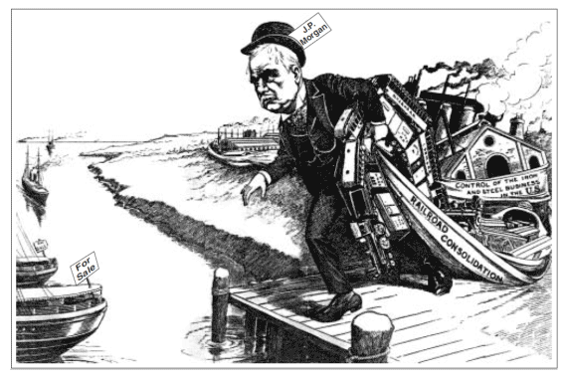

- Which 19th-century business practice does this cartoon illustrate?
- forming cooperatives C. establishing trade zones
- creating monopolies D. expanding global markets

- The cartoonist would most likely support federal government attempts to
- pass antitrust legislation C. limit regulation of business
- establish high tariffs D. stop industrial pollution

- Which generalization about population growth is supported by information in this chart?
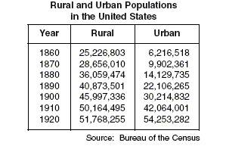
- For every census listed, rural population exceeded urban population.
- By 1920, more people lived in cities than in rural areas.
- The Civil War significantly slowed the rate of population growth.
- Most urban population growth was due to people migrating from rural areas.

Please Answer each of these Questions with 5 facts in 5-8 sentences. Use the Page numbers to assist you.

Chapter 13 Section 1 - pages 437 – 442
How did Industrialization and New Technology affect the economy and society?
    - New technologies improve communication and transportation. Improved transportation allowed factories to change the way they created goods and that led to the system o mass production which replaced performing tasks by hand.
    - Industrialization increased the population of the United States cities because farms required fewer workers. Increased production made the United States more involved with the economies of foreign nations Waste form industries created pollution and caused people to be concerned about their environment.

Chapter 16 Section 3 - pages 533 – 539
What led to the rise of the populist movement, and what effect did it have?
    - Farmers organized the Grange movement and the Farmers Alliances leading to the creation of the Populist Party which supported economic and political reforms. Populist initiatives became reality like the graduated income tax, regulation of the railroads, and more flexible monetary system.
    - Established the Icc and the sub0treauries to provide farmers with low- interest loans
    - End political corruption, increase the money supply and began government ownership of the railroads.
    - Although the Party did not survive, many its ideals became law it persuaded politics to listen to the common people.

