Homework # 9- 11/20/17
Do Now:
“Attempts by Spain to restore its authority at the end of the Napoleonic Wars triggered a series of independence movements in the Spanish colonies. The U.S. recognized the independence of these nations, but feared Spain might try to reconquer them. President Monroe announced the Monroe Doctrine (1823).”
~ The Key to Understanding U.S. History and Government
“The Monroe Doctrine had four main points:
1) The United States would not get involved in European affairs.
2) The United States would not interfere with existing European colonies in the Western Hemisphere.
3) No other nation could form a new colony in the Western Hemisphere.
4) If a European nation tried to control or interfere with a nation in the Western Hemisphere, the United States would view it as a hostile act against this nation.”
~ americaslibrary.gov

- What were the circumstances leading to the formulation of the Monroe Doctrine?

- What were its major provisions (requirements)?

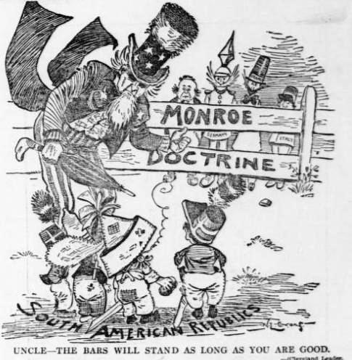
- Explain the meaning of this Political Cartoon.

How A Nation Expanded, Defended Itself, and Came to View Itself After Its Revolution:
Washington’s Farewell Address:
“In early 1796, President George Washington decided not to seek reelection for a third term and began drafting his farewell address to the American people. The address went through numerous drafts, in large part due to suggestions made by Alexander Hamilton.
Washington urged Americans to avoid excessive political party spirit and geographical distinctions. In foreign affairs, he warned against long-term alliances with other nations.” ~ ourdocuments.gov
Excerpt from Washington’s Farewell Address:
“The great rule of conduct for us in regard to foreign nations is in extending our commercial relations, to have with them as little political connection as possible. So far as we have already formed engagements, let them be fulfilled with perfect good faith. Here let us stop. Europe has a set of primary interests which to us have none; or a very remote relation. Hence she must be engaged in frequent controversies, the causes of which are essentially foreign to our concerns. Hence, therefore, it must be unwise in us to implicate ourselves by artificial ties in the ordinary vicissitudes of her politics, or the ordinary combinations and collisions of her friendships or enmities.”
Thomas Jefferson and the Louisiana Purchase (1803):
“During Jefferson’s first term, thousands of American farmers had moved west to the lands between the Appalachian Mountains and the Mississippi River. They used the port of New Orleans at the base of the Mississippi River to export much of their produce.
The Louisiana Territory had been given to Spain by France at the end of the French and Indian War. Americans became alarmed when it was learned that Spain had transferred the area back to France by the Treaty of San Ildefonso (1800) and that Spanish officials left in control of New Orleans had ended the right of American farmers to use the port (suspension of the ‘right of deposit.’) Jefferson, fearful of a strong and aggressive France as a neighbor and concerned over conflicts concerning the use of New Orleans sent James Monroe and Robert Livingston to France to try to buy New Orleans. Napoleon, burdened with problems in Europe, decided to sell the entire Louisiana Territory to the United States for $15,000,000.
Problems arose when the strict constructionist Jefferson realized that the Constitution did not authorize Congress to purchase territory. Jefferson was forced to modify his constitutional theories because of the importance of the purchase, and in 1803 the treaty was ratified authorizing the purchase, which nearly doubled the size of the United States.”
~ U.S. History and Government

- What did Washington warn Americans about in his farewell address and what was his
Advice to Americans regarding Europe?

- What is a policy of avoiding entanglements with other nations called?

- What happened during Jefferson’s first term as President?

- Why was New Orleans important?

- What did Jefferson fear & What was his solution?

- State the participants and causes of the War of 1812?
Reading: The War of 1812
“Britain’s defeat at the 1781 Battle of Yorktown marked the conclusion of the American Revolution and the beginning of new challenges for a new nation. Not even three decades after the signing of the Treaty of Paris, which formalized Britain’s recognition of the United States of America, the two countries were again in conflict. Resentment for Britain’s interference with American international trade, combined with American expansionist visions, led Congress to declare war on Great Britain on June 18, 1812.

In the early stages of the war, the American navy scored victories in the Atlantic and on Lake Erie while Britain concentrated its military efforts on its ongoing war with France. But with the defeat of Emperor Napoléon’s armies in April 1814, Britain turned its full attention to the war against an ill-prepared United States.

Angered by British interference with American trade, the young United States was intent on reaffirming its recently won independence. Instead, a series of defeats left Americans anxious and demoralized. They were stunned when, on August 24, 1814, British troops marched into Washington, D.C., and set the Capitol building and White House ablaze.
America’s future seemed more uncertain than ever as the British set their sights on Baltimore, Maryland, a vital seaport. On September 13, 1814, British warships began firing bombs and rockets on Fort McHenry, which protected the city’s harbor. The bombardment continued for twenty-five hours while the nation awaited news of Baltimore’s fate.

By the “dawn’s early light” of September 14, 1814, Francis Scott Key, who was aboard a ship several miles distant, could just make out an American flag waving above Fort McHenry. British ships were withdrawing from Baltimore, and Key realized that the United States had survived the battle and stopped the enemy advance. Moved by the sight, he wrote a song celebrating ‘that star-spangled banner’ as a symbol of America’s triumph and endurance.”
~ Smithsonian.com

- What British action stunned the Americans?

- What was the outcome of the war?

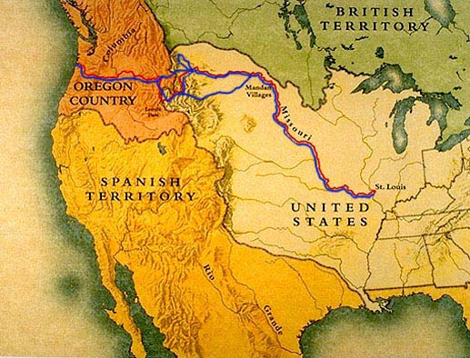

- What do Lewis and Clark conclude about the role of the government and the benefits that can be gained from the territory?
“We view this passage across the continent as affording immense advantages to the fur trade, but fear that the advantages which it offers as a communication for the productions of the East Indies to the United States and thence to Europe will never be found equal on an extensive scale to that by way of the Cape of Good Hope; still we believe that many articles not bully, brittle nor of a very perishable nature may be conveyed to the United States by this route with more facility and at less expense than by that at present practiced.

If the government will only aid, even if in a very limited manner, the enterprise of her citizens I am fully convinced that we shall shortly derive the benefits of a most lucrative trade from this source, and that in the course of ten or twelve years a tour across the continent by the route mentioned will be undertaken by individuals with as little concern as a voyage across the Atlantic is as present.”

[Lewis and Clark Expedition, (1804–06): “U.S. military expedition, led by Captain Meriwether Lewis and Lieutenant William Clark, to explore the Louisiana Purchase and the Pacific Northwest. The expedition was a major chapter in the history of American exploration.” ~ Britannica]

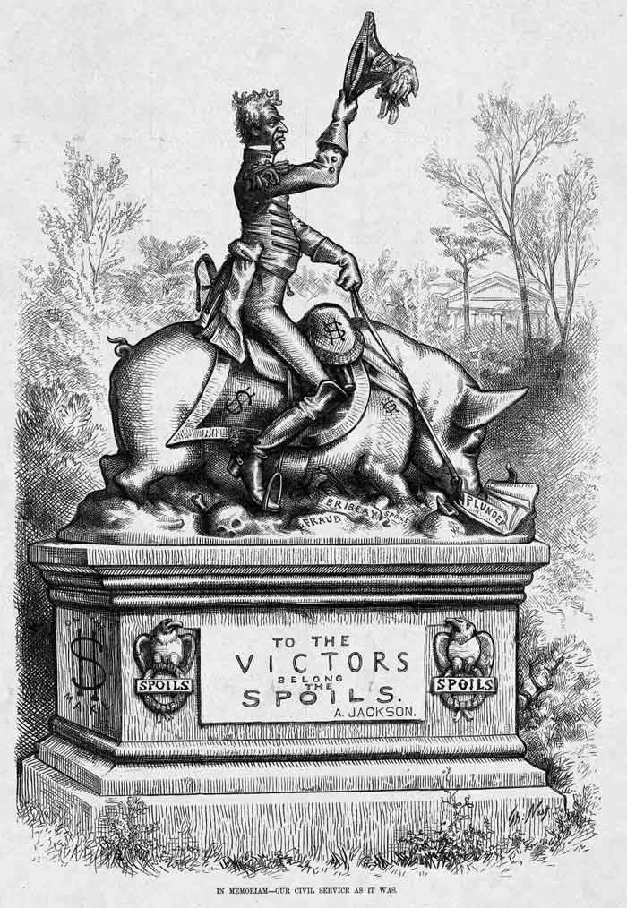___________________________________________________________________
“One of the nation’s strongest leaders was President Andrew Jackson. A hero in the war of 1812, Jackson was elected President in 1828. A native of Tennessee, Jackson was the first President not born to wealth and not from an Eastern state. His main supporters were the common people, especially laborers and Western frontiersmen.” ~ The Key to Understanding U.S. History and Government

Andrew Jackson Quotes:
“Without union our independence and liberty would never have been achieved; without union they never can be maintained.”

“The moment we engage in confederations, or alliances with any nation we may from that time date the downfall of our republic.”

- Was Andrew Jackson a “Man of the People”?

The Presidency of Andrew Jackson
Democratic Reforms:
- After Jackson’s election, the states eliminated property qualifications, so that most white adult males could vote.
- Selection of Presidential candidates by party leaders was replaced by nominating conventions where popularly elected members of each political party chose the candidates.
The Spoils System:
- Jackson believed the President should act as the voice of the common people.
- To make government more responsive to popular needs, Jackson used the “spoils system.”
- Supporters who helped in his election were appointed to government posts in place of existing officials.
- Jackson believed in changing office-holders so that more people had experience in government.
- He felt that circulating government posts was less likely to lead to corruption than permanent government officials.
The War on the National Bank:
- Jackson disliked the National Bank believing it gave an unfair advantage to Eastern investors and bankers.
- Farmers resented the Bank because it made it hard to borrow money.
- The Bank’s Constitutionality was upheld by the Supreme Court, but in 1836, Jackson refused to renew the Bank’s charter and the Bank ended.
The Native American Indians:
- Jackson believed Native American Indians were blocking the nation’s westward expansion.
- Under Jackson, Congress moved all remaining Native American Indians to territories west of the Mississippi River.
- Jackson refused to help the Cherokees of Georgia, even though the Supreme Court had declared their forcible removal unconstitutional.
The Federal Union:
- In 1832, South Carolina threatened to secede [to formally withdraw from the Union] from the nation because it opposed tariffs on imports.
- Jackson threatened to use force and the crisis was avoided.
- He became a symbol for national unity over sectional interests.
“More nearly than any of his predecessors, Andrew Jackson was elected by popular vote; as President he sought to act as the direct representative of the common man.

In his first Annual Message to Congress, Jackson recommended eliminating the Electoral College. He also tried to democratize Federal officeholding. Already state machines were being built on patronage, and a New York Senator openly proclaimed ‘that to the victors belong the spoils…’

Two parties grew out of the old Republican Party – the Democratic Republicans, or Democrats, adhering to Jackson; and the National Republicans, or Whigs, opposing him. Henry Clay, Daniel Webster, and other Whig leaders proclaimed themselves defenders of popular liberties against the usurpation of Jackson. Hostile cartoonists portrayed him as King Andrew I.

Behind their accusations lay the fact that Jackson, unlike previous Presidents, did not defer to Congress in policy-making but used his power of the veto and his party leadership to assume command. The greatest party battle centered around the Second Bank of the United States, a private corporation but virtually a Government-sponsored monopoly. When Jackson appeared hostile toward it, the Bank threw its power against him. ‘The bank,’ Jackson told Martin Van Buren, ‘is trying to kill me, but I will kill it!’ Jackson, in vetoing the recharter bill, charged the Bank with undue economic privilege.

When South Carolina undertook to nullify the tariff, Jackson ordered armed forces to Charleston and privately threatened to hang Calhoun. Violence seemed imminent until Clay negotiated a compromise: tariffs were lowered and South Carolina dropped nullification. ~ WhiteHouse.gov from “The Presidents of the United States of America,” by Frank Freidel and Hugh Sidey.
- What did Jackson want to eliminate?

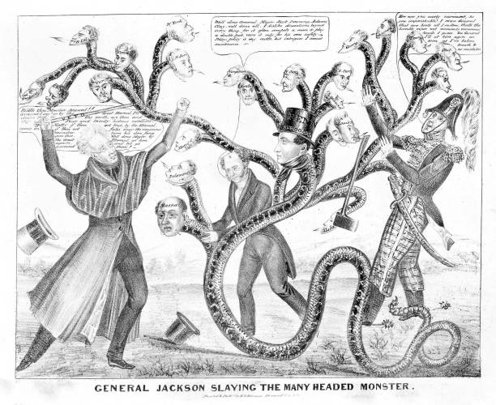
- What did Jackson believe about government officeholders?

A Trail of Tears: The Indian Removal Act
Do Now:
“The Indian Removal Act was signed into law by Andrew Jackson on May 28, 1830, authorizing the president to grant unsettled lands west of the Mississippi in exchange for Indian lands within existing state borders. A few tribes went peacefully, but many resisted the relocation policy. During the fall and winter of 1838 and 1839, the Cherokees were forcibly moved west by the United States government. Approximately 4,000 Cherokees died on this forced march, which became known as the ‘Trail of Tears.’

President Andrew Jackson outlined his Indian removal policy in his Second Annual Message to Congress on December 6, 1830. Jackson’s comments on Indian removal begin with the words, ‘It gives me pleasure to announce to Congress that the benevolent [well-meaning and kindly] policy of the Government, steadily pursued for nearly thirty years, in relation to the removal of the Indians beyond the white settlements is approaching to a happy consummation. Two important tribes have accepted the provision made for their removal at the last session of Congress, and it is believed that their example will induce the remaining tribes also to seek the same obvious advantages.’”

“In 1838 and 1839, as part of Andrew Jackson’s Indian removal policy, the Cherokee nation was forced to give up its lands east of the Mississippi River and to migrate to an area in present-day Oklahoma. The Cherokee people called this journey the ‘Trail of Tears,’ because of its devastating effects. The migrants faced hunger, disease, and exhaustion on the forced march. Over 4,000 out of 15,000 of the Cherokees died.” ~ pbs.org

Questions:
- What was stated in the Indian Removal Act?

- Discuss two different reactions to the policy among Native American Indians.

Quote about the “Trail of Tears”: “We are overwhelmed; our hearts are sickened; our utterance is paralyzed, when we reflect on the condition in which we are placed by the audacious practices of unprincipled men…” ~ Memorial from the Cherokee Nation
- What happened to the Cherokees as a result of the Indian Removal Act?

- How did President Andrew Jackson defend his “benevolent” policy?

Note: “On May 28, 1830, President Andrew Jackson signed the Indian Removal Act, formalizing his administration’s policy of sending to the West Indians living east of the Mississippi River on lands desired by whites. During the next decade, the U.S. government pursued removal of the southeastern tribes through treaties negotiated in an atmosphere of intimidation and coercion. The effort to force Cherokees from their lands in Georgia produced the Treaty of New Echota, signed by a small faction of the Cherokee Nation in 1835.” ~ oswego.edu

Note: “When the Cherokee nation was threatened by the state of Georgia and President Jackson’s 1830 Indian Removal Act, Chief John Ross embraced the American legal system, ultimately winning his case in the Supreme Court. Ross continued to fight removal even after Jackson ignored the Supreme Court decision and United States government officials accepted a fraudulent treaty signed by an unauthorized group of Cherokees. Faced with no other options, in 1838 he worked with the federal government to plan the forced relocation to Oklahoma. Ross witnessed the ‘Trail of Tears’ and suffered the loss of his wife during the tragic move. He would go on to lead the Cherokee nation until his death in 1866.” ~ pbs.org

- Should the U.S. government compensate descendants of the Cherokee people who journeyed on this ‘Trail of Tears’ for the terrible suffering their ancestors experienced? Defend your point of view.

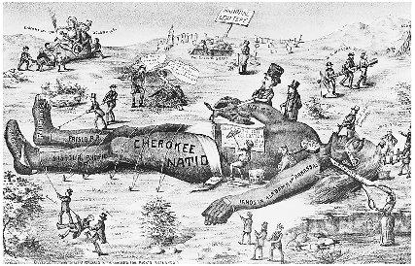The Primary Source: Cherokee letter protesting the Treaty of New Echota; Letter from Chief John Ross, “To the Senate and House of Representatives,” [Red Clay Council Ground, Cherokee Nation, September 28, 1836]
Quotes: Vine Deloria Jr. [Advocate of Native American Indian Rights] “The historical image of the Indians is pretty well set, we are the bad guys who burned the wagon trains and images are the white man’s game.”
- How does the treatment of the Cherokee violate the ideals of the U.S. Constitution?

“…By the stipulations of this instrument, we are despoiled of our private possessions, the indefeasible property of individuals. We are stripped of every attribute of freedom and eligibility for legal self-defence. Our property may be plundered before our eyes; violence may be committed on our persons; even our lives may be taken away, and there is none to regard our complaints. We are denationalized; we are disfranchised. We are deprived of membership in the human family! We have neither land nor home, nor resting place that can be called our own.

We are overwhelmed! Our hearts are sickened, our utterance is paralized, when we reflect on the condition in which we are placed, by the audacious practices of unprincipled men, who have managed their stratagems with so much dexterity as to impose on the Government of the United States, in the face of our earnest, solemn, and reiterated protestations.
The instrument in question is not the act of our Nation; we are not parties to its covenants; it has not received the sanction of our people. The makers of it sustain no office nor appointment in our Nation, under the designation of Chiefs, Head men, or any other title, by which they hold, or could acquire, authority to assume the reins of Government, and to make bargain and sale of our rights, our possessions, and our common country. And we are constrained solemnly to declare, that we cannot but contemplate the enforcement of the stipulations of this instrument on us, against our consent, as an act of injustice and oppression, which, we are well persuaded, can never knowingly be countenanced by the Government and people of the United States; nor can we believe it to be the design of these honorable and highminded individuals, who stand at the head of the Govt., to bind a whole Nation, by the acts of a few unauthorized individuals.

Tariff or Not to Tariff
- What is a tariff? _

- Why did the Southerners dislike the tariff of 1828?

- Sectionalism : What does this passage suggest about economic differences between the northern and western states and the southern states?

- Why was the doctrine of nullification a threat to the Union?
“On April 22, 1828, the Tariff of 1828 – better known as the Tariff of Abominations – passed the House of Representatives, 105 to 94. The tariff sought to protect New England manufacturing interests and western agricultural products from competition with foreign imports; however, the resulting tax on foreign goods severely devalued southern cotton exports. President John Quincy Adams approved the bill in a de facto endorsement of its sectional favoritism, essentially sealing his loss to Andrew Jackson in the 1828 presidential election. Vice President John C. Calhoun of South Carolina anonymously penned the South Carolina Exposition and Protest, articulating the doctrine of nullification. The doctrine emphasized a state’s right to reject federal laws within its borders and questioned the constitutionality of taxing imports without the explicit goal of raising revenue. Calhoun later took credit for the doctrine in 1832 to the detriment of his presidential ambitions. Following their statesman’s lead, the South Carolina legislature nullified the tariff in November 1832. While other southern states disagreed with the tariff, South Carolina was the only state to invoke nullification. Following a few tense months, South Carolina eventually accepted a compromise tariff in January 1833. The constitutional crisis was only temporarily averted, as tensions remained between northern and southern states.”
~ history.house.gov
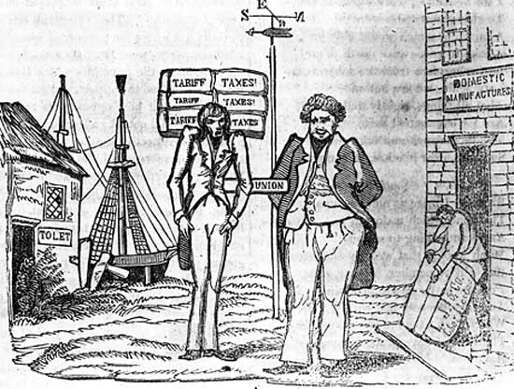 Cartoon drawn during the nullification controversy showing the manufacturing North getting fat at Southern expense; Library of Congress
25. Explain how the manufacturing North was getting fat at the expense of the South:

26. What points does President Andrew Jackson make in his Proclamation that clearly reveal his views on the issue of nullification?

Excerpt from Andrew Jackson’s Nullification Proclamation (1832): ~ gilderlehrman.org
The laws of the United States must be executed. I have no discretionary power on the subject – my duty is emphatically pronounced in the Constitution. Those who told you that you might peaceably prevent their execution, deceived you – they could not have been deceived themselves. They know that a forcible opposition could alone prevent the execution of the laws, and they know that such opposition must be repelled. Their object is disunion, but be not deceived by names; disunion, by armed force, is TREASON. Are you really ready to incur its guilt?

If you are, on the head of the instigators of the act be the dreadful consequences – on their heads be the dishonor, but on yours may fall the punishment – on your unhappy State will inevitably fall all the evils of the conflict you force upon the government of your country….the consequence must be fearful for you, distressing to your fellow-citizens here, and to the friends of good government throughout the world. Its enemies have beheld our prosperity with a vexation they could not conceal – it was a standing refutation of their slavish doctrines, and they will point to our discord with the triumph of malignant joy.

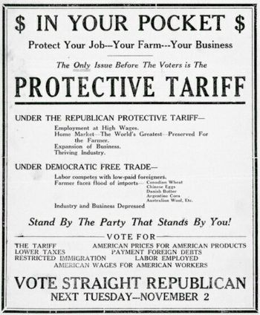It is yet in your power to disappoint them. There is yet time to show that the descendants of the Pinckneys, the Sumpters, the Rutledges, and of the thousand other names which adorn the pages of your Revolutionary history, will not abandon that Union to support which so many of them fought and bled and died. I adjure you, as you honor their memory – as you love the cause of freedom, to which they dedicated their lives – as you prize the peace of your country, the lives of its best citizens, and your own fair fame, to retrace your steps. Snatch from the archives of your State the disorganizing edict of its convention – bid its members to re-assemble and promulgate the decided expressions of your will to remain in the path which alone can conduct you to safety, prosperity, and honor…”

27. According to this poster, what are the benefits of the protective tariff?

28. According to this poster, what are the disadvantages of free trade or no protective tariffs?

Let’s Examine the Opposite of a Tariff! Let’s Examine NAFTA!
“On January 1, 1994, the North American Free Trade Agreement between the United States, Canada, and Mexico (NAFTA) entered into force. All remaining duties and quantitative restrictions were eliminated, as scheduled, on January 1, 2008. NAFTA created the world’s largest free trade area, which now links 450 million people producing $17 trillion worth of goods and services. Trade between the United States and its NAFTA partners has soared since the agreement entered into force.
- What is NAFTA?

- What are the benefits of NAFTA to the U.S. economy?

- What are the disadvantages of NAFTA for the U.S. economy? ______

U.S. goods and services trade with NAFTA totaled $1.6 trillion in 2009 (latest data available for goods and services trade combined). Exports totaled $397 billion. Imports totaled $438 billion. The U.S. goods and services trade deficit with NAFTA was $41 billion in 2009. The United States has $918 billion in total (two ways) goods trade with NAFTA countries (Canada and Mexico) during 2010. Goods exports totaled $412 billion; Goods imports totaled $506 billion. The U.S. goods trade deficit with NAFTA was $95 billion in 2010.

Trade in services with NAFTA (exports and imports) totaled $99 billion in 2009 (latest data available for services trade). Services exports were $63.8 billion. Services imports were $35.5 billion. The U.S. services trade surplus with NAFTA was $28.3 billion in 2009.”
~ ustr.gov

- Our true policy is to steer clear of permanent alliances . . . ." President Washington made this statement to warn against United States involvement in  - European military conflicts  - international trade  - the race for overseas colonies  - westward expansion  - President George Washington pursued a foreign policy of neutrality during his administration primarily because he believed that  - the United States needed time to gain economic and military strength  - treaties were prohibited by the Constitution  - the United States should not expand by force  - alliances should be established with both France and England  - The legal basis for the United States purchase of the Louisiana Territory was the  - power granted to the President to make treaties  - President’s power as Commander in Chief  - authority of Congress to declare war  - Senate’s duty to approve the appointment of ambassadors  - One reason James Madison and Thomas Jefferson objected to Alexander Hamilton’s financial policies was that they believed  - the establishment of a national bank was unconstitutional  - a laissez-faire policy would not help the country’s economy  - the government should encourage industrial development  - high tariffs were needed to protect America’s economic interests |  | - When President Thomas Jefferson acquired the Louisiana Territory from France, he demonstrated that he had modified his belief that  - the Constitution should be strictly interpreted  - the federal government should limit individual rights  - adding territory would lead to regional rivalries  - commercial development was the main goal of the federal government  - Which geographic advantage did the United States gain by purchasing the Louisiana Territory from France in 1803?  - warm-water ports on the Atlantic coast  - rich fishing areas in the Great Lakes  - full control of the Mississippi River  - vast coal reserves in the region west of Pennsylvania  - The Louisiana Purchase initially presented a dilemma for President Thomas Jefferson because he believed it would  - lead to war with Great Britain  - bankrupt the new nation  - force Native American Indians off their lands  - violate his strict constructionist view of the Constitution  - During the presidency of Andrew Jackson, the spoils system resulted in  - federal laws being nullified by the states  - elected officials rewarding their supporters with government jobs  - all free males being given the right to vote  - the end of political corruption in the federal government
- The Indian Removal Act of 1830:  - Called for the relocation of all eastern tribes across the Mississippi River.  - Led to a mass movement of Native Americans that was called the Trail of Tears.  - Led to the movement of the Creek, Choctaw, Chickasaw, Cherokee, and Seminole.  - All of the above  - The Indian Removal Act was passed because the Indians were  - occupying lands wanted by white settlers  - a menace to white settlers  - occupying public lands  - opposed to nullification  - In 1830 Congress passed the Indian Removal Act in which Andrew Jackson _____.  - Was against individual ownership of land.  - Expressed sincere concern for Native Americans’ well-being and for the preservation of their arts.  - Called the Native Americans savages, without using the buffering adjective “noble.”  - Did not feel that Native Americans could be civilized.  - In the early 1800s, which factor was most important in the development of Northern manufacturing centers?  - abundance of water power  - availability of slave labor in the North  - development of gold mines  - access to passes through the Appalachian Mountains  - Climatic conditions in the southern colonies most directly influenced the development of  - democratic institutions  - a canal system  - the plantation system  - the coal industry |  |  | - President Andrew Jackson used the spoils system to  - veto bills he disliked  - enforce Supreme Court decisions  - move Native American Indians off their traditional lands  - provide jobs to political party supporters  - A major criticism of the electoral college is that it  - limits the influence of the two-party political system  - allows a president to be elected without a majority of the popular vote  - forces each political candidate to campaign in every state  - makes the federal election process too expensive  - Most tariffs in the 19th century were intended to  - Allow access to cheap foreign imports  - raise revenue and protect domestic manufacturing  - redistribute wealth among the social classes  - limit American exports  - President Andrew Jackson’s policy toward Native American Indians was created to  - encourage Native American Indians to become part of mainstream American society  - force Native American Indians to move west of the Mississippi River  - improve educational opportunities for Native American Indians  - grant citizenship to Native American Indians  - Before the start of the Civil War, many Southern political leaders supported  - States rights  - higher tariff rates  - voting rights for women  - repeal of the Fugitive Slave Act
 | - The Cherokees were supported in their unsuccessful battle against removal by  - President Jackson.  - The Supreme Court.  - Congress.  - The state of Georgia.  - The state of North Carolina.  - When the Indian removal was completed,  - Every Indian west of the Mississippi River was gone.  - Every Indian tribe east of the Mississippi was gone.  - The Indians were relocated in reservations much like the tribal lands they left.  - The Indians were far enough removed from whites where they would not face further encroachments.  - Only elements of the Seminoles and Cherokees remained.  - What was a main reason large plantations developed in the South during the colonial period?  - British laws discouraged tenant farming.  - Cotton could only be grown in wetlands.  - Southern mountains led to the development of isolated, self-sufficient farms.  - The coastal plain in the South contained large areas of fertile soil.  - The climate and topography of the southeastern United States had a major impact on the history of the United States before 1860 because the region  - became the center of commerce and manufacturing  - developed as the largest domestic source of steel production  - was the area in which most immigrants chose to settle  - provided agricultural products that were processed in the North and in Europe |  |  | - The difference between Jackson's Indian policy and those of previous presidents was that Jackson  - Wanted to relocate the Indians to the lands west of the Mississippi.  - Demanded a much speedier and thorough removal of all eastern tribes to reservations located west of the Mississippi.  - Was the first president to endorse the outright slaughter of several obstinate tribes.  - Was the first president to support the Cherokees’ assertion of self-government.  - Was the first president to oppose the rights of separate states to assert their jurisdiction over the tribes living within their borders.  - During the early 1800s, which factor contributed the most to the start of the Industrial Revolution in the United States?  - a restriction on European immigration  - the end of the slave labor system  - an abundance of natural resources  - the availability of electricity  - The principal reason Congress raised tariff rates in the late 1800s and early 1900s was to  - increase personal income taxes  - lower prices for American consumers  - guarantee high wages to American workers  - protect United States businesses from foreign competition

Pick 2 Question and provide 5-8 sentences with 5 facts in paragraph format to answer each question. 2 paragraphs total.

Section 5 : Pages 255–259 : What major political issues emerged during the 1830’s?

Section 4 : Pages 249-254: What changes did Andrew Jackson represent in American Political Life?

Section 3 : Pages 242- 247: How did domestic and foreign policies reflect the nationalism of the times?

Section 2 : Pages 232 -238: How did the North and South differ during the first half of the 1800’s?

Section 1 : Pages 228-232: How did transportation developments and industrialization affect the nation’s economy.

____________________________________________________________________________________________________________________________________________________________________________________________________________________________________________________________________________________________________________________________________________________________________________________________________________________________________________________________________________________________________________________________________________________________________________________________________________________________________________________________________________________________________________________________________________________________________________________________________________________________________________________________________________________________________________________________________________________________________________________________________________________________________________________________________________________________________________________________________________________________________________________________________________________________________________________________________________________________________________________________________________________________________________________________________________________________________________________________________________________________________________________________________________________________________________________________________________________________________________________________________________________________________________________________________________________________________________________________________________________________________________________________________________________________________________________________________________________________________________________________________________________________________________________________________________________________________________________________________________________________________________________________________________________________________________________________________________________________________________________________________________________________________________________________________________________________________________________________________________________________________________________________________________________________________________________________________________________________________________________________________________________________________________________________

