11th

|  |  |
| --- | --- |
| **Missouri Compromise** | **Kansas and Nebraska Act** |
| * To preserve the balance of power in Congress between slave and free states, the Missouri Compromise was passed in 1820 admitting Missouri as a slave state and Maine as a free state. * Furthermore, with the exception of Missouri, this law prohibited slavery in the Louisiana Territory north of the 36° 30´ latitude line. * In 1854, the Missouri Compromise was repealed by the Kansas-Nebraska Act. * Three years later the Missouri Compromise was declared unconstitutional by the Supreme Court in the Dred Scott decision, which ruled that Congress did not have the authority to prohibit slavery in the territories. | * The Kansas-Nebraska Act repealed the Missouri Compromise, allowing slavery in the territory north of the 36° 30´ latitude. * Introduced by Senator Stephen Douglas of Illinois, the Kansas-Nebraska Act stipulated that the issue of slavery would be decided by the residents of each territory, a concept known as popular sovereignty. * After the bill passed on May 30, 1854, violence erupted in Kansas between pro-slavery and anti-slavery settlers, a prelude to the Civil War. |

**`Textbook Page 324-325**

1. **How did Northerners and Southerners view slavery?**
   1. **Because northerners did not rely on slavery many did not have strong opinions about it,**
   2. **Some however believed that it was morally wrong,**
   3. **Many southerners viewed slavery as an integral part of their economy and did not want to end it**
2. **Why was the Wilmot Proviso denounced by the South and supported by the North?**
   1. **The Proviso was legislation designed to ban slavery in any territory acquired from Mexico. The South Wanted Slavery to exist in new territories, but the North did not.**
   2. **The addition of territories aroused the question whether slavery should be extended into new territories**
3. **How did California Statehood spark a crisis over slavery?**
   1. **If California were admitted as a free state, the country would have more free states than slave states, the south feared that this shift in power would lead to a universal ban on slavery**

**Missouri Compromise vs. Kansas Nebraska Act**

1. **Why did opponents of slavery view the Kansas Nebraska Act as a threat?**
   1. **According to the Missouri compromise the land should have been closed to slavery the Kansa Nebraska act allowed slavery to spread to these territories if the residents voted for it. This allowed the revival of the idea of allowing territories to choose rather than it been mandated.**

‘How is it that we hear the loudest yelps for liberty among the drivers of Negroes?’ This question of English author Samuel Johnson strikes at the core of the slavery controversy in the American quest for self-government. Americans affirmed their independence with the ringing declaration that “all men are created equal.” But some of them owned African slaves and were unwilling to give them up as they formed new federal and state governments. So ‘to form a more perfect union’ in 1787, certain compromises were made in the Constitution regarding slavery in hopes that they would eventually be able to wean themselves off the ‘peculiar institution.’ This settled the slavery controversy for the first few decades of the American republic.

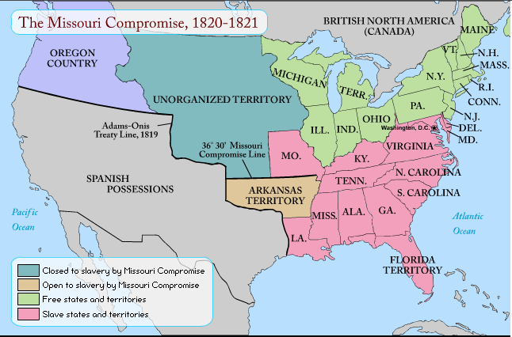

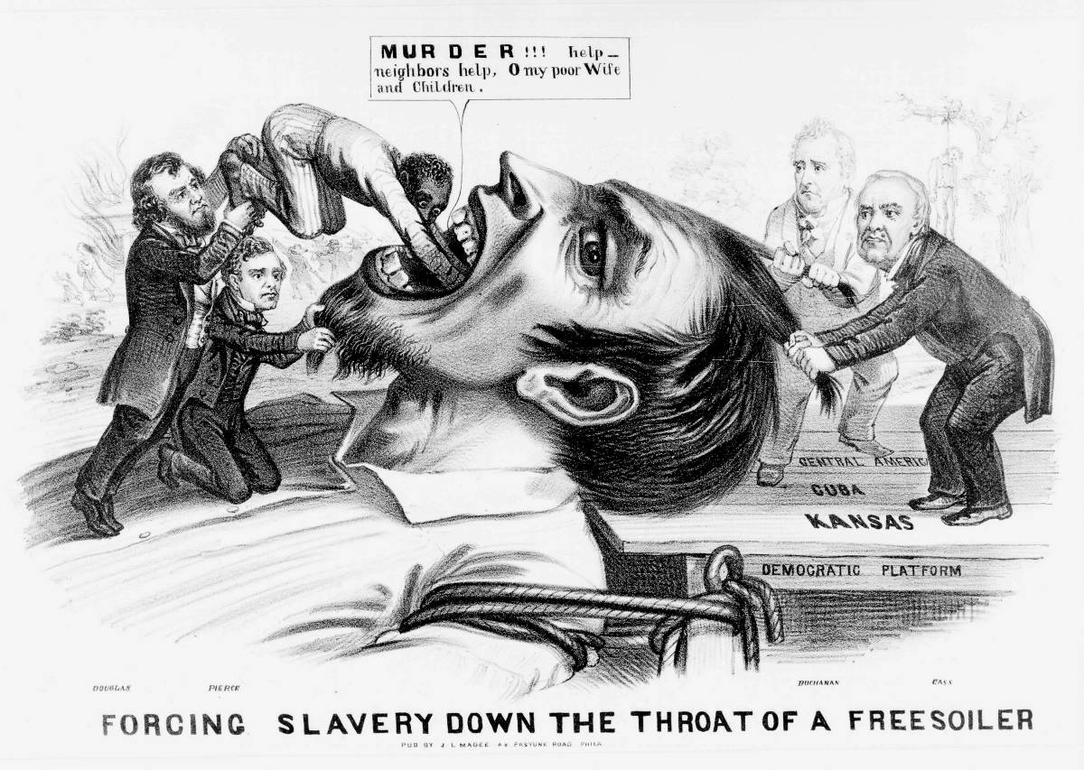 This situation changed with the application of Missouri for statehood in 1819. It changed the political landscape so dramatically that when former president Thomas Jefferson heard about the enactment of the Missouri Compromise of 1820, he wrote, ‘This momentous question, like a fire bell in the night, awakened and filled me with terror. I considered it at once as the knell of the Union.’

Textbook Pages 331-332

1. **How did northerners respond to the Fugitive Slaves Act?** 
   1. **Northerners responded by passing personal liberty laws and helping escaped slaves remain free.**

**Textbook Pages 335-337**

1. **How did the creation of two governments in the Kansas Territory lead to violence?**
   1. **Each government wanted to succeed. Both antislavery and proslavery settlers were willing to go to great lengths to make sure that the territory adopted their beliefs towards slavery. Tensions mounted, and the resulted violence known as bleeding Kansas**

**Nat Turner:**

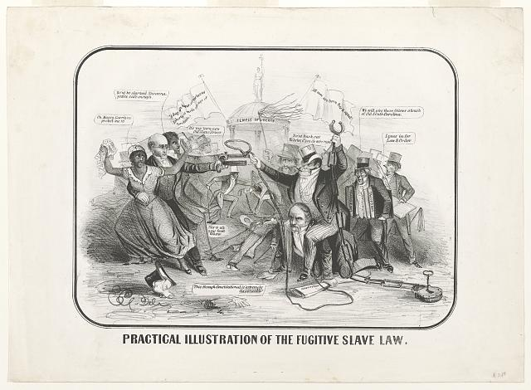

1. Nat Turner’s Rebellion, the most effective slave revolt, erupted in Southampton County, Virginia, on the night of August 21, 1831.
2. Nat Turner and his followers killed nearly sixty white people as they moved toward an armory at Jerusalem, Virginia.
3. Halted mere miles from their goal, the approximately seventy-five insurgents were soon killed or captured by the militia.
4. Turner’s November execution failed to assuage fears of continued insurrection.
   1. Across the South, renewed legislative efforts to forbid education and greatly restrict movement and assembly further constrained the lives of enslaved people.
5. **What outcome would Nat Turners Rebellion have on the Fugitive Slave laws?** 
   1. It would have increased their severity and the amount they were used

*The cartoon entitled “Practical illustration of the Fugitive Slave Law” shows abolitionist William Lloyd Garrison (left) holding a slave woman in one arm and pointing a pistol toward a burly slave catcher mounted on the back of Daniel Webster.  
  
 The print might have been produced in Boston, a center of bitter opposition to the Fugitive Slave Act in 1850 and 1851.*

**Frederick Douglass:**

1. Frederick Douglass was born into slavery in Maryland.
2. He learned to read and write as a boy [The slave master’s wife had taught him the alphabet but then the slave master forbade her to teach Frederick to read and write].
3. Frederick gave away his food to neighborhood boys to teach him to read.
4. At the age of twenty, Douglass succeeded in escaping from slavery by impersonating a sailor.
5. Douglass became a lecturer for the Massachusetts Anti-Slavery Society and a colleague of William Lloyd Garrison.
6. He published his own newspaper, The North Star, participated in the first women’s rights convention at Seneca Falls, in 1848, and wrote three autobiographies.
7. He became a trusted advisor to Abraham Lincoln.
8. **What did Frederick Douglass learn as a child that changed his life? __**
   1. **He was given the opportunity to learn how to read and write even as a slave which was illegal.**
9. **How did Frederick Douglass escape from slavery?**
   1. **He impersonated a sailor and worked as a lecturer for the Anti-Slavery Society.**

**Primary Source:**

|  |  |  |  |
| --- | --- | --- | --- |
| **Frederick Douglass Describes a Whipping**   |  | | --- | | **Primary source: Frederick Douglass, *Narrative of the Life of Frederick Douglass, An American Slave, Written by Himself*, autobiography, 1845.  Caption: Radical abolitionists sought to document their claims about the horrors of slavery.** | |  |  |

[. . . ] Aunt Hester went out one night,—where or for what I do not know,—and happened to be absent when my master desired her presence. He had ordered her not to go out evenings, and warned her that she must never let him catch her in company with a young man, who was paying attention to her belonging to Colonel Lloyd. The young man's name was Ned Roberts, generally called Lloyd's Ned. Why master was so careful of her, may be safely left to conjecture. She was a woman of noble form, and of graceful proportions, having very few equals, and fewer superiors, in personal appearance, among the colored or white women of our neighborhood.   
  
Aunt Hester had not only disobeyed his orders in going out, but had been found in company with Lloyd's Ned; which circumstance, I found, from what he said while whipping her, was the chief offence. Had he been a man of pure morals himself, he might have been thought interested in protecting the innocence of my aunt; but those who knew him will not suspect him of any such virtue. Before he commenced whipping Aunt Hester, he took her into the kitchen, and stripped her from neck to waist, leaving her neck, shoulders, and back, entirely naked. He then told her to cross her hands, calling her at the same time a d——d b—-h. After crossing her hands, he tied them with a strong rope, and led her to a stool under a large hook in the joist, put in for the purpose. He made her get upon the stool, and tied her hands to the hook. She now stood fair for his infernal purpose. Her arms were stretched up at their full length, so that she stood upon the ends of her toes. He then said to her, “Now, you d——d b—-h, I'll learn you how to disobey my orders!” and after rolling up his sleeves, he commenced to lay on the heavy cow skin, and soon the warm, red blood (amid heart-rending shrieks from her, and horrid oaths from him) came dripping to the floor. I was so terrified and horror-stricken at the sight, that I hid myself in a closet, and dared not venture out till long after the bloody transaction was over. I expected it would be my turn next. It was all new to me. I had never seen anything like it before. I had always lived with my grandmother on the outskirts of the plantation, where she was put to raise the children of the younger women. I had therefore been, until now, out of the way of the bloody scenes that often occurred on the plantation. [. . . ]

1. **What impact would an account like this have on Northerners? What might it produce as a result?** 
   1. **This would lead to a greater dislike of slavery by Northerners and could lead to more individuals become abolitionists.**

**The cartoon entitled “Practical illustration of the Fugitive Slave Law” shows abolitionist William Lloyd Garrison (left) holding a slave woman in one arm and pointing a pistol toward a burly slave catcher mounted on the back of Daniel Webster.  
  
 The print might have been produced in Boston, a center of bitter opposition to the Fugitive Slave Act in 1850 and 1851.**

**Sojourner Truth:**

1. **Sojourner Truth was enslaved for approximately twenty-eight years of her life.**
2. **After her conversion to Christianity, she took the name Sojourner Truth: “Sojourner because I was to travel up and down the land showing people their sins and being a sign to them, and Truth because I was to declare the truth unto the people.”**

**As a women’s rights activist, Truth faced additional burdens that white women did not have, plus the challenge of combating a suffrage movement which did not want to be linked to anti-slavery causes, believing it might hurt their cause.**

1. **Why did Sojourner Truth take this name?** 
   1. **After her conversion to Christianity, she took the name Sojourner Truth: “Sojourner because I was to travel up and down the land showing people their sins and being a sign to them, and Truth because I was to declare the truth unto the people**
2. **Why did Sojourner Truth face additional burdens as a women’s rights activist?** 
   1. **They were not only combatting racism but also suffrage during this time**
3. **Why was William Lloyd Garrison considered a radical in the abolitionist movement?**

**William Lloyd Garrison:**

1. **William Lloyd Garrison was considered a radical in the abolitionist movement.**
2. **Publisher of the anti-slavery newspaper, *The Liberator*, and co-founder of the American Anti-Slavery Society, Garrison called for the immediate end to slavery, believing in the equality of the races and in the ability of free African Americans to successfully assimilate into white society.**
3. **This philosophy put him at odds with abolitionists who doubted the notion of racial equality and who sought to gradually end slavery.**

**Although he called for a peaceful approach to abolishing slavery, Garrison’s criticism of the Constitution as a pro-slavery document and his inclusion of women in the abolitionist movement prompted some members of the American Anti-Slavery Society to leave in 1839 and form the American and Foreign Anti-Slavery Society.**

* 1. **He wanted an immediate end to slavery not a gradual change.**

1. **Why did some individuals leave William Lloyd Garrison’s abolitionist movement?**

There had always been differences between northern and southern states, the former more commercial and the latter more agrarian in outlook and livelihood. But no difference was so potentially divisive as the South’s insistence on the right to hold slaves and the North’s growing aversion to it. The newly acquired territory to the West, resulting from the Louisiana Purchase in 1803, brought the issue of the extension of slavery to a slow boil in 1819. Both sides, North and South, were concerned about the balance of power in the Senate being disrupted by the admission of new states carved out of the Louisiana Territory. The legislative and rhetorical interventions of Kentucky Representative Henry Clay, a slaveowner who worked for gradual emancipation and colonization, were crucial to averting a sectional division of the American union.

1. **What issue faced the framers of the U.S. Constitution when they wrote “all men are created equal”?**
2. **What other issue divided the northern and southern states?**
3. **Why did northern and southern states view tariffs differently?**
4. **Explain the nullification crisis.**

When Maine requested admission as a free state in 1820, Congress agreed to a compromise where Missouri was permitted to come into the union with a constitution of its own choosing, which meant no restriction regarding slavery. In addition to Maine’s admission in 1820 as a free state and Missouri’s eventual admission as a slave state (in 1821), Illinois Senator Jesse B. Thomas suggested that in the balance of the Louisiana Territory north of the 36º30’ parallel (which ran along Missouri’s southern border) slavery would be prohibited forever. The Missouri Compromise thereby maintained an equal number of free and slaveholding states in the American union. But it proved only a temporary settlement of the slavery controversy. Another territorial dispute, involving Texas and Mexico, would later stoke the fires of sectional conflict over the spread of slavery into the western territories.

But slavery in the territories was not the only issue dividing North and South. The question of tariffs (or taxes) on foreign imports proved so volatile that one state tried to nullify an act of Congress and threatened to secede from the Union. South Carolina saw tariffs imposed by the national government on foreign imports not for general revenue purposes, but to help domestic, manufacturing industries located mainly in the North. With depressed cotton prices and reduced foreign demand for raw goods from the South, the 1828 and 1832 tariffs eventually provoked South Carolina to desperate measures.

Flags were flown at half-mast in Charleston, South Carolina, and throughout the South there was talk of boycotting northern goods. By 1832, when Congress passed a new tariff bill that did not lower tariff rates enough to please the southern states, talk turned openly to nullification. South Carolina went so far as to call a state convention that declared the Tariff Acts of 1828 and 1832 ‘null, void, and no law, nor binding upon’ the state.

Whereupon President Andrew Jackson rebuked South Carolina and threatened to invade the state. When Congress passed his 1833 ‘Force Bill,’ which empowered the military to collect the tariffs, the now Senator Henry Clay fashioned yet another compromise that revised the tariff to South Carolina’s satisfaction. This kept the tariff on the books and South Carolina in the Union. ~ edsitement.neh

**19. Why did the supreme court deny Scott his freedom?**

**The Dred Scott Case:**

“One of the most important cases ever tried in the United States was heard in St. Louis’ Old Courthouse. The Supreme Court decided the case in 1857, and hastened the start of the Civil War.

When the first case began in 1847, Dred Scott was about 50 years old. He had spent his entire life as a slave and was illiterate. Dred Scott moved to St. Louis with the Blows in 1830, but was soon sold due to his master’s financial problems. He was purchased by Dr. John Emerson; a military surgeon stationed at Jefferson Barracks, and accompanied him to posts in Illinois and the Wisconsin Territory, where slavery had been prohibited by the Missouri Compromise of 1820. During this period, Dred Scott married Harriet Robinson, also a slave, at Fort Snelling; they later had two children, Eliza and Lizzie. John Emerson married Irene Sanford during a brief stay in Louisiana. In 1842, the Scott’s returned with Dr. and Mrs. Emerson to St. Louis. John Emerson died the following year, and it is believed that Mrs. Emerson hired out Dred Scott, Harriet, and their children to work for other families.

On April 6th, 1846, Dred Scott and his wife Harriet filed suit against Irene Emerson for their freedom. For almost nine years, Scott had lived in free territories, yet made no attempt to end his servitude. It is not known for sure why he chose this particular time for the suit. It is known that the suit was not brought for political reasons. It is thought that friends in St. Louis who opposed slavery had encouraged Scott to sue for his freedom on the grounds that he had once lived in a free territory. In the past, Missouri courts supported the doctrine of ‘once free, always free.’

Dred Scott could not read or write and had no money. He needed help with his suit. John Anderson, the Scott’s minister, may have been influential in their decision to sue, and the Blow family, Dred’s original owners, backed him financially. The support of such friends helped the Scotts through nearly eleven years of complex and often disappointing litigation.

It is difficult to understand today, but under the law in 1846 whether or not the Scotts were entitled to their freedom was not as important as the consideration of property rights. If slaves were indeed valuable property, like a car or an expensive home today, could they be taken away from their owners because of where the owner had taken them? In other words, if you drove your car from Missouri to Illinois, and the State of Illinois said that it was illegal to own a car in Illinois; could the authorities take the car away from you when you returned to Missouri?

* 1. **It ruled that slaves were property therefor they did not have the same rights as citizens**

**Textbook Page 342**

* + 1. **How were African Americans affected by the Court’s decision?**
  1. **The court ruling that African Americans were not citizens resulted in the loss of their legal right to sue in court.**
  2. **They also lost the protection of the us government that they would have received as citizens**
  3. **It also guaranteed that congress could not ban slavery from any territory because it would go against due process of law.**

In an atmosphere of increasing distrust between North and South, the Dred Scott case is considered by the U.S. Supreme Court. On March 6, 1857, Chief Justice Roger B. Taney reads the official opinion of the court. Taney feels that Dred Scott’s suit for freedom should be dismissed for the following reasons: At the time of the adoption of the Constitution, African-Americans were not considered to be citizens, thus Dred Scott had no right to sue in court. Residence in Wisconsin Territory had no effect on Dred Scott’s status because the Missouri Compromise was invalid. Congress had no power to pass laws that limited slavery, because the right of property in a slave was guaranteed by the Constitution.” ~ nps.gov

**Reading:**

“John Brown was a man of action – a man who would not be deterred from his mission of abolishing slavery. On October 16, 1859, he led 21 men on a raid of the federal arsenal at Harpers Ferry, Virginia. His plan to arm slaves with the weapons he and his men seized from the arsenal was thwarted, however, by local farmers, militiamen, and Marines led by Robert E. Lee.   
  
During his first fifty years, Brown moved about the country, taking along his ever-growing family. (He would father twenty children.) Working at various times as a farmer, wool merchant, tanner, and land speculator, he never was financially successful. His lack of funds, however, did not keep him from supporting causes he believed in. He helped finance the publication of David Walker’s Appeal and Henry Highland’s ‘Call to Rebellion’ speech. He gave land to fugitive slaves. He and his wife agreed to raise a black youth as one of their own. He also participated in the Underground Railroad and, in 1851, helped establish the League of Gileadites, an organization that worked to protect escaped slaves.  
  
 In 1847 Frederick Douglass met Brown for the first time in Springfield, Massachusetts. Of the meeting Douglass stated that, ‘though a white gentleman, [Brown] is in sympathy a black man, and as deeply interested in our cause, as though his own soul had been pierced with the iron of slavery.’ It was at this meeting that Brown first outlined his plan to Douglass to lead a war to free slaves.  
  
 Despite his contributions to the antislavery cause, Brown did not emerge as a figure of major significance until 1855 after he followed five of his sons to the Kansas territory. There, he became the leader of antislavery guerillas and fought a proslavery attack against the antislavery town of Lawrence. The following year, in retribution for another attack, Brown went to a proslavery town and brutally killed five of its settlers. Brown and his sons would continue to fight in the territory and in Missouri for the rest of the year.  
  
 Brown returned to the east and began to think more seriously about his plan for a war in Virginia against slavery. He sought money to fund an ‘army’ he would lead. On October 16, 1859, he set his plan to action when he and 21 other men – 5 blacks and 16 whites –raided the federal arsenal at Harpers Ferry.  
  
 Brown was wounded and quickly captured, and moved to Charlestown, Virginia, where he was tried and convicted of treason. Before hearing his sentence, Brown was allowed make an address to the court.

1. **What happened at Harper’s Ferry? Why?**
   1. **John brown raided the arsenal as a way to provide slaves with weapons so that they could revolt against their masters.**
   2. **John brown was an abolitionist**
2. **How did John Brown’s actions affect people’s views about slavery and about his life and mission?** 
   1. many Northerners began to speak favorably of the militant abolitionist

… I believe to have interfered as I have done . . . in behalf of His despised poor, was not wrong, but right. Now, if it be deemed necessary that I should forfeit my life for the furtherance of the ends of justice and mingle my blood further with the blood of my children, and with the blood of millions in this slave country whose rights are disregarded by wicked, cruel, and unjust enactments, I submit: so, let it be done.’

Although initially shocked by Brown’s exploits, many Northerners began to speak favorably of the militant abolitionist. ‘He did not recognize unjust human laws, but resisted them as he was bid…,’ said Henry David Thoreau in an address to the citizens of Concord, Massachusetts. ‘No man in America has ever stood up so persistently and effectively for the dignity of human nature. . . .’ John Brown was hanged on December 2, 1859.” **~ pbs.org**

1. **Explain the meaning of one of the political cartoon.**

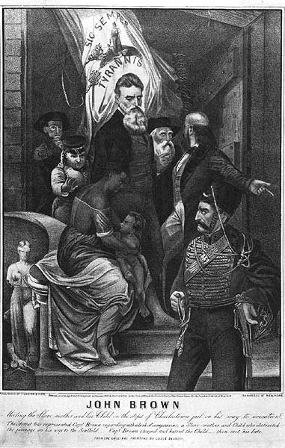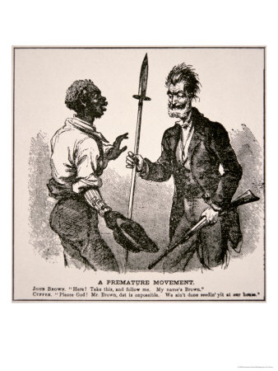

“This print, published by the New York lithography firm of Currier and Ives in 1863, was based on a painting by Louis Ransom depicting John Brown pausing on the steps of the Charlestown, Virginia, jail, surrounded by armed soldiers, and leaning down to kiss the small child proffered to him by an African-American woman. The legend of Brown kissing a slave child on the way to his execution originated with an account of the execution in the New York Tribune on December 6, 1859. This account was reprinted in other newspapers and in early Brown biographies. In fact, Brown encountered only soldiers and jail personnel on the way to his execution. Fearing that the painting would draw angry crowds during the July 1863 New York City draft riots; Barnum removed Ransom’s painting from the American Museum.” ~ chnm.gmu.edu

**Primary Source: John Brown's Speech to the Court at his Trial**

**November 2, 1859 ~ law2.umkc.edu**

**I have, may it please the court, a few words to say. In the first place, I deny everything** but what I have all along admitted – the design on my part to free the slaves. I intended certainly to have made a clean thing of that matter, as I did last winter when I went into Missouri and there took slaves without the snapping of a gun on either side, moved them through the country, and finally left them in Canada. I designed to have done the same thing again on a larger scale. That was all I intended. I never did intend murder, or treason, or the destruction of property, or to excite or incite slaves to rebellion, or to make insurrection.   
  
 I have another objection; and that is, it is unjust that I should suffer such a penalty. Had I interfered in the manner which I admit, and which I admit has been fairly proved (for I admire the truthfulness and candor of the greater portion of the witnesses who have testified in this case) – had I so interfered in behalf of the rich, the powerful, the intelligent, the so-called great, or in behalf of any of their friends – either father, mother, brother, sister, wife, or children, or any of that class – and suffered and sacrificed what I have in this interference, it would have been all right; and every man in this court would have deemed it an act worthy of reward rather than punishment.

This court acknowledges, as I suppose, the validity of the law of God. I see a book kissed here which I suppose to be the Bible, or at least the New Testament. That teaches me that all things whatsoever I would that men should do to me, I should do even so to them. It teaches me, further, to “remember them that are in bonds, as bound with them.” I endeavored to act up to that instruction. I say I am yet too young to understand that God is any respecter of persons. I believe that to have interfered as I have done – as I have always freely admitted I have done – in behalf of His despised poor was not wrong, but right. Now, if it is deemed necessary that I should forfeit my life for the furtherance of the ends of justice, and mingle my blood further with the blood of my children and with the blood of millions in this slave country whose rights are disregarded by wicked, cruel, and unjust enactments – I submit; so let it be done!

Let me say one word further.   
  
 I feel entirely satisfied with the treatment I have received on my trial. Considering all the circumstances it has been more generous than I expected. But I feel no consciousness of guilt. I have stated that from the first what was my intention and what was not. I never had any design against the life of any person, nor any disposition to commit treason, or excite slaves to rebel, or make any general insurrection. I never encouraged any man to do so, but always discouraged any idea of that kind.   
  
 Let me say also a word in regard to the statements made by some of those connected with me. I hear it has been stated by some of them that I have induced them to join me. But the contrary is true. I do not say this to injure them, but as regretting their weakness. There is not one of them but joined me of his own accord, and the greater part of them at their own expense. A number of them I never saw, and never had a word of conversation with till the day they came to me; and that was for the purpose I have stated.

**Choose two Focus Questions from Chapter 10 to write a 5-8 sentence paragraph with 5 facts. (2 paragraphs)**

* **Section 10.1 – Pages 324-329** 
  + **- How did congress try to resolve the dispute between North and South over Slavery?**
* **Section 10.2 - Pages 331-337** 
  + **- How did the Fugitive Slave Act and the Kansas- Nebraska Act increase tensions between the North and the South?**
* **Section 10.3 – Pages 339 -345**
  + **- What political developments widened the void between the North and the South?**

|  |  |  |  |
| --- | --- | --- | --- |
| 1. **Which group benefited most directly from the Supreme Court decision in *Dred Scott* v. *Sanford* (1857)?**    * + 1. abolitionists C. slave owners        2. immigrants D. enslaved persons 2. **The principle of popular sovereignty was an important part of the**    * + 1. Indian Removal Act        2. Homestead Act        3. Kansas-Nebraska Act        4. Dawes Act 3. **“Missouri Compromise Allows Two New States into the Union”**   **“Congress Agrees to Compromise of 1850”**  **“Popular Sovereignty Adopted Under Kansas-Nebraska Act”**  **Which issue is reflected in these headlines?**   * + - 1. status of slavery in the territories and states       2. growth of agriculture on the Great Plains       3. clash of federal and state powers       4. conflicts with foreign nations over the West  1. **“Uncle Tom’s Cabin Stirs Controversy”**   **“Kansas Rocked by Bloody Conflict”**  **“John Brown’s Raid Angers South”**  **Which statement about the United States in the 1850s is best supported by these headlines?**   * + - 1. The nation had grown increasingly divided over the future of slavery.       2. Americans had lost confidence in the plan for Reconstruction.       3. Northern and Southern voters were united in support of popular sovereignty.       4. Support for abolitionist movement decreased during period. | | **5. “Compromise Enables Maine and Missouri to Enter the Union”**  **“California Joins the Union as Part of Compromise of 1850”**  **“Kansas-Nebraska Act Establishes Popular**  **Sovereignty in the Territories”**  **Which issue is most closely associated with these headlines?**   * + - 1. status of slavery in new states       2. negotiation of the Oregon Treaty       3. expansion of land for reservations       4. influence of political parties on economic Development   **6. Most Southern political leaders praised the Supreme Court decision in *Dred Scott* v. *Sanford* (1857) because it**   * + - 1. granted citizenship to enslaved persons       2. upheld the principle of popular sovereignty       3. supported the right of a state to secede from the Union       4. protected the property rights of slave owners in the territories   **7. The Supreme Court ruling in *Dred Scott* v. *Sanford* (1857) helped to increase sectional conflict because the decision**   1. denied Congress the power to regulate 2. slavery in the territories allowed for the importation of enslaved 3. persons for ten years prohibited slavery in lands west of the 4. Mississippi River gave full citizenship to all slaves   **8. Which statement about the Missouri**  **Compromise (1820) is most accurate?**   * + - 1. Slavery was banned west of the Mississippi River.       2. Unorganized territories would be governed by the U.S. and Great Britain.       3. The balance between free and slave states was maintained.       4. The 36°30' line formed a new boundary between the United States and Canada. | |
| 1. **John Brown’s raid at Harpers Ferry:**   (A) Was endorsed by the Republican party.  (B) Precipitated a slave insurrection.  (C) Was ignored by Southerners because of its small size.  (D) Strengthened disunion sentiment in the South.   1. **When he raided Harpers Ferry, John Brown apparently hoped to** 2. Convince non-slaveholding southerners to oppose slavery. 3. Provoke a slave insurrection. 4. Discredit northern abolitionists. 5. Frighten the North and South into negotiating a compromise on slavery. 6. Help make Kansas a free state. 7. **The attack at Harper’s Ferry took place in the present state of**   (A) North Carolina  (B) Virginia  (C) West Virginia  (D) Ohio   1. **What was Abraham Lincoln's opinion of the John Brown's raid on Harpers Ferry?** 2. He considered John Brown a martyr. 3. He believed John Brown should be commended for his attempt at providing. 4. He provided slaves with the opportunity to rebel. 5. He denounced John Brown’s raid on Harpers Ferry and called it foolish. 6. He called him a Christian hero. | | **13. What was the purpose of John Brown's raid on Harper’s Ferry?**   * 1. to secure enough ammunition from a federal arsenal to carry out a large-scale operation against slavery in the South   2. to make the issue of "Bloody Kansas" more public   3. to make himself a martyr to the abolitionist cause   4. to begin a series of rumors of slave insurrection so that southern slaveholders might be frightened into agreeing to end slavery   **14. The abolitionist movement, the women’s suffrage movement, and the 1960’s civil rights movement are all examples of reform efforts that**  (A) succeeded without causing major controversy  (B) developed significant popular support  (C) achieved their goals without government action  (D) failed to affect the nation as a whole   1. **Sectional differences developed in the United States largely because** 2. the Federal Government adopted a policy of neutrality 3. economic conditions and interests in each region varied 4. only northerners were represented at the Constitutional Convention 5. early Presidents favored urban areas over rural areas | |