**Louisiana Purchase Review:**

1. **What was an effect of the Louisiana Purchase?**
   1. Opened land to the west for settlement
2. **Identify two factors that encouraged expansion into the west.** 
   1. Growing Population – Dependent on Agriculture required more land
   2. Economic depressions – people seek land a traditional symbol of wealth
3. **Who was excluded from the ideals of self-government?**
   1. Women
   2. African Americans
   3. Native Americans

“The Louisiana Purchase in 1803 opened a large amount of land in the west to settlement by European Americans. Several factors encouraged expansion into the west. The growing population, dependent on agriculture as the primary economic activity, required more land. Economic depressions in 1818 and 1839 motivated some settlers to seek their fortunes on the frontier. Indeed, the opportunity for advancement where land – the traditional symbol of wealth – was inexpensive or free drew many across the Mississippi. In the 1840s, the phrase ‘Manifest Destiny’ was coined to provide a sense of mission for expansion. Manifest Destiny suggested that it was the fate of the United States to expand from the Atlantic to the Pacific, spreading the ideals of self-government across the land. (Note that these ideals were not applied to all Americans; African Americans, Native Americans, women, and others were excluded.) The discovery of gold and silver in western areas drew even more settlers toward the Pacific.”

~ loc.gov

**Page 301 Text Book**

1. **What was Manifest Destiny? How did it encourage people to settle the region of New Mexico, Texas and California?**
   1. Idea that the United States had a God Given right to control most or all North America.
   2. It helped to motivate settlers to go west and justified it by pointing out the weakness of the Mexican Government and economy. Making them seem inferior

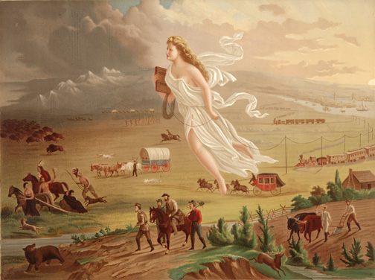

1. **How did the Mountain Men Contribute to Westward Expansion?** 
   1. They forged routes across the Great Plains, and Rocky Mountains that settlers would later follow
   2. Linked the United States with the Pacific Coast

Page 304 Text Book

1. **Why did Brigham Young lead the Mormons west to found New Zion? What is New Zion Today?** 
   1. People were hostile to them in Illinois and Young wanted to settle where Mormons could live in their own way Modern Day Utah

*TITLE American Progress ARTIST John Gast*

**Textbook Pages 305-306**

**Textbook Page 307- 308**

1. **Why was the annexation of territories so controversial?**
   1. Northerners and pacifists did not want Texas added as a slave state and did not want to fight a war with Mexico; Southerners and expansionists wanted the territory and additional slave states
2. Put the Following Events in chronological order on the time line below
3. Battle of the Alamo
4. Santa Anna Signs treaty recognizing Texan Independence
5. Stephen F. Austin leads the settlement of the lands east of San Antonio
6. Texans rebel against Mexican rule and form a new nation known as the Lone Stare Republic
7. Santa Anna seizes power in Mexico
8. **What was the outcome of the Mexican- American War?**

**The Annexation of Texas, 1845:**

“In the 1820s, Americans began settling in the Mexican province of Texas. These settlers declared their independence in 1835, when Mexico tried to prohibit further immigration from the United States. After being captured by Texan rebels, General Santa Anna of Mexico signed a treaty recognizing their independence. In 1845, Congress voted to annex Texas.

Shortly afterwards, a dispute broke out between the United States and Mexico over the southern border of Texas. U.S. President Polk sent troops into the contested area.

In the Mexican – American war, the United States had great advantages. It was larger, wealthier, and more populous than Mexico. The lack of industries and a larger army and navy with advanced artillery along with fewer well trained military generals, led to Mexico’s defeat.

Mexico was quickly defeated and forced to give up California, Nevada, Utah, Arizona, and parts of Colorado and New Mexico. In the Treaty of Guadalupe Hidalgo, the United States paid the Mexican Government $15 million for these areas.” ~ *The Key to Understanding U.S. History and Government*

* 1. The Americans with a larger and better trained army and navy achieved victory and conquered all of Texas, New Mexico and California

**Three More Acquisitions:**

* The Gadsden Purchase (1853) from Mexico
  + Added southern New Mexico and Arizona
* In an agreement with Great Britain in 1846, the line dividing Canada and the United States at the 49th parallel was extended westwards to the Pacific. This gave the United States part of the Oregon Territory.
* In 1867, the United States purchased Alaska from Russia for $7.2 million. At first Secretary of State William Seward’s purchase met with ridicule. But Alaska proved to be an important acquisition for its natural resources. In 1959, Alaska became the 49th state. ~ The Key to Understanding U.S. History and Government

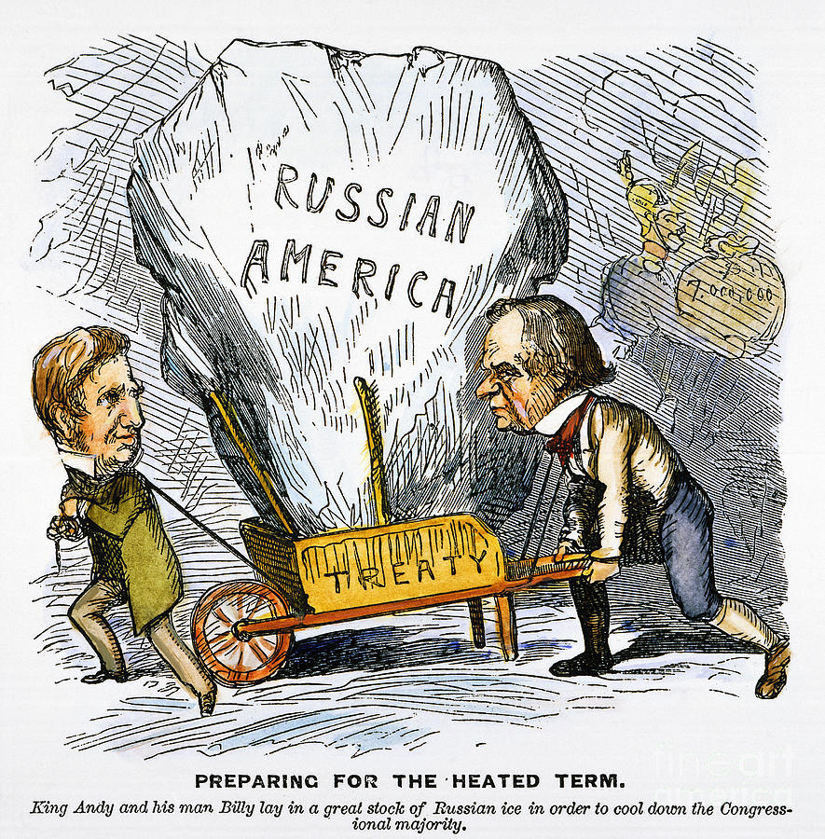

1. **Explain the meaning of the political cartoon:**

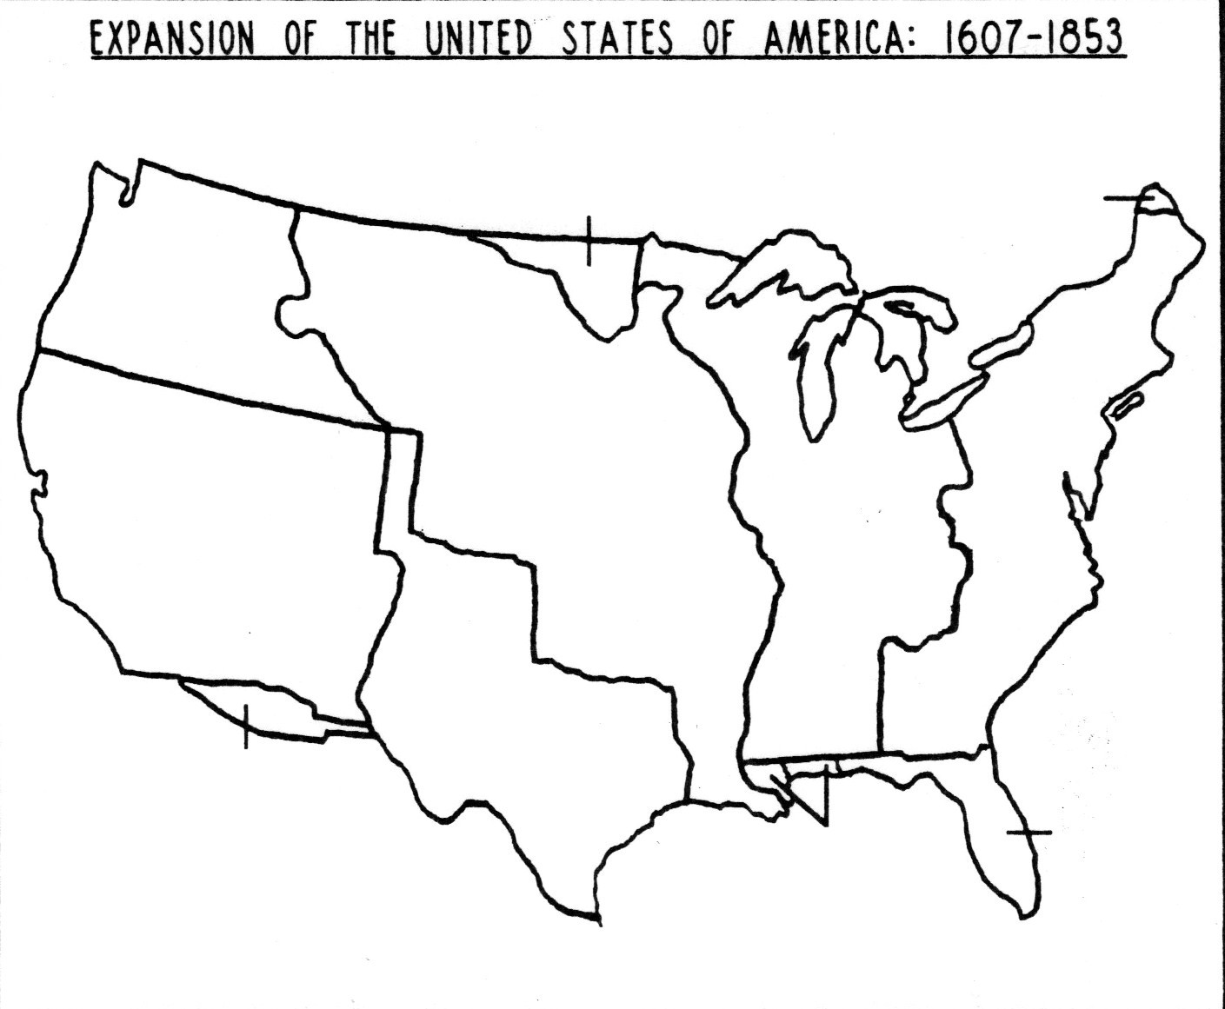

1. **Complete the Manifest Destiny map below using the following Word Bank and page 312 of the Textbook:**

**Oregon Territory (1846)**

**Texas Annexation (1845)**

**Gadsden Purchase (1853)**

**Mexican Cession (1848)**

**Louisiana Purchase (1803)**

**Florida Treaty (1819)**

**Treaty of Paris (1783)**

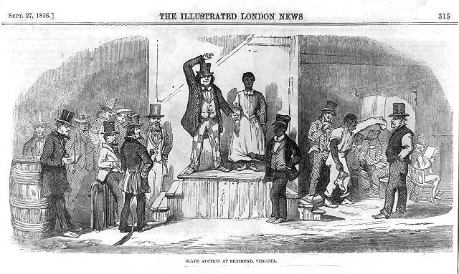

**Textbook Page 311-312**

1. **How did the Mexican American War serve to heighten tensions over slavery?**
   1. The war gave the United States new territories potential states which could upset the balance of North-South power in congress
   2. It made slavery a prominent issue splitting the two main political parties along the Norther South lines or proslavery anti-slavery lines
2. **Review - Who were abolitionists and what did they believe?**

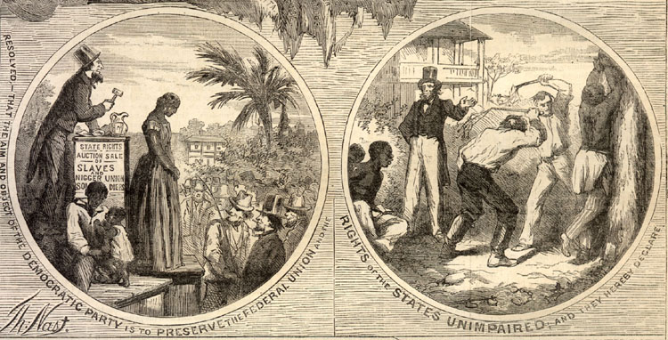

* 1. Abolitionists were citizens of the US that wished to eliminate slavery stating that it went against the constitutional rights secured by the United States

“…Although African-Americans had been brought to British America since the time of Jamestown colony, American slavery adopted many of its defining characteristics in the 19th century. The cotton gin had not been invented until the last decade of the 1700s. This invention led the American south to emerge as the world’s leading producer of cotton. As the south prospered, southerners became more and more nervous about their future. Plantation life became the goal of all the south, as poor yeoman farmers aspired to one day become planters themselves. Rebellions and abolitionists led southerners to establish an even tighter grip on the enslaved.” ~ ushistory.org

1. **Why did southerners become more nervous about their future as the south prospered?**

Homestead Act-

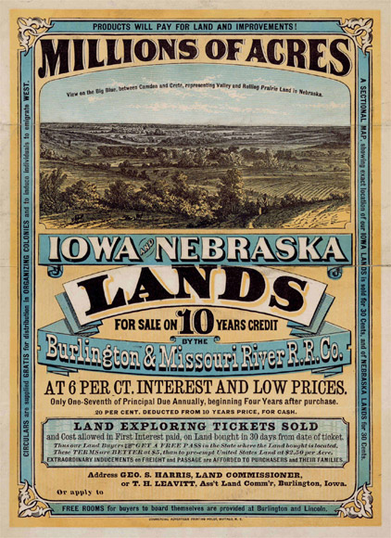

“The Homestead Act, enacted during the Civil War in 1862, provided that any adult citizen, or intended citizen, who had never borne arms against the U.S. government could claim 160 acres of surveyed government land. Claimants were required to ‘improve’ the plot by building a dwelling and cultivating the land. After 5 years on the land, the original filer was entitled to the property, free and clear, except for a small registration fee. Title could also be acquired after only a 6-month residency and trivial improvements, provided the claimant paid the government $1.25 per acre. After the Civil War, Union soldiers could deduct the time they had served from the residency requirements.

1. **What were the requirements for acquiring land through the Homestead Act?** 
   1. Any adult could claim 160 acres of surveyed gov land
   2. The land had to be improved upon and would be theirs free and clear after 5 years
   3. Could live on land 6months and then pay $1.25 per acre
2. **Why did few people benefit from the Homestead Act?** 
   1. Couldn’t afford to build a farm or have necessary tools, seeds and livestock
3. **Who acquired most of land as a result of the Homestead Act?** 
   1. Most of the land went to speculators, cattlemen, miners, lumbermen, and railroads.

Although this act was included in the Republican party platform of 1860, support for the idea began decades earlier. Even under the Articles of Confederation, before 1787, the distribution of government lands generated much interest and discussion.

The act, however, proved to be no panacea for poverty. Comparatively few laborers and farmers could afford to build a farm or acquire the necessary tools, seed, and livestock. In the end, most of those who purchased land under the act came from areas quite close to their new homesteads (Iowans moved to Nebraska, Minnesotans to South Dakota, and so on).

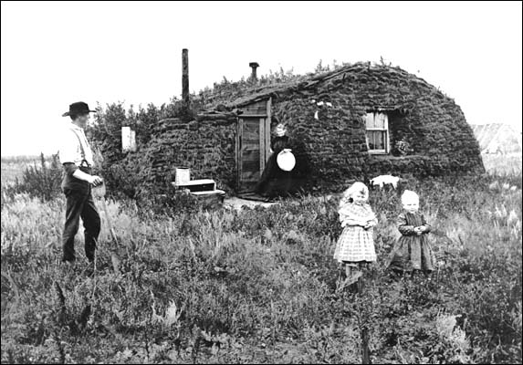

Unfortunately, the act was framed so ambiguously that it seemed to invite fraud, and early modifications by Congress only compounded the problem. Most of the land went to speculators, cattlemen, miners, lumbermen, and railroads. Of some 500 million acres dispersed by the General Land Office between 1862 and 1904, only 80 million acres went to homesteaders. Indeed, small farmers acquired more land under the Homestead Act in the 20th century than in the 19th.” ~ ourdocuments.gov

**“In the early 19th century, as the United States expanded economically, each section of the country developed its own special characteristics:**

|  |  |  |
| --- | --- | --- |
| **The Northeast** | **The South** | **The Northwest** |
| * Became a center of manufacturing, shipping, fishing and small farms * Witnessed the growth of a new class of factory workers * Factories and cities began to dramatically change traditional lifestyles | * Its dominant institution was slavery * Although most Southerners never owned slaves, much of the region’s economy was based on profits from the use of slave labor on large plantations, which grew crops such as cotton | * Included present-day Wisconsin, Illinois, Indiana, Michigan, and Ohio * Became the nation’s breadbasket * Its grain was shipped by river and canal to the Northeast and South * Small farmers predominated in this area |

These regional differences led to the rise of sectionalism as early as the 1820s. Sectionalism referred to the greater loyalty many Americans felt towards their section (North, South, or West) than towards the country. Each section wanted the federal government to follow policies favorable to itself. These differences between sections made a clash appear almost inevitable.”

~ The Key to Understanding U.S. History and Government

1. **What happened economically in the United States by the early 19th century?** 
   1. Economic growth based on characteristics of the region led to sectionalism
2. **What issue might divide the nation?** 
   1. More devotion to one’s section over the Union as a whole

**Textbook Reading pages 279 -280**

1. **What were the outcomes of Nat Turners Revolt?**
   1. Southerners reacted by passing stringent laws and controls regarding slavery
   2. It became illegal to teach slaves to read
   3. Forbidden to gather in groups unless overseers were present
   4. Inspired free people in the North to work against slavery

**Textbook Reading pages 282 – 283**

1. **How did abolitionists attempt to bring about the end of slavery in the United States?** 
   1. They created anti-slavery publications, formed abolitionist societies
   2. Made speeches and used moral suasion to support their arguments

**Elizabeth Cady Stanton and Susan B. Anthony Adapted from Gerda Lerner’s *The Woman in American History***

|  |  |
| --- | --- |
| **Elizabeth Cady Stanton** | **Susan B. Anthony** |
| 1. 1815 – 1902 2. Ms. Stanton grew up with four sisters in the well-to-do household of conservative Judge Cady, in upstate New York. The only boy in the family had died as a youth, and nothing any of the girls did could ever make up to Judge Cady for the fact that he had no son. 3. She married Henry Stanton over the strong objections of her father, who resented the young man’s radical, abolitionist views. 4. Elizabeth Cady Stanton is believed to have been the driving force behind the 1848 Seneca Falls Convention, and for the next fifty years played a leadership role in the women's rights movement. | 1. 1820 – 1906 2. At the time Elizabeth Cady Stanton met young Susan B. Anthony in 1851, the Quaker schoolteacher was an abolitionist and active worker in temperance reform. 3. She was a poor writer but had a marvelous ability to inspire others to work as unceasingly as she did. 4. Her collaboration with Mrs. Stanton, to whom writing, and felicity of expression came naturally, was of immense value to her, and gradually she became a most effective and accomplished speaker. 5. Unmarried and free from domestic responsibility, Susan B. Anthony could provide the drive and energy both women needed if they were to accomplish their goal. 6. She one said, “I have never lost my faith, not for a moment. Failure is impossible.” |

“Among the reform movements of the 1830s was the women’s rights movement that sought to overcome the inferior status of women. Chief among the issues were women’s lack of rights concerning property, voting, and education. In 1848, Lucretia Mott and Elizabeth Cady Stanton organized the Women’s Rights Convention at Seneca Falls, New York. Minimal gains were made, and by the 1850s, women were focusing more and more on the issue of suffrage.” ~ U.S. History and Government

“In July of 1848, Elizabeth Cady Stanton and Lucretia Mott spearheaded the first women’s rights convention in American history.  Although the Convention was hastily organized and hardly publicized, over 300 men and women came to Seneca Falls, New York to protest the mistreatment of women in social, economic, political, and religious life.  The Declaration of Sentiments and Resolutions issued by the Convention, which was modeled after the Declaration of Independence, detailed the ‘injuries and usurpations’ that men had inflicted upon women and demanded that women be granted all of the rights and privileges that men possessed, including the right to vote.” ~ faculty.uml.edu

1. **What did the women’s rights movement of the 1830s seek to overcome?** 
   1. The Right to vote
2. **Who organized the Women’s Rights Convention at Seneca Falls, New York?** 
   1. Lucretia Mott and Elizabeth Cady Stanton organized the Women’s Rights Convention at Seneca Falls, New York.
3. **What document was issued by the Convention? What was the document modeled on and what was its main demand?** 
   1. The Declaration of Sentiments and Resolutions issued by the Convention
   2. modeled after the Declaration of Independence
   3. detailed the ‘injuries and usurpations’ that men had inflicted upon women and demanded that women be granted all of the rights and privileges that men possessed, including the right to vote

**Textbook Pages 274- 275**

1. **What did the public-school movement accomplish?**
   1. It established free public schools that children were required to attend and the percentage of American children attending school increased
   2. Schools were established to create many well-educated teachers

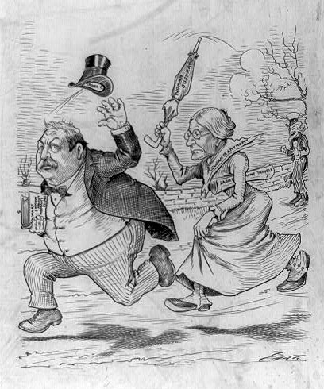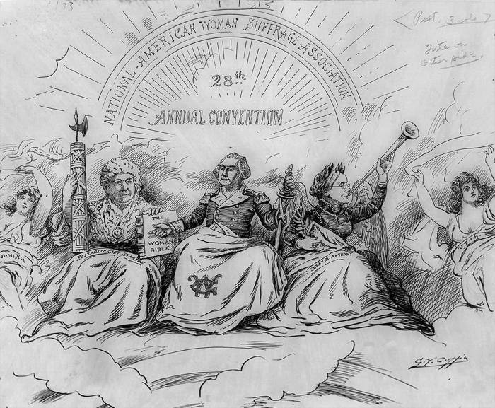

“The Apotheosis of Suffrage,” a cartoon mocking Stanton and Anthony

CREDIT: Coffin, George Yost, artist. “The Apotheosis of Suffrage.” 1896. Cartoon Drawings, Prints and Photographs Division, Library of Congress.

This cartoon shows Susan B. Anthony chasing after President Grover Cleveland in her fight for women’s right to vote

CREDIT: Cartoon showing President Grover Cleveland, carrying book “What I know about women’s clubs,” being chased with an umbrella by Susan B. Anthony, as Uncle Sam laughs in background, 1892-1896. Prints and Photographs Division, Library of Congress. Reproduction Number LC-USZ62-96565.

1. **What attitudes in society affected men’s perceptions of women and how did these attitudes influence ideas on women’s suffrage?**
   1. Men were the ones who controlled the government and their perception of women was that they were week and they’re for they questioned if they should have the same rights as men.

|  |  |
| --- | --- |
| 1. **The term Manifest Destiny was first used to support**    1. independence from Great Britain    2. westward expansion to the Pacific Ocean    3. efforts to stop secession of Southern states    4. laws restricting labor union activity 2. **In the mid-1800s, the growth of the populations of California and the western territories was mainly a result of the**    1. discovery of gold and silver    2. opening of the Panama Canal    3. migration of freedmen after the Civil War    4. secession of the Southern states 3. **In the late 1800s, rapid industrial development resulted in**    1. A decrease in tariff rates    2. A decrease in population growth    3. An increase in the rate of urbanization    4. An increase in the price of farm products 4. **The annexation of Texas and the Mexican Cession are best described as efforts by the United States to**    1. remove European threats    2. limit the spread of slavery    3. end wars of aggression    4. fulfill Manifest Destiny 5. **In the period from 1860 to 1890, which experience was shared by most Native Americans living in western states?** 6. They maintained control of their traditional lands. 7. They benefited economically from government policy. 8. They became farmers and small business owners. 9. They were forced to live on reservations. | **6. The phrase “by military conquest, treaty, and purchase” describes the**   1. steps in the growth of American industry 2. methods used to expand the territory of the United States 3. major parts of President Woodrow Wilson’s Fourteen Points 4. causes of the United States entry into the Korean War 5. **In 1862, the Homestead Act providing free land to settlers and the Pacific Railway Act were passed primarily to** 6. achieve Northern victory in the Civil War 7. develop the Midwest and western parts of the country 8. improve the lives of freed slaves 9. expand overseas markets to Asia and Europe     **7. Which conclusion can best be drawn from the information in this chart?**   * 1. The Southern states led the nation in manufacturing.   2. Manufacturing production in the Western states exceeded that of the New England states.   3. The Middle states led the nation in all categories related to manufacturing.   4. The New England states depended more on agriculture than on manufacturing.   **8. Which geographic feature connected the iron ore fields of the upper Midwest to major steel centers?**   * 1. Great Lakes   2. Gulf of Mexico   3. Hudson River   4. Tennessee River valley |

|  |  |
| --- | --- |
| * + 1. **How did Elizabeth Cady Stanton learn so much about the laws of the United States?**   1. She went to law school.   2. Her husband was a Supreme Court Judge.   3. Her father was a lawyer and a judge.   4. Her mother taught her.      1. **In 1872, Susan B. Anthony argued that this amendment to the United States Constitution gave her the right to vote.**  1. the Fourteenth Amendment 2. the Fifteenth Amendment 3. the Nineteenth Amendment 4. the First Amendment    * 1. **Antisuffragists made all the following claims EXCEPT:** 5. Women were represented in politics by male family members. 6. The enfranchisement of women would disrupt families and destroy homes. 7. Women were emotionally and mentally incapable of voting. 8. Women’s votes would purify politics and effect needed reforms. 9. Exercising the vote would undermine and corrupt female character.    * 1. **The first woman's rights convention in America was held in:** 10. Boston, MA 11. Seneca Falls, NY 12. Cheyenne, WY 13. Jamestown, VA | * + 1. **Which of the following statements best expresses the “justice” argument for woman suffrage?**   1. As women were morally superior, their enfranchisement would improve political life.   2. Women voters would defeat corruption, gambling, and the saloon.   3. Women’s votes were needed to protect the family and promote progressive reform.   4. Women deserved the same rights as men and were entitled to vote.   5. Modern municipal government would benefit from female competence and expertise.      1. **In the late 1860s, after the end of the Civil War, Susan B. Anthony:**   6. opposed the Fourteenth Amendment because it did away with provisions counting slaves as three fifths of a person   7. supported the Fourteenth Amendment because it would provide the justification for women to vote   8. supported the Fourteenth Amendment because it allowed women to submit petitions to their representatives   9. opposed the Fourteenth Amendment because it limited the right of voting to male citizens   **15. In 1873, Susan B. Anthony went on trial, charged with:**   * 1. protesting in front of the White House   2. voting in a presidential election   3. founding an illegal organization   4. preventing men from voting |

**Choose one Focus Questions from Chapter 8 and one from Chapter 9 to write a 5-8 sentence paragraph with 5 facts. (2 paragraphs)**

**8.1 How did the Second Great Awakening affect life in the United States? 266-272**

**8.2 What were the main features of the public school, penitentiary, and temperance reform movements? 273 - 277**

**8.3 How did reformers try to help enslaved people? 278 – 285**

**8.4 What steps did American women take to advance their rights in the mid 1800’s? 286- 290**

**9.1 What were the causes of Westward Migration? Pages 298 – 304**

**9.2 How did the revolution in Texas lead to war with Mexico? 305- 309**

**9.3 What were the effects of the Mexican American War and California Gold Rush? 310 -315**

**________________________________________________________________________________________________________________________**

**____________________________________________________________________________________________________________________________________________________________________________________________________________________________________________________________________________________________________________________________________________________________________________________________________________________________________________________________________________________________________________________________________________________________________________________________________________________________________________________________________________________________________________________________________________________________________________________________________________________________________________________________________________________________________________________________________________________________________________________________________________________________________________________________________________________________________________________________________________________________________________________________________________________________________________________________________________________________________________________________________________________________________________________________________________________________________________________________________________________________________________________________________________________________________________________________________________________________________________________________________________________________________________________________________________________________________________________________________________________________________________________________________________________________________________________________________________________________________________________________________________________________________________________________________________________________________________________________________________________________________________________________________________________________________________________________________________________________________________________________________________________________________________________________________________________________________________________________________________________________________________________________________________________________________________________________________________________________________________________________________________________________________________________________________________________________________________________________________________________________________________________________________________________________________________________________________________________________________________________________________________________________________________________________________________________________________________________________________________________________________________________________________________________________________________________________________________________________________________________________________________________________________________________________________________________________________________________________________________________________________________________________________________________________________________________________________________________________________________________________________________________________________________________________________________________________________________________________________________________________________________________________________________________________________________________________________________________________________________________________________________________________________________________________________________________________________________________________________________________________________________________________________________________________________________________________________________________________________________________________________________________________________________________________________________________________________________________________________________________________________________________________________________________________________________________________________________________________________________________________________________________________________________________________________________________________________________________________________________________________________________________________________________________________________________________________________________________________________________________________________________________________________________________________________________________________________________________________________________________________________________________________________________________________________________________________________________________________________________________________________________________________________________________________________________________________________________________________________________________________________________________________________________________________________________________________________________________________________________________________________________________________________________________________________________**