**The Spanish-American War**

1. **What territories did the United States gain control of after the war? Bullets**
2. **What did President William McKinley do on April 11, 1898? Why did President McKinley do this? TTQA**

1. **What did the U.S. Congress do on April 20, 1898 and how did the Spanish government respond to the U.S. ultimatum? TTQA**

“The Spanish-American War of 1898 ended Spain’s colonial empire in the Western Hemisphere and secured the position of the United States as a Pacific power. U.S. victory in the war produced a peace treaty that compelled the Spanish to relinquish claims on Cuba, and to cede sovereignty over Guam, Puerto Rico, and the Philippines to the United States. The United States also annexed the independent state of Hawaii during the conflict. Thus, the war enabled the United States to establish its predominance in the Caribbean region and to pursue its strategic and economic interests in Asia…

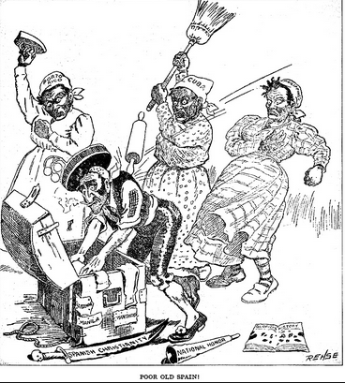 On April 11, 1898, President William McKinley asked Congress for authorization to end the fighting in Cuba between the rebels and Spanish forces, and to establish a ‘stable government’ that would ‘maintain order’ and ensure the ‘peace and tranquility and the security’ of Cuban and U.S. citizens on the island. On April 20, the U.S. Congress passed a joint resolution that acknowledged Cuban independence, demanded that the Spanish government give up control of the island, foreswore any intention on the part of the United States to annex Cuba, and authorized McKinley to use whatever military measures he deemed necessary to guarantee Cuba’s independence.

The Spanish government rejected the U.S. ultimatum and immediately severed diplomatic relations with the United States. McKinley responded by implementing a naval blockade of Cuba on April 22 and issued a call for 125,000 military volunteers the following day. That same day, Spain declared war on the United States, and the U.S. Congress voted to go to war against Spain on April 25.”

~ state.gov

**4. Who’s Point of view does this political cartoon represent? Why?**

|  |  |
| --- | --- |
| **Causes of the Spanish-American War:**  **-** By the 1890s, Spain’s New World empire had been reduced to a few islands in the Caribbean  - In 1894, Cuban sugar workers rebelled from Spain seeking their independence; a Spanish army was sent to Cuba to crush the rebellion with brutal force  - Americans felt they had a moral obligation to help Cuba gain independence  **- Yellow Journalism🡪**Publishers like William Randolph Hearst and Joseph Pulitzer sensationalized news events to sell more newspapers; deliberately distorted the news with Cuba with exaggerated stories of atrocities  - The American government wanted to protect American investments in Cuba  - The Spanish Ambassador, De Lôme, called President McKinley “weak” in a private letter that was published in the press  **- The battleship *U.S.S. Maine*** was blown up in Havana harbor, killing 250 American sailors; even though the explosion was probably caused by accidental fire, the press blamed the explosion on Spanish sabotage | **Results of the Spanish-American War:**  **-** Finding it hard to resist the public outcry, President McKinley asked Congress for a declaration of war against Spain shortly after the explosion of the *Maine*  - The Spanish-American War lasted less than four months  - American forces quickly overcame the Spanish navy in the Philippines and Spanish troops on Cuba  - As a result of the war, the United States acquired the Philippines, Puerto Rico, and Guam  - Cuba became independent in name but fell under the indirect control of the United States  - The United States emerged from the war with a colonial empire  - American leaders reversed the nation’s traditional policy by becoming imperialist  - Imperialism refers to the control of one country by another; often for the following reasons🡪  * Need for raw materials and markets  * Strategic Reasons  * Nationalism  * Attitudes towards other Peoples |

“The Progressive Ear coincided with a period of greater American involvement in foreign affairs. Many Americans believed that the United States, as one of the world’s leading industrial nations, should play a greater role on the world stage. The Spanish-American War marked a major turning point in American foreign relations, changing the United States from a nation without colonies to one in possession of an overseas empire.” **~ The Key to Understanding U.S. History and Government**

**5. What had happened to Spain’s empire by the 1890s? TTQA**

**6. Why did Yellow Journalism change Americans perception of events in Cuba? TTQA**

**7. What did the American government want to protect in Cuba?**

**8. What did the United States gain as a result of the Spanish-American War?**

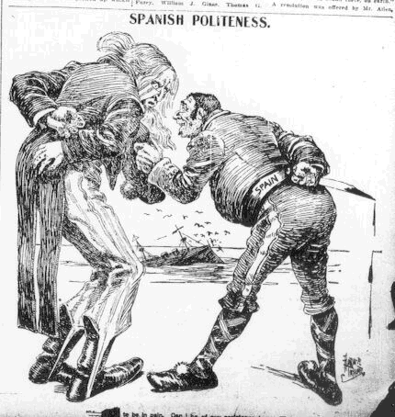

**9. How did the United States change after the Spanish- American War?**

**10. Why is this image an example of Yellow Journalism?**

“The Spanish-American War is often referred to as the first ‘media war.’ During the 1890s, journalism that sensationalized – and sometimes even manufacture – dramatic events was a powerful force that helped propel the United States into war with Spain. Led by newspaper owners William Randolph Hearst and Joseph Pulitzer, journalism of the 1890s used melodrama, romance, and hyperbole to sell millions of newspapers – a style that became known as yellow journalism.

The term yellow journalism came from a popular *New York World* comic called ‘Hogan's Alley,’ which featured a yellow-dressed character named the ‘the yellow kid.’ Determined to compete with Pulitzer’s *World* in every way, rival *New York Journal* owner William Randolph Hearst copied Pulitzer’s sensationalist style and even hired ‘Hogan's Alley’ artist R.F. Out cault away from the World. In response, Pulitzer commissioned another cartoonist to create a second yellow kid. Soon, the sensationalist press of the 1890s became a competition between the ‘yellow kids,’ and the journalistic style was coined ‘yellow journalism.’ Yellow journals like the *New York Journal* and the *New York World* relied on sensationalist headlines to sell newspapers.” ~ pbs.org

**Textbook Page 593**

**11. Why did many Americans favor the Cubans in their struggle for independence? TTQA**

* **The Cuban struggle for independence reminded the Americans of their own revolutionary heritage.**

**12. Text book Pages 595-597**

**What role did the Rough Riders play in Cuba? And Why did few Americans die in these battles? TTQA**

* **The rough riders helped secure the high ground of the kettle and San Juan hills and helped bring about the Spanish surrender of Santiago.**

**The Rough Riders**

“The most famous of all the units fighting in Cuba, the ‘Rough Riders’ was the name given to the First U.S. Volunteer Cavalry under the leadership of Theodore Roosevelt. Roosevelt resigned his position as Assistant Secretary of the Navy in May 1898 to join the volunteer cavalry. The original plan for this unit called for filling it with men from the Indian Territory, New Mexico, Arizona, and Oklahoma. However, once Roosevelt joined the group, it quickly became the place for a mix of troops ranging from Ivy League athletes to glee-club singers to Texas Rangers and Indians.

**13. Who was the leader of this First U.S. Volunteer Cavalry? & Describe the men who made up the “Rough Riders”.**

Roosevelt and the commander of the unit Colonel Leonard Wood trained and supplied the men so well at their camp in San Antonio, Texas, that the Rough Riders was allowed into the action, unlike many other volunteer companies. They went to Tampa at the end of May and sailed for Santiago de Cuba on June 13. There they joined the Fifth Corps, another highly trained, well supplied, and enthusiastic group consisting of excellent soldiers from the regular army and volunteers.

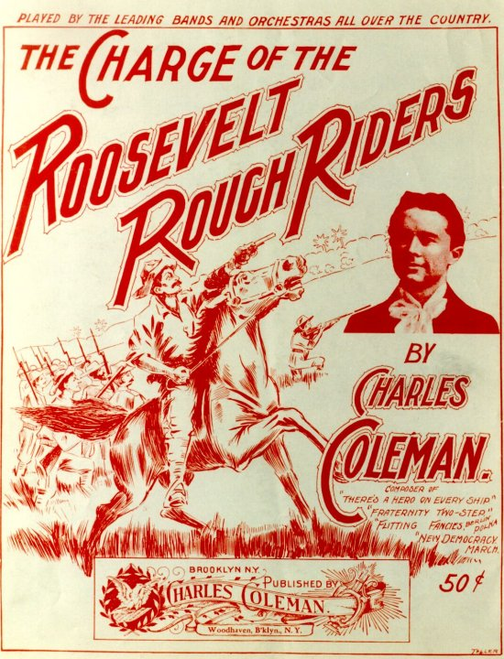

The Rough Riders saw battle at Las Guásimas when General Samuel B. M. Young was ordered to attack at this village, three miles north of Siboney on the way to Santiago. Although it was not important to the outcome of the war, news of the action quickly made the papers. They also made headlines for their role in the Battle of San Juan Hill, which became the stuff of legend thanks to Roosevelt's writing ability and reenactments filmed long after.” ~ loc.gov

**14. What does this poster reveal about how historical events are sometimes remembered?**

**An Open Door, a Commodore, and the U.S. in Asia**

The following excerpt is from an interview with Walter LaFeber [a distinguished historian] about the U.S.A.’s Open Door Policy. Please read the excerpt and answer the questions that follow.

**15. What was the American “Open Door Policy”? TTQA**

**16. Why did the Europeans not want an “Open Door Policy? TTQA**

**17. How did the Chinese view the Europeans and the Americans?**

“The United States doesn’t see itself in this way. Our position is – and it’s quite different than the other imperial powers’ position – the American position is that we do not want to colonize China. We do not want China carved up. We want to keep China whole. This is known traditionally in American history as the ‘Open Door policy’. We want China to remain whole to have its administrative integrity uncompromised, and we want to sell to all of China, not parts of it. The European powers, on the other hand, particularly the Russians, the Germans, and the Japanese want to carve up China. They want parts of China for themselves. A major reason for this is that the United States believes – I think it’s right – , that it can, in an open door situation, that it can compete with anybody, that we have the cheapest steel, the cheapest locomotives, the cheapest textiles, we can processed more cheaply than anyone. If we only have what the American Secretary of State, John Hay, calls a ‘fair field and no favor’ in 1900, then we can make a lot of money out of China. The other European powers and the Japanese realize this. So what they want to do is essentially colonize China, carve up parts of China, and keep the United States, as well as other powers, out. This, we think, puts us on a collision course with the other powers. The Chinese do not make this kind of distinction. They notice that when, for example, the foreign powers intervene in China in 1900, the Americans are fighting alongside the other foreign powers.” ~ pbs.org

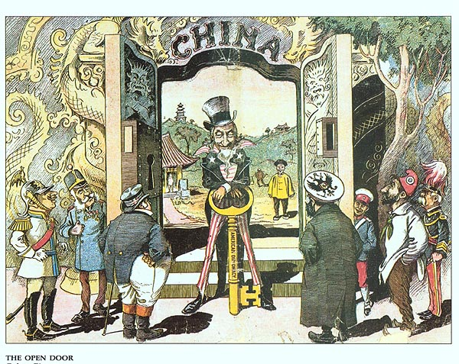

**Note:**

*“Americans were in an advantageous position for trade with East Asia, since they were separated from this region only by the Pacific Ocean. After 1898, control of the Philippines, Midway, Hawaii, Guam, and Samoa made the United States an important power in the Pacific. This increased American opportunities for trade with both China and Japan, leading to American political involvement in these countries.”* **~ The Key to Understanding U.S. History and Government**

**Analyze the following chart:**

|  |  |
| --- | --- |
| **The U.S. in China:**   * In China, European powers had established “spheres of influence,” threatening to cut off Americans from trade * Secretary of State John Hay announced the “Open Door Policy,” favoring equal trading rights for all foreign nations in China * In 1900, a rebellion was started by a group of Chinese nationalists, known as Boxers, who opposed the growing Western influence in China * The Boxer Rebellion threatened foreigners living in China * An international army, with U.S. participation, crushed the rebellion * Afterwards the United States announced it opposed any attempt by other nations to use the rebellion as an excuse to dismember China | **The U.S. and Japan:**   * The United States opened an isolationist Japan to Western trade and influence when Commodore Matthew Perry landed there with American gunships in 1853 * By the 1890s, Japan had adopted many Western ways and had become an industrial power * Japan even adopted imperialist policies * In 1894-1895, Japanese forces drove China out of Korea and Taiwan, and incorporated Taiwan into the Japanese empire * In 1905, Japan surprised the West by defeating Russia in the Russo-Japanese War * Americans feared seeing either Japan or Russia becoming dominant in the Far East * President Theodore Roosevelt brought both sides to a peace settlement in the Treaty of Portsmouth (1905), winning the Nobel Peace Prize for his efforts |

**18. What did the Europeans establish in China?**

**19. What did the Boxer Rebellion threaten?**

**20. How did the Europeans and the Americans react to the Boxer Rebellion?**

**21. Who was Commodore Perry and what did he do?**

**22. In 1905 why was the outcome of the Russo Japanese War surprising and Concerning to the Europeans and Americans?**

* **Japan wanted to protect its interests in China without competition from Russia, and Japan expansion made other countries fear the they would lose their trading rights. Weaker countries might fear the Japan would seize some of their territory**

**Text book page 586- 588**

**23. What factors influenced Americans to play a more active role in the world? Include an economic and social reason in the answer.**

* **Americans had surplus goods and wanted to find other markets for them in addition, imperialists embraced social Darwinism and believed in America’s Manifest Destiny.**

**24. Textbook Page 588**

**How could the acquisition known as “Seward’s Folly” contribute to the U.S. trade with Japan?**

* **He opened the country to trade with Japan through Alaska which meant Japan could buy raw materials from Alaska, and U.S. merchant ships could refuel in Alaska on their way to Japan.**

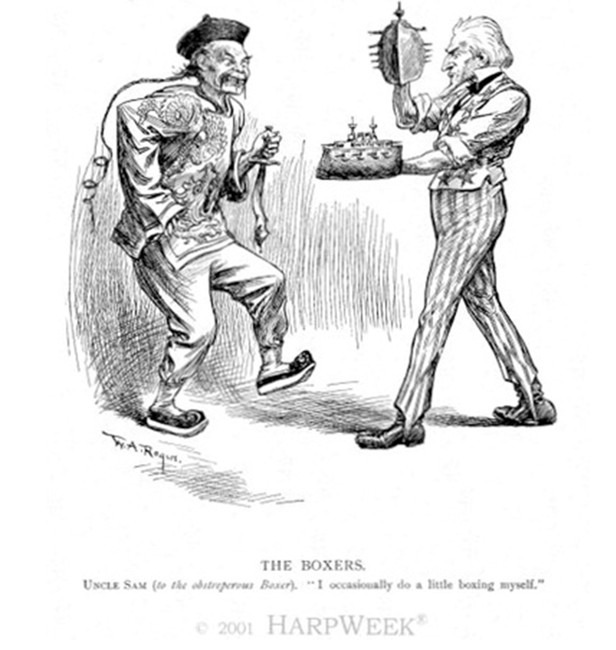**25. What event is being depicted in the image to the left?**

“In his annual messages to Congress in 1904 and 1905, President Theodore Roosevelt expanded the Monroe Doctrine. The corollary stated that not only were the nations of the Western Hemisphere not open to colonization by European powers, but that the United States had the responsibility to preserve order and protect life and property in those countries.

European intervention in Latin America resurfaced as an issue in U.S. foreign policy when European governments began to use force to pressure several Latin American countries to repay their debts. For example, British, German, and Italian gunboats blockaded Venezuela’s ports in 1902 when the Venezuelan government defaulted on its debts to foreign bondholders. Many Americans worried that European intervention in Latin America would undermine their country’s traditional dominance in the region.

To keep other powers out and ensure financial solvency, President Theodore Roosevelt issued his corollary. ‘Chronic wrongdoing…may in America, as elsewhere, ultimately require intervention by some civilized nation,’ he announced in his annual message to Congress in December 1904, ‘and in the Western Hemisphere the adherence of the United States to the Monroe Doctrine may force the United States, however reluctantly, in flagrant cases of such wrongdoing or impotence, to the exercise of an international police power.’

Roosevelt tied his policy to the Monroe Doctrine, and it was also consistent with his foreign policy of ‘walk softly, but carry a big stick.’ Roosevelt stated that in keeping with the Monroe Doctrine, the United States was justified in exercising ‘international police power’ to put an end to chronic unrest or wrongdoing in the Western Hemisphere. This so-called Roosevelt Corollary – a corollary is an extension of a previous idea – to the Monroe Doctrine contained a great irony. The Monroe Doctrine had been sought to prevent European intervention in the Western Hemisphere, but now the Roosevelt Corollary justified American intervention throughout the Western Hemisphere. In 1934, Franklin D. Roosevelt renounced interventionism and established his Good Neighbor policy within the Western Hemisphere.” ~ ourdocuments.gov

**26. What was stated in the Monroe Doctrine?**

**27. Why did European intervention in Latin America become a problem in 1902? TTQAA**

**28. According to President Theodore Roosevelt, what did his corollary justify?**

|  |  |  |  |
| --- | --- | --- | --- |
| **The U.S. and Cuba:**  - After the Spanish-American War, Cuba became a protectorate under American control  - U.S. forces remained on the island, and American businesses invested heavily in Cuba  - Cubans were forced to agree to the Platt Amendment, which gave the United States the right to intervene in Cuban affairs at any time  - The Platt Amendment was later repealed in the 1930s  - The U.S. sought to keep foreign powers out of the Caribbean because they might pose a threat to U.S. security  ~ The Key to Understanding U.S. History and Government | **The Panama Canal:**  - The Spanish-American War highlighted the need for a canal, so that the U.S. navy could send ships between the Atlantic and Pacific Oceans without circling South America  - By 1903, Americans decided to build the canal across Panama [Panama was still a part of Colombia]  - The government of Colombia could not agree to terms with the United States, while Panamanian rebels wished to establish their independence  - Roosevelt made a deal with the rebels  - Roosevelt ordered U.S. warships in the area to protect them  - Roosevelt next recognized Panamanian independence  - In return, the US received land for the canal | **The Big Stick Policy**:  - In 1904, Roosevelt barred European countries from using force to collect debts owed by the Dominican Republic  - The U.S. would intervene to collect the debt, acting as an “international police power”  - This Roosevelt Corollary to the Monroe Doctrine became known as the Big Stick Policy, since Roosevelt boasted he would “walk softly but carry a big stick”  - The corollary was used to justify sending troops to the West Indies and Central America | **Woodrow Wilson and Latin America:**  - Seeking additional bases in the Caribbean, Wilson bought the Virgin Islands from Denmark in 1917  - Wilson sent troops to Haiti, Nicaragua, and the Dominican Republic to protect American interests  - Wilson became involved in the Mexican Revolution; troops of the rebel leader Pancho Villa murdered Americans both in Mexico and across the border  - Wilson sent troops to Mexico but Villa eluded capture and Wilson withdrew the troops in 1917, when America entered World War I |

1. **What happened to Cuba after the Spanish-American War?**
2. **What was the Platt Amendment?**
3. **Why did the U.S. want to keep foreign powers out of the Caribbean?**
4. **Why did Americans want a canal in the Western Hemisphere?**
5. **According to this political cartoon, how did the United States view their enrollment in Panama?**

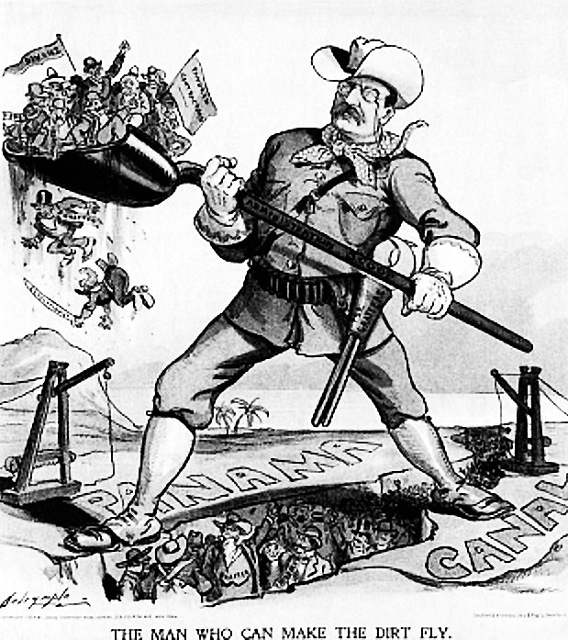

1. **What did the Panamanians want? And Why did the U.S. government help the Panamanians?**
2. **What did the U.S. act like in Latin America?**
3. **Why was the Roosevelt Corollary known as the Big Stick Policy?**
4. **Why did President Wilson send American troops to Haiti, Nicaragua, and the Dominican Republic?**
5. **Why did the U.S. become involved in the Mexican Revolution?**
6. **Why did President Wilson withdraw U.S. troops from Mexico?**
7. **One important conclusion that can be drawn as a result of the United States experience in both the Spanish-American War (1898) and the Persian Gulf War (1991) is that**
8. only the President should decide issues of war and peace
9. the media are a powerful influence in shaping American public opinion toward war
10. the public has little confidence in the ability of the American military
11. international organizations play a decisive role in determining the outcome of a war
12. **Why did the United States formulate the Open Door policy toward China?**
13. to develop democratic institutions and practices in China
14. to prevent a European and Japanese monopoly of Chinese trade and markets
15. to establish a military presence on the Chinese mainland
16. to support Japanese efforts to industrialize China
17. **The reason the U.S. developed Open Door policy was**
18. allow the United States to expand its trade with China
19. demonstrate the positive features of democracy to Chinese leaders
20. aid the Chinese Nationalists in their struggle with the Chinese Communists
21. encourage Chinese workers to come to the United States
22. **Involvement in the Spanish-American War, acquisition of Hawaii, and introduction of the Open Door policy in China were actions taken by the United States Government to**
23. establish military alliances with other nations
24. gain overseas markets and sources of raw materials
25. begin the policy of manifest destiny
26. support isolationist forces in Congress
27. **Involvement in the Spanish-American War, acquisition of Hawaii, and the Open Door policy in China were actions taken by the United States Government to**
28. establish military alliances with other nations
29. gain overseas markets and sources of raw materials
30. begin the policy of manifest destiny
31. support isolationist forces in Congress
32. **Which statement best describes President Theodore Roosevelt’s foreign policy position toward Latin America in the early 1900’s?**
33. The United States should reduce its involvement in Latin American affairs.
34. The Monroe Doctrine permits the United States to intervene actively in the affairs of Latin American nations.
35. Latin American nations should form an organization to help them achieve political and economic stability.
36. The United States should give large amounts of financial aid to help the poor of Latin America.
37. **The Monroe Doctrine declared that the United States would**
38. prevent the establishment of new European colonies anywhere in the world
39. help colonies in North and South America adopt a democratic form of government
40. view European interference in the Americas as a threat to the national interest of the United States
41. prevent other nations from trading with South American nations
42. **Which foreign policy position was held by both President James Monroe and President Theodore Roosevelt?**
43. Trade with other nations should be sharply reduced.
44. The United States should follow a policy of isolationism.
45. A special relationship should exist between the United States and the nations of Latin America.
46. The United States should send troops to aid revolutionary movements in European nations
47. **During the late 19th and early 20th centuries, United States policy toward Latin America was most strongly characterized by**
48. friendship and trust
49. intervention and paternalism
50. tolerance and humanitarianism
51. indifference and neglect
52. **The principle that the United States has the right to act as the "policeman of the Western Hemisphere" and intervene in the internal affairs of Latin American nations was established by the**
53. Good Neighbor policy
54. Open Door policy
55. Roosevelt Corollary to the Monroe Doctrine
56. Marshall Plan
57. **Which argument was used to support United States acquisition of overseas possessions in the late 1800’s?**
58. The United States needed to obtain raw materials and new markets.
59. The spread of Marxist ideas had to be stopped because they threatened world peace.
60. The United States should be the first world power to build a colonial empire.
61. The doctrine of Manifest Destiny had become obsolete.
62. **The main reason the United States implemented the Open Door policy in China was to**
63. promote immigration
64. expand democratic reforms
65. encourage religious freedom
66. guarantee access to markets

1. *“But today we are raising more than we can consume. Today we are making more than we can use. Today our industrial society is congested; there are more workers than there is work; there is more capital than there is investment. We do not need more money—we need more circulation, more employment. Therefore, we must find new markets for our produce, new occupation for our capital, new work for our labor. . . .”*  **~ Senator Albert J. Beveridge, 1898**

**This statement provides a reason why political leaders of the late 1800s adopted the policy of**

1. imperialism
2. isolationism
3. protectionism
4. collective security
5. **Which argument was used to support United States acquisition of overseas possessions in the late 1800’s?**
   1. The United States needed to obtain raw materials and new markets.
   2. The spread of Marxist ideas had to be stopped because they threatened world peace.
   3. The United States should be the first world power to build a colonial empire.
   4. The doctrine of Manifest Destiny had become obsolete.
6. **During the late 19th and early 20th centuries, United States intervention in Latin America was motivated by the United States desire to**
   1. protect its growing investments in Latin America
   2. encourage Latin American trade with Europe
   3. end Latin American independence movements
   4. reduce the influence of communism in Latin America
7. **From 1900 to 1915, a basic aim of United States foreign policy was to**
8. develop close economic ties with African nations
9. oppose revolutionary movements in western Europe
10. promote United States influence in Latin America
11. prevent the spread of communism in western Europe and Asia
12. **Throughout United States history, the most important aim of the country’s foreign policy has been**
13. participation in international organizations
14. advancement of national self-interest
15. containment of communism
16. development of military alliances
17. **Which United States foreign policy was most directly related to the rise of big business in the late 1800s?**
18. containment C. imperialism
19. détente D. neutrality
20. **United States annexation of the Philippines (1898) and military involvement in Vietnam (1960’s and 1970’s) are similar because in each event the United States**
21. achieved its long-range foreign policy objectives
22. put the domino theory into action
23. demonstrated the strength and success of its military power
24. provoked domestic debate about its involvement in the internal affairs of other nations
25. **One way in which the Panama Canal and the Suez Canal are geographically similar is that each is located on**
26. a peninsula
27. an archipelago
28. an isthmus
29. an island

**Choose two of the essay questions**

**Answer each using 5-8 sentences and at least 5 facts.**

**Ideas are listed below.**

**How and Why did the United States take a more active role in World Affairs?**

Open door Policy, Imperialism, Executive Economy, Big Stick Policy, Monroe Doctrine, Social Darwinism, Seward’s Folly, Spanish American War, Panama Canal, Platt Amendment, Moral Diplomacy,

**What were the Social, Economic and Political causes and effects of the Spanish American War?**

Yellow Journalism, Rough Riders, Treaty of Paris, The Sinking of the Maine, Cuban Rebels, Puerto Rico, Guam, Philippines

**How did the United States extended its influence in Asia?**

Spheres of Influence, Open Door Policy, Mathew Perry, Boxer Rebellion, Gentlemen’s Agreement, Great White Fleet, Russo Japanese War,