

8

Name: ___________________________________________________

**11th**



“The Continental Congress adopted the Articles of Confederation, the first constitution of the United States, on November 15, 1777. However, ratification of the Articles of Confederation by all thirteen states did not occur until March 1, 1781. The Articles created a loose confederation of sovereign states and a weak central government, leaving most of the power with the state governments. The need for a stronger Federal government soon became apparent and eventually led to the Constitutional Convention in 1787. The present United States Constitution replaced the Articles of Confederation on March 4, 1789.” **~ loc.gov**

**Questions:**

1. **State 2 significant facts about the Articles of Confederation.**
2. **____________________________________________________________________**
3. **____________________________________________________________________**
4. **What replaced the Articles of Confederation? ________________________________________________________________________**

***Analyze the following chart on the Constitutional Convention:***

1. **What did the delegates primarily want & Why?**
2. **Why were small states concerned about the issue of representation?**
3. **What was the Great, or Connecticut, Compromise?**
4. **Describe the U.S. Congress or the legislative branch of government in the U.S.**
5. **What was the Three-Fifths Compromise?**
6. **What concerns did the delegates have to consider about government and power when drafting a new Constitution?**

**Analyze the following diagram on Checks and Balances (state.gov):**

|  |  |  |
| --- | --- | --- |
| Legislative | Executive | Judicial |
| * Congress can override the President’s veto with a two-thirds vote in both the House and Senate * Congress controls the budget * Congress approves Presidential nominations * Congress can impeach the president and judges | * The President can veto congressional legislation * The President nominates judges | * The court can declare presidential acts unconstitutional * The court can declare laws unconstitutional |

1. **Why did the framers of the Constitution separated the branches of government into an executive, legislative, and judicial branch?**



1. **In American history, we often speak of the American system of government as a system of checks and balances. Explain the check part of checks and balances. What does it mean to check?**
2. **Explain the balances part of checks and balances.**

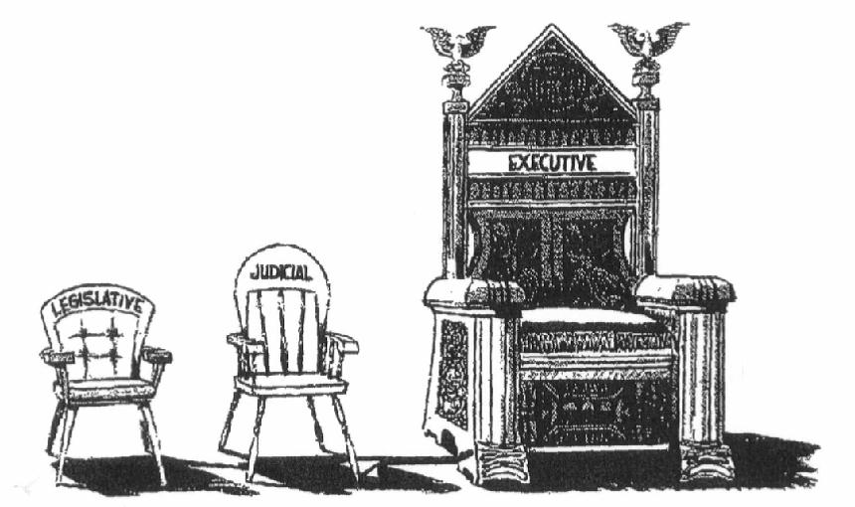

1. **What is the cartoonists suggesting about the American system of checks and balances?**

**Analyze the chart below concerning the three branches of government: Adapted from uen.org**

|  |  |  |
| --- | --- | --- |
| **Legislative** | **Executive** | **Judicial** |
| * Congress (Bicameral)  1. House of Representatives   (representation determined by population)   1. Senate   (Two Senators for every State)   * Its job is to make laws * Decides on who and what to tax and how to use tax money * Each house meets separately but they can come together for joint sessions | * The president of the United States, the vice president, and the major departments of government * Together, all the leaders, along with the president, vice president, and a few other people, make up the cabinet * The job of the executive branch is to enforce the laws | * Made up of the Supreme Court and other courts * Its job is to interpret the laws |

**P.S. And don’t forget that the public also is part of the system of checks and balances. If citizens aren’t satisfied with an official, they can choose to not reelect him or her.**

“The Federalist Papers were a series of eighty-five essays urging the citizens of New York to ratify the new United States Constitution. Written by Alexander Hamilton, James Madison, and John Jay, the essays originally appeared anonymously in New York newspapers in 1787 and 1788 under the pen name ‘Publius’…The Federalist Papers are considered one of the most important sources for interpreting and understanding the original intent of the Constitution.” ~ loc.gov

**Excerpts from Federalist No. 51**

“TO WHAT expedient then, shall we finally resort, for maintaining in practice the necessary partition of power among the several departments, as laid down in the Constitution? The only answer that can be given is…by so contriving the interior structure of the government as that its several constituent parts may, by their mutual relations, be the means of keeping each other in their proper places…

In order to lay a due foundation for that separate and distinct exercise of the different powers of government, which to a certain extent is admitted on all hands to be essential to the preservation of liberty, it is evident that each department should have a will of its own; and consequently should be so constituted that the members of each should have as little agency as possible in the appointment of the members of the others…

But the great security against a gradual concentration of the several powers in the same department, consists in giving to those who administer each department the necessary constitutional means and personal motives to resist encroachments of the others…”

1. **What are the Federalist Papers?**
2. **According to the authors of Federalist Paper No. 51, why must the power of government be partitioned or divided among several departments?**
3. **According to the authors of Federalist Paper No. 51, what is essential to the preservation of liberty?**

**Two Differing Points of View:**

|  |  |
| --- | --- |
| **Federalists** | **Antifederalists** |
| * Supported the ratification (to approve and formally sanction) of the Constitution * In favor of a stronger Union, Federalists felt that anarchy could result without a stronger national government * Many came from business and propertied classes * Had a personal economic interest in the establishment of a strong stable government * Alexander Hamilton and John Adams were early federalist leaders | * Did not fear strong government as much as they feared a strong centralized government at the expense of local state governments * A major concern was the potential danger to individual liberties posed by the lack of a bill of rights * Wanted the states to maintain a large degree of sovereignty * But also wanted Congress to act for the states in areas where the state could not act for themselves – notably foreign policy, western settlement, commerce, and disputes between states * Thomas Jefferson was an early antifederalist leader |

1. **What did federalists support?**
2. **Identify two important federalists.**
3. **What did antifederalists want Congress to do?**
4. **Identify an important early antifederalist.**

**Principles of the Constitution**

|  |
| --- |
| 1. Separation of Powers   Article I of the Constitution: Devoted to the Congress (Legislative Branch)  Article II of the Constitution: Devoted to the President (Executive Branch)  Article III of the Constitution: Devoted to the Federal Judiciary (Judicial Branch) |
| 1. Checks and Balances  * Prevents the abuse of power by any one of them * A system that allows each branch of a government to amend or veto acts of another branch so as to prevent any one branch from exerting too much power |
| 1. Federalism  * Concept of distributing powers of government between one central or national government (usually called the “federal government”) and the governments of several states into which a country is divided |
| 1. Structure of the Constitution  * A Preamble setting forth the reasons the Constitution was adopted * A main body of seven articles divided into sections and clauses * Shortly after ratification, an appendix of amendments to the Constitution |

1. **How does the U.S. Constitution realize Montesquieu’s concept of “separation of powers”?**
2. 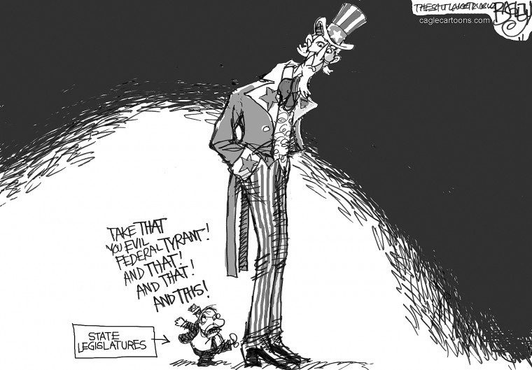**The Preamble of the Constitution establishes that the people are the source of authority. How does this differ from Divine Right Theory?**
3. **Explain the meaning of the political cartoon**

|  |
| --- |
| **Amendment I** - Congress shall make no law respecting an establishment of religion, or prohibiting the free exercise thereof; or abridging the freedom of speech, or of the press; or the right of the people peaceably to assemble, and to petition the Government for a redress of grievances. |
| **Amendment II -** A well regulated Militia, being necessary to the security of a free State, the right of the people to keep and bear Arms, shall not be infringed. |
| **Amendment III-** No Soldier shall, in time of peace be quartered in any house, without the consent of the Owner, nor in time of war, but in a manner to be prescribed by law. |
| **Amendment IV -** The right of the people to be secure in their persons, houses, papers, and effects, against unreasonable searches and seizures, shall not be violated, and no Warrants shall issue, but upon probable cause, supported by Oath or affirmation, and particularly describing the place to be searched, and the persons or things to be seized. |
| **Amendment V -** No person shall be held to answer for a capital, or otherwise infamous crime, unless on a presentment or indictment of a Grand Jury, except in cases arising in the land or naval forces, or in the Militia, when in actual service in time of War or public danger; nor shall any person be subject for the same offence to be twice put in jeopardy of life or limb; nor shall be compelled in any criminal case to be a witness against himself, nor be deprived of life, liberty, or property, without due process of law; nor shall private property be taken for public use, without just compensation. |
| **Amendment VI** - In all criminal prosecutions, the accused shall enjoy the right to a speedy and public trial, by an impartial jury of the State and district wherein the crime shall have been committed, which district shall have been previously ascertained by law, and to be informed of the nature and cause of the accusation; to be confronted with the witnesses against him; to have compulsory process for obtaining witnesses in his favor, and to have the Assistance of Counsel for his defence. |
| **Amendment VII -** In Suits at common law, where the value in controversy shall exceed twenty dollars, the right of trial by jury shall be preserved, and no fact tried by a jury, shall be otherwise re-examined in any Court of the United States, than according to the rules of the common law. |
| **Amendment VIII** - Excessive bail shall not be required, nor excessive fines imposed, nor cruel and unusual punishments inflicted. |
| **Amendment IX -** The enumeration in the Constitution, of certain rights, shall not be construed to deny or disparage others retained by the people. |
| **Amendment X** - The powers not delegated to the United States by the Constitution, nor prohibited by it to the States, are reserved to the States respectively, or to the people. |

“The United States Constitution is unusually difficult to amend.  As spelled out in Article V, the Constitution can be amended in one of two ways.  First, amendment can take place by a vote of two-thirds of both the House of Representatives and the Senate followed by a ratification of three-fourths of the various state legislatures (ratification by thirty-eight states would be required to ratify an amendment today).  This first method of amendment is the only one used to date.  Second, the Constitution might be amended by a Convention called for this purpose by two-thirds of the state legislatures, if the Convention's proposed amendments are later ratified by three-fourths of the state legislatures.” ~law2.umkc.edu

1. **Although there are two ways to amend the Constitution, describe the one way that thus far has been used?**

**Quick Summary of Amendments 11 – 27 (Adapted from brighthubeducation.com):**

|  |
| --- |
| **Amendment XI:** A citizen cannot sue a state if he or she is not a resident of that state. It also prohibits citizens of foreign countries from suing the United States or any state. |
| **Amendment XII:** The twelfth amendment retains the Electoral College and changes the process for electing the President and Vice President. According to the twelfth amendment, each Electoral College voter must cast a distinct ballot for both president and vice president. The two may not live in the same state. If the Electoral College vote does not produce a majority then the House of Representatives chooses a president. If the Electoral College does not produce a majority vote for Vice President, the Senate chooses one. |
| **Amendment XIII:** Slavery is not allowed. |
| **Amendment IV:** The 14th amendment broadens the definition of citizenship to include former slaves. It prohibits states from denying United States citizens rights guaranteed by the Constitution. The fourteenth amendment prohibits Confederate officials from holding public office, repealable by a 2/3 vote in each house of Congress. The fourteenth amendment prohibits financial restitution to Confederate soldiers and slaveholders. |
| **Amendment XV:** The fifteenth amendment makes it illegal to deny someone the right to vote based on race or color. It also prevents states from denying the right to vote to freed slaves. |
| **Amendment XVI:** Congress has the right to levy federal income taxes. |
| **Amendment XVII:** The seventeenth amendment changes the method of electing United States senators. Senators are no longer chosen by state legislatures; they are now elected by popular vote. The amendment also sets forth the process for replacing senators who cannot fulfill their term: the governor of the state will call for an election and may, with approval from the state legislature, appoint a temporary replacement. |
| **Amendment XVIII:** The eighteenth amendment bans the sale and consumption of alcohol in the United States. |
| **Amendment XIX**:The right of citizens of the United States to vote shall not be denied or abridged by the United States or by any state on account of sex. Congress shall have power to enforce this article by appropriate legislation. |
| **Amendment XX:** After an election, the president of the United States will assume office on January 20; U.S. senators and representatives will assume office on January 3. Congress shall meet at least once per year. |
| **Amendment XXI:** The eighteenth article of amendment to the Constitution of the United States is hereby repealed.  **Amendment XXII:**The twenty-second amendment limits the president of the United States to two terms. Those assuming office may be elected twice only if they serve in the capacity of president for less than two years as the replacement president. |
| **Amendment XXIII:**Washington D.C. is allotted the right to send electors to the Electoral College for the election of the president of the United States according to the same rules that apply to individual states. |
| **Amendment XXIV:** The twenty-fourth amendment abolishes the poll tax, a tax paid for the right to vote. |
| **Amendment XXV:** The twenty-fifth amendment establishes the chain of authority if the president is unable to perform his duties. |
| **Amendment XXVI:** The twenty-sixth amendment lowers the voting age from twenty-one to eighteen. |
| **Amendment XXVII:** This amendment was actually proposed by the founding fathers in the Bill of Rights, but did not pass. It ensures that congressional pay raises will not take effect until an election is held after the raise has been approved. |

1. **With what amendment did women get the right to vote?**
2. **What amendment was repealed?**
3. **What event led to the ratification of the 13th, 14th, and 15th amendments?**
4. **After which president was the 22nd amendment ratified?**
5. **Why is the 25th amendment important?**
6. **What is a poll tax?**
7. **What does the 16th amendment state?**
8. **What does the 17th amendment change?**

|  |
| --- |
| Biographical Facts:   * Served as Chief Justice of the Supreme Court from 1801 to 1835 * His interpretations of the Constitution and his frequent use of judicial review laid the groundwork for establishing the importance of the federal judiciary and the supremacy of the national government over the states * His decisions gave a unity to the nation by enormously expanding the power of the federal government |

“Although most of the Framers of the Constitution anticipated that the Federal judiciary would be the weakest branch of Government, the U.S. Supreme Court has come to wield enormous power with decisions that have reached into the lives of every citizen and resolved some of the most dramatic confrontations in U.S. history. The word of the Supreme Court is final. Overturning its decisions often requires an amendment to the Constitution or a revision of Federal law.

|  |
| --- |
| Key Decisions of the Marshall Court:   1. Marbury v. Madison (1803) 2. Secretary of State James Madison had refused to deliver a commission (official appointment) to William Marbury, appointed by President Adams before leaving office 3. Marbury asked the Supreme Court to require Madison to deliver his commission, based upon the Judiciary Act of 1789 4. The Court ruled that this part of the Judiciary Act was unconstitutional and that the Court couldn’t deliver the commission 5. Thus, the Court established the principle of judicial review 6. McCulloch v. Maryland (1819) 7. Congress created the Bank of the United States, with a branch in Maryland 8. Maryland’s legislature passed a law requiring the branch to pay a state tax 9. Bank officials refused to pay 10. The Court ruled that a state could not tax an agency of the national government, such as the bank 11. The Court further said that when a state law conflicts with a federal law, the federal law must be supreme 12. Finally, the Court held that the creation of the national bank was constitutional 13. Although the Constitution did not give Congress the expressed powers to create a bank, it was “necessary and proper” for Congress to do so to carry out its other powers 14. Gibbons v. Ogden (1824) 15. Ogden had been granted a monopoly by New York State to operate a steamboat between New York and New Jersey 16. Gibbons was granted a similar license by the federal government 17. Ogden sued to stop Gibbons 18. Gibbons appealed to the Supreme Court 19. The Court ruled that New York State had no right to grant the license 20. Only the federal government, according to the U.S. Constitution, could regulate interstate commerce (trade between states) |

The power of the Supreme Court has evolved over time, through a series of milestone court cases. One of the Court’s most fundamental powers is judicial review – the power to judge the constitutionality of any act or law of the executive or legislative branch. Some of the Framers expected the Supreme Court to take on the role of determining the constitutionality of Congress’s laws, but the Constitution did not explicitly assign it to the Court. Marbury v. Madison, the 1803 landmark Supreme Court case, established the power of judicial review. From the modest claim of William Marbury, who sought a low-paying appointment as a District of Columbia Justice of the Peace, emerged a Supreme Court decision that established one of the cornerstones of the American constitutional system.” ~ archives.gov

1. **What did most of the framers of the Constitution anticipate about the Federal judiciary (the judicial branch of government)?**
2. **What landmark Supreme Court case in 1803 established the power of judicial review?**
3. **Who was William Marbury?**
4. **Who was John Marshall?**
5. **What important principle was established in Marbury v. Madison?**
6. **What important principles were established in McCulloch v. Maryland?**
7. **What important principle was established in Gibbons v. Ogden?**
8. **How did Chief Justice John Marshall increase the power of the judiciary?**
9. **How did Chief Justice John Marshall increase the power of the executive branch?**

|  |  |
| --- | --- |
| 1. **The Great Compromise enabled delegates at the Constitutional Convention (1787) to**    1. establish the principle of popular sovereignty in the territories    2. give Congress the exclusive right to declare war if the nation is attacked    3. protect the interests of states with small populations and states with large populations    4. provide for the indirect election of the president through the electoral college 2. **Which constitutional principle best protects the public from abuse by one branch of government?**    1. equality    2. federalism    3. executive privilege    4. checks and balances   **Base your answers to questions on the speakers’ statements below and on your knowledge of social studies.**  *Speaker A*: As it stands now, the Constitution does not protect civil liberties.  *Speaker B*: The system of checks and balances will control any abuse of power by a branch of government.  *Speaker C*: The demands of the majority will overwhelm the minority.  *Speaker D*: The amendment process will allow the Constitution to be changed when the need arises.   1. **How was the concern of *Speaker A* resolved?**    1. adoption of the elastic clause    2. establishment of the House of Representatives    3. creation of the federal court system    4. addition of the Bill of Rights 2. **Which two speakers support the ratification of the Constitution?** 3. *A* and *D* 4. *B* and *D* 5. *A* and *C* 6. B and B | 1. **The writings of John Locke, Jean-Jacques Rousseau, and Baron de Montesquieu are significant in U.S. because they**    1. opposed the use of slave labor in the Americas    2. supported the absolute right of the king to impose taxes    3. encouraged the formation of political parties and political machines    4. influenced the authors of the Declaration of Independence and the Constitution 2. *“…The accumulation of all powers, legislative, executive, and judiciary, in the same hands, whether of one, a few, or many, and whether hereditary, self-appointed, or elective, may justly be pronounced the very definition of tyranny….”* **— James Madison**   **Which feature of the United States Constitution was included to address the concern expressed by James Madison?**   * + 1. electoral college     2. checks and balances     3. Bill of Rights     4. amendment process  1. **The Three-fifths Compromise was included in the Constitution to resolve a conflict over the**    1. counting of enslaved persons in relation to taxation and representation    2. reimbursement of plantation owners for runaway slaves    3. number of votes needed to approve a treaty in the Senate    4. number of states needed to ratify a proposed amendment 2. • A bicameral legislature is created in which states have equal representation in the Senate, but representation in the House depends on population.   • An enslaved person is counted as three-fifths of one person for purposes of both representation and taxation.  **These two statements describe**   * + 1. grievances included in the Declaration of Independence     2. provisions found in the Articles of Confederation     3. compromises reached at the Constitutional Convention     4. amendments included in the Bill of Rights |

|  |  |
| --- | --- |
| 1. **Which statement most accurately describes federalism?**    1. The judicial branch of government has more power than the other two branches.    2. The president and vice president divide executive power.    3. Power is divided between the national government and the states.    4. Power is shared between the two houses of Congress. 2. **What is a principle of government that is stated in the Preamble to the United States Constitution?**    1. Federal laws must be subject to state approval.    2. The power of government comes from the people.    3. The right to bear arms shall not be infringed.    4. All men and women are created equal. 3. **In the United States Constitution, the power to impeach a federal government official is given to**   **the**   * 1. House of Representatives   2. president   3. state legislatures   4. Supreme Court  1. **A constitutional power specifically delegated to the federal government is the power to**    1. regulate marriage and divorce    2. establish education standards    3. declare war    4. issue driver’s licenses 2. ***Federalism* is a term used to define the division of power between the**    1. President and the vice president    2. Senate and the House of Representatives    3. National and state levels of government    4. Three branches of the federal government | 1. “The United States shall guarantee to every state in this Union a republican form of government, and shall protect each of them against invasion; and on application of the legislature, or of the executive (when the legislature cannot be convened), against domestic violence.” **— United States Constitution, Article IV, Section 4**   **According to this excerpt, a goal of the framers of the Constitution was to ensure that the United States**   * 1. remained neutral during domestic conflicts involving the states   2. supported the right of each state to resist presidential decisions   3. provided for the common defense of every state   4. approved a bill of rights to protect citizens from government tyranny  1. **Passing marriage and divorce laws, creating vehicle and traffic regulations, and setting high school graduation requirements are examples of powers traditionally**    1. exercised solely by local governments    2. reserved to the state governments    3. delegated entirely to the federal government    4. shared by the national and local governments 2. “. . . it is the opinion of this committee that a national government ought to be established consisting of a Supreme Legislature, Judiciary, and Executive. . . .”**— Resolution submitted by Edmund Randolph, delegate to the Constitutional Convention, 1787**   **In adopting this resolution, the framers of the Constitution showed their belief in the idea of**   * 1. **judicial review**   2. **an elastic clause**   3. **States rights**   4. **separation of powers** |

**Directions: Choose 2 – Write 5 -8 sentence and incorporate 5 facts to support your answer. Each response needs to be its own paragraph. Hint use Chapter 5 of the text book to help you.**

* + - 1. Section 5.1– What form of national government did the Patriots create initially and what events revealed that a new government was necessary?
      2. Section 5.2 – What new system of national government did the delegates agree upon at the Constitutional Convention?
      3. Section 5.3 – How did Americans ratify the Constitution and what are its basic principles?

__________________________________________________________________________________________________________________________________________________________________________________________________________________________________________________________________________________________________________________________________________________________________________________________________________________________________________________________________________________________________________________________________________________________________________________________________________________________________________________________________________________________________________________________________________________________________________________________________________________________________________________________________________________________________________________________________________________________________________________________________________________________________________________________________________________________________________________________________________________________________________________________________________________________________________________________________________________________________________________________________________________________________________________________________________________________________________________________________________________________________________________________________________________________________________________________________________________________________________________________________________________________________________________________________________________________________________________________________________________________________________________________________________________________________________________________________________________________________________________________________________________________________________________________________________________________________________________________________________________________________________________________________________________________________________________________________________________________________________________________________________________________________________________________________________________________________________________________________________________________________________________________________________________________________________________________________________________________________________________________________________________________________________________________________________________________________________________________________________________________________________________________________________________________________________________________________________________________________________________________________________________________________________________________________________________________________________________________________________________________________________________________________________________________________________________________________________________________________________________________________________________________________________________________________________