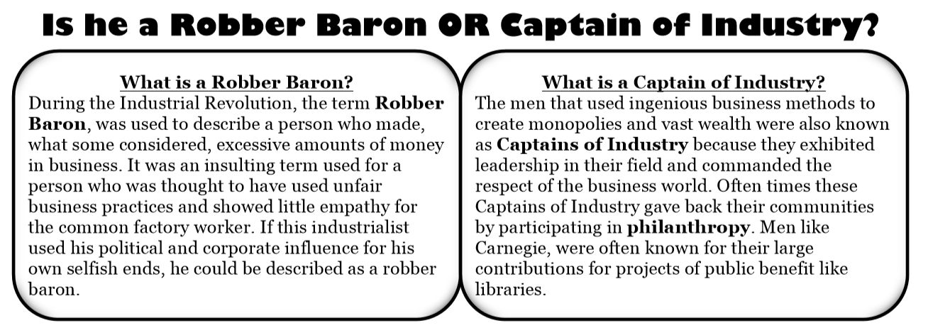
Standard: 4.2.3 Analyze and evaluate how technology and ideas have shaped U.S. History.

Name of Industrialist _________________________________________________

Born:_____________________________ Died:__________________________

Lived:_____________________________________________________________

Family?Wife/Children:____________________________________________________________________________________________________________________________________________________________________________________________________________________

Education: _________________________________________________________

Net Worth:_________________________________________________________

Start of their Business: How did he make his money? First Job? ___________________________________________________________________________________________________________________________________________________________________________________________________________________________________________________________________________________________________________________________________________________________________________________________________________________________________________________________________________________________________________________________________________________________

How did he acquire his wealth?
____________________________________________________________________________________________________________________________________________________________________________________________________________________________________________________________________________________________________________________
____________________________________________________________________________________________________________________________________________________________________________________________________________________________________________________________________________________________________________________

Industry he came to dominate? ________________________________________________________________________________________________________________________________________________________________________________________________________________________________________________________________________________________________________________________________________________________________________________________________________________________________________________________________________________________________________________________________________________________________________________________________________________________________________

How did he treat his workers? ___________________________________________________________________________________________________________________________________________________________________________________________________________________________________________________________________________________________________________________________________________________________________________________________________________________________________________________________________________________________________________________________________________________________

How did he spend his money? ___________________________________________________________________________________________________________________________________________________________________________________________________________________________________________________________________________________________________________________________________________________________________________________________________________________________________________________________________________________________________________________________________________________________

Examples of the GOOD things he did: ___________________________________________________________________________________________________________________________________________________________________________________________________________________________________________________________________________________________________________________________________________________________________________________________________________________________________________________________________________________________________________________________________________________________

Examples of the BAD things he did:
___________________________________________________________________________________________________________________________________________________________________________________________________________________________________________________________________________________________________________________________________________________________________________________________________________________________________________________________________________________________________________________________________________________________

His Legacy: ___________________________________________________________________________________________________________________________________________________________________________________________________________________________________________________________________________________________________________________________________________________________________________________________________________________________________________________________________________________________________________________________________________________________

Extra Information:
____________________________________________________________________________________________________________________________________________________________________________________________________________________________________________________________________________________________________________________

ANDREW CARNEGIE (STEEL)
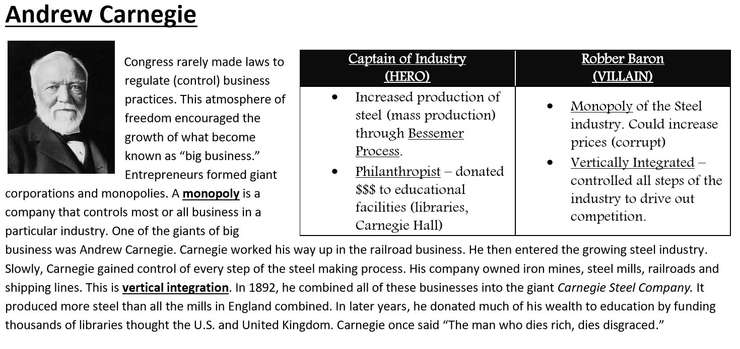

Time Line: Rags to Riches
http://www.pbs.org/wgbh/americanexperience/features/carnegie-timeline-rags-to-riches/

Carnegie Biography
http://www.pbs.org/wgbh/americanexperience/features/carnegie-biography/

The Richest Man in the World: Andrew Carnegie
http://www.pbs.org/wgbh/americanexperience/films/carnegie/

Philanthropy 101
http://www.pbs.org/wgbh/americanexperience/features/carnegie-philanthropy-101/

The Steel Business
http://www.pbs.org/wgbh/americanexperience/features/carnegie-steel-business/

Ducksters for Kids
https://www.ducksters.com/biography/alexander_graham_bell.php

Andrew Carnegie: Man of Steel Video
https://www.pbs.org/video/gilded-age-andrew-carnegie-man-steel-9vlxyd/

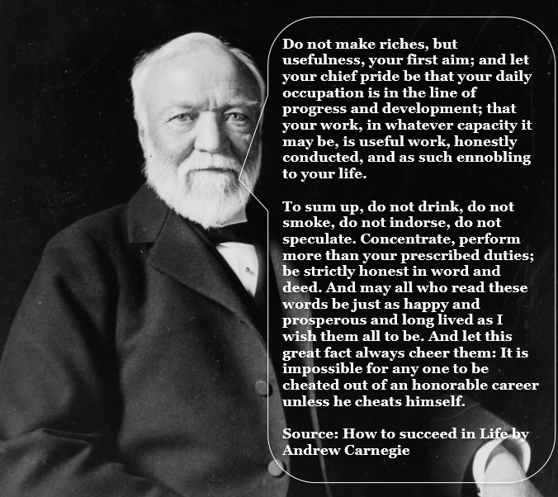

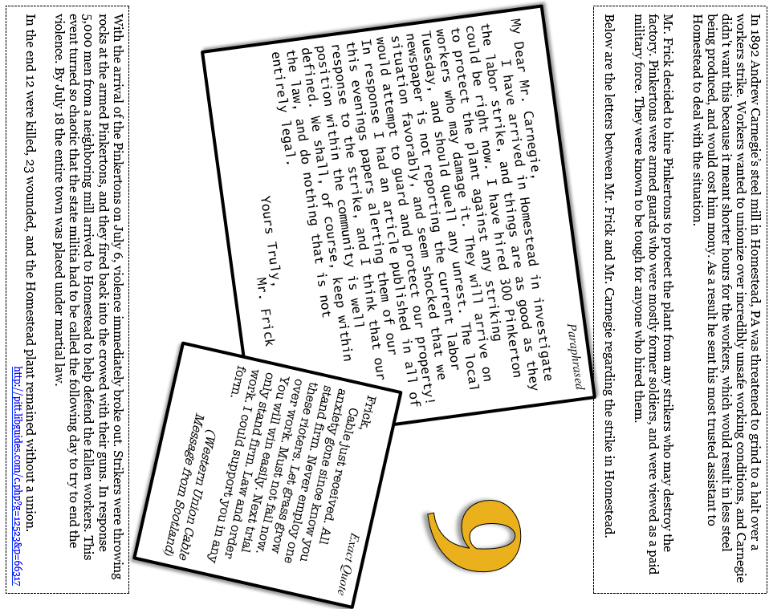

JOHN D. ROCKEFELLER (OIL)
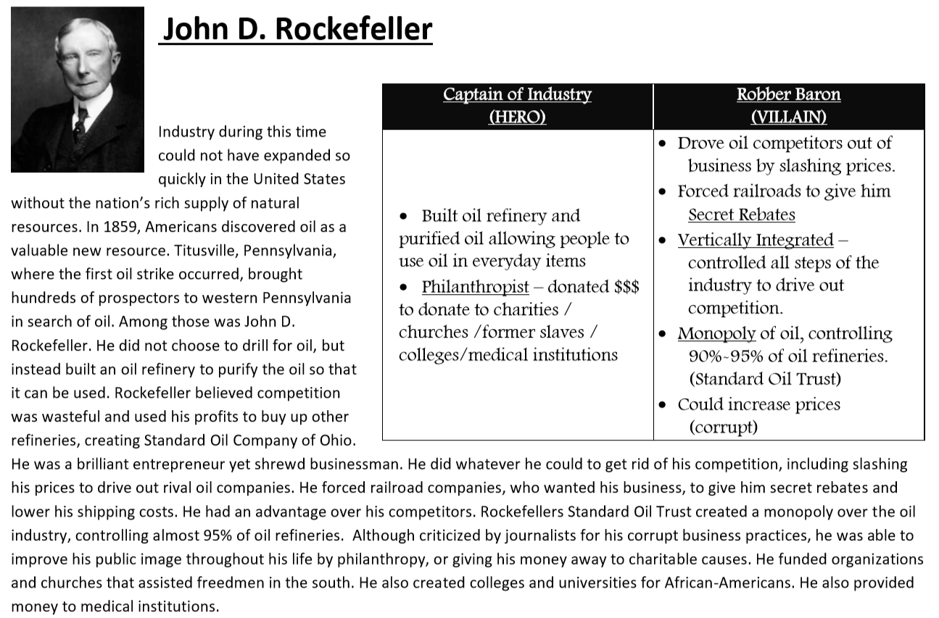
Ducksters for Kids
https://www.ducksters.com/biography/entrepreneurs/john_d_rockefeller.php
Fact Summary
https://www.history.com/topics/early-20th-century-us/john-d-rockefeller
The Rockefellers Time Line
https://www.pbs.org/wgbh/americanexperience/features/rockefellers-timeline/
The Rockefellers Chapter 1 Video
https://www.pbs.org/wgbh/americanexperience/features/rockefellers-chapter-one/
John /d, Rockefeller and the /standard Oil /company
http://www.micheloud.com/FXM/SO/rock.htm
Rockefeller and Standard Oil... Rags to riches...
http://www.bilderberg.org/whatafel.htm

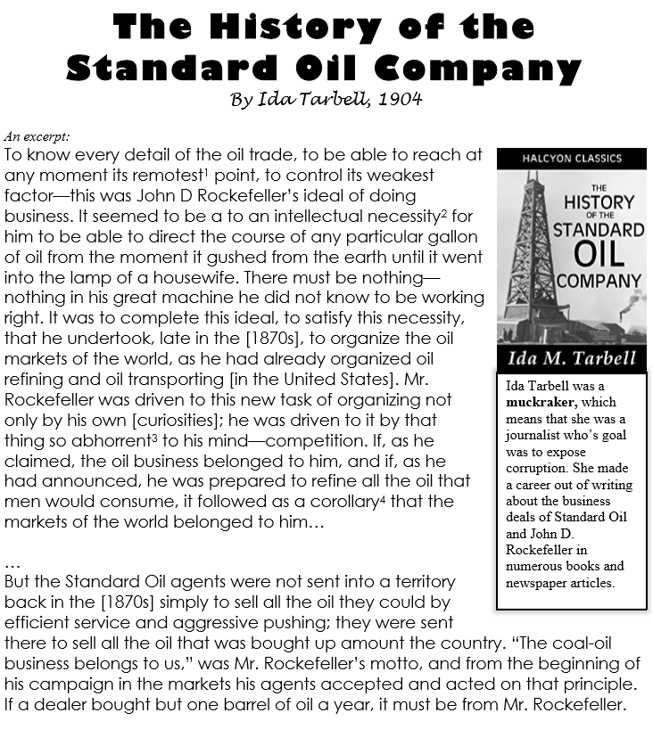

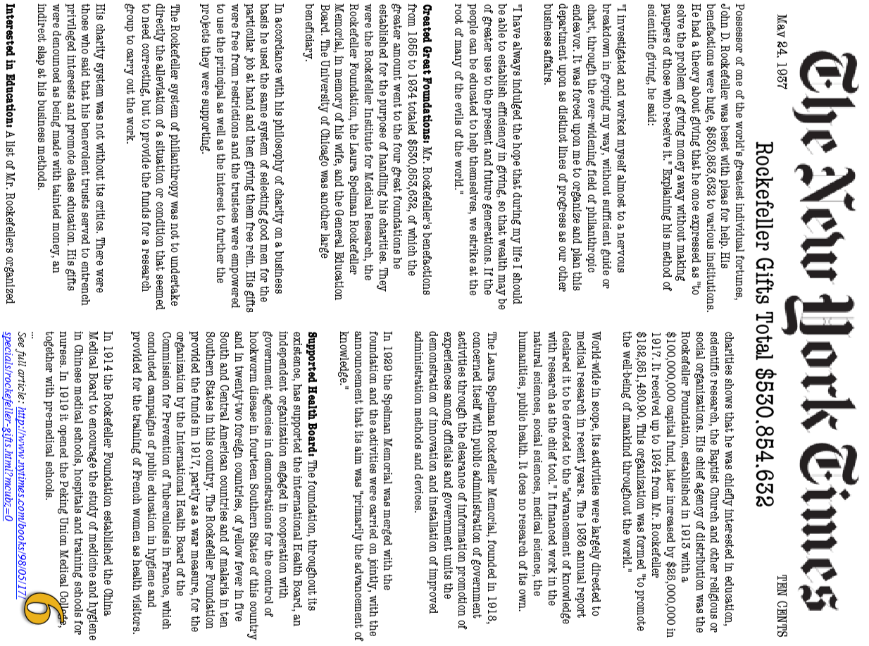

CORNEIUS VANDERBILT (STEAMSHIPS AND RAILROADS)
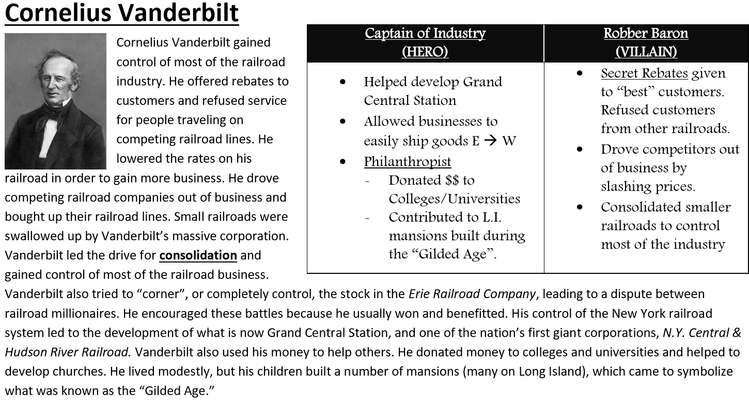

Ducksters for Kids
https://school.eb.co.uk/levels/foundation/article/Cornelius-Vanderbilt/626142

Fact Summary
https://www.history.com/topics/19th-century/cornelius-vanderbilt

Cartoon, "The Great Race for the Western Stakes"
http://loc.harpweek.com/LCPoliticalCartoons/IndexDisplayCartoonMedium.asp?SourceIndex=People&IndexText=Fisk%2C+James&UniqueID=33&Year=1870

Cornelius Vanderbilt
http://www.voteview.com/vanderb2.htm

Why We Should Be Lucky Bill Gates and Warren Buffet Don't Take After Cornelius Vanderbilt
http://hnn.us/articles/43736.html

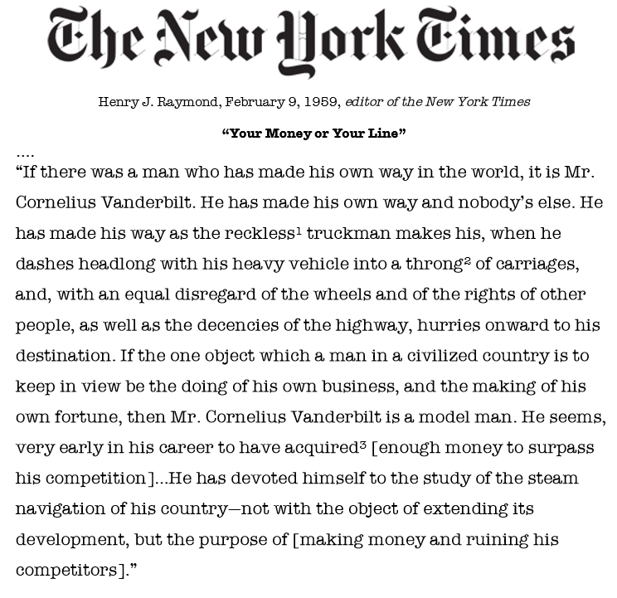

JOHN Pierpont Morgan (BANKING AND FINANCE)
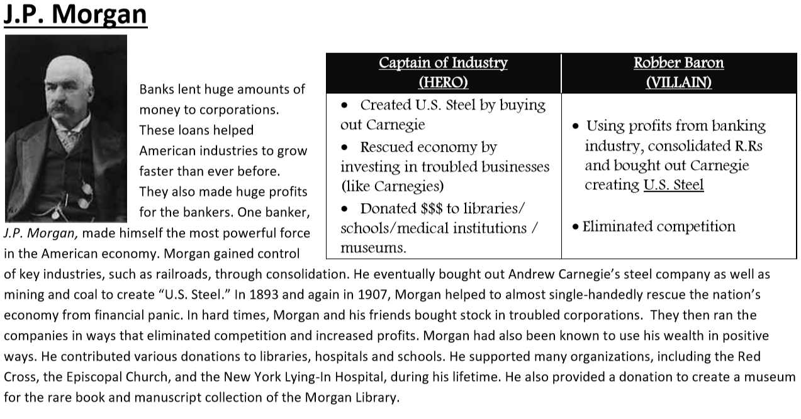

Fact Summary
https://www.history.com/topics/19th-century/john-pierpont-morgan

J.P. Morgan (Brief Biography}
http://www.pbs.org/wgbh/amex/1900/peopleevents/pande10.html

Capital and Labor
http://www.learner.org/biographyofamerica/prog17/transcript/index.html

The Morgan Bonds
http://projects.vassar.edu/1896/morganbonds.html

The House of Morgan
http://coat.ncf.ca/our_magazine/links/53/morgan.html

John Pierpont Morgan and the American Corporation
http://claver.gprep.org/fac/sjochs/jpmorgan-1.htm

John Pierpont Morgan
http://thehobophilosopher.blogspot.com/2006/02/john-pierpont-morgan.html

